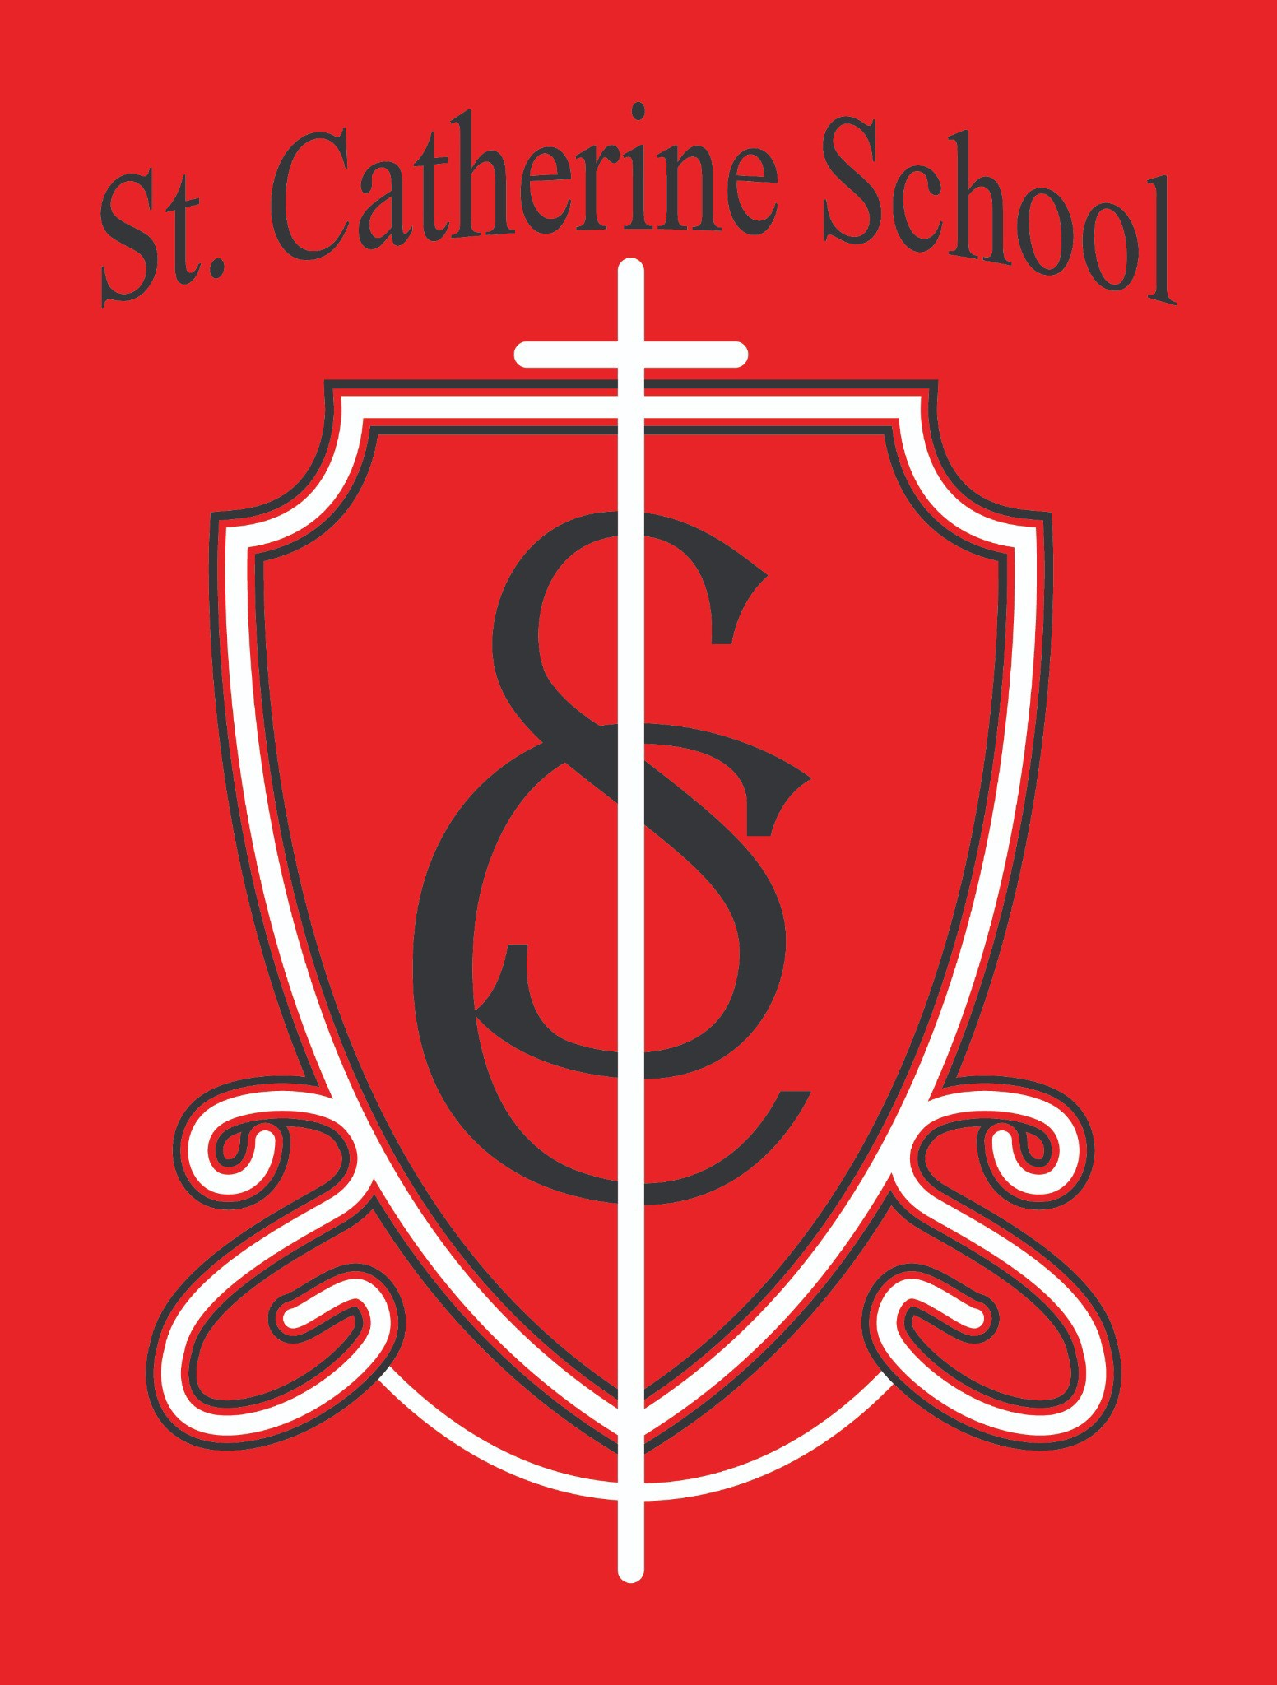

St. Catherine School Weekly Newsletter (Week of May 4th - May 8th)

Principal's Message
Dear St. Catherine Families,
We had such a wonderful spring program this week, and I am so thankful for the hard work of our students, Ms. Busch, and Mr. Kjelland. It was a beautiful opportunity to see our students share their gifts and talents with our school community.
During the program, I was also grateful to recognize two very deserving recipients of this year’s St. Catherine School awards.
Bridgetown Builders, represented by Donny Eberle, was named the recipient of the Business Friend of St. Catherine School Award. Donny, who is the parent of one St. Catherine alumnus and three current St. Kate’s students, along with Bridgetown Builders, has done an incredible amount of work for our school this past year. From the huge undertaking of helping to open Little Saints Childcare, to renovating space for our new music room, to completing important security upgrades, they have consistently moved mountains to ensure our school has what it needs. Their commitment to our mission is exceptional.
We were also honored to present the Friend of St. Catherine School Award to Brad and Patricia Buck. The Bucks consistently volunteer their time quietly and determinedly, always offering to help and seeing projects through. I have never known them to lose their good nature, and they are consistently one of the first families to offer their time and talent. Two current St. Kate’s students are true examples of Christian service.

Families and supporters like these are the reason I come to work each day. They believe in our mission, support it with joy and generosity, and see our school as an extension of their family. I could not imagine better recipients of this year’s awards.
Please join me in congratulating them!

Reminders

We have 88 raffle tickets left to sell and need them all sold by the end of the day on Monday. Please consider purchasing a ticket, or ask relatives and friends to support our school by purchasing one as well. As a reminder, they are $100 each, and the grand prize is $5,000 cash, with 5 $1,000 cash prizes.

Fundraisers like this directly support the mission of St. Catherine School. Thank you to everyone who has already purchased tickets and supported this effort. Tickets will be available at all three Masses this weekend, and we hope, together as a parish and school community, to sell every ticket.

Please pay lunch bills and tuition balances before June 30th. It is important for us to close out our fiscal year with complete and accurate bookkeeping. Please pay the outstanding balances promptly or arrange a payment plan if needed. This is an important part of your obligation as a parent and helps support the continued operation of our school ministry.

Our tuition assistance application for the 2026–2027 school year remains open. St. Catherine School is committed to making Catholic education accessible to families whenever possible, and we encourage any family who may benefit from tuition assistance to apply. Approximately 20% of our families receive some level of tuition assistance support each year, and all applications are handled confidentially through our tuition assistance committee.

Families may apply online through FACTS Grant & Aid at: https://online.factsmgt.com/grant-aid/inst/414FV/landing-page?

Please also remember that many class activities, celebrations, and field trips are taking place during these final weeks of school. Please stay in touch with classroom teachers and the school office so you don't miss important information or permission slips.

The next two weeks is especially busy:
Tuesday, May 12th – Big Ticket Raffle Drawing at 10:30 AM in the school chapel. There was a misprint on the raffle tickets regarding the drawing date.
Wednesday, May 13th – Field Day
Thursday, May 14th – 5th and 6th Grade Field Trip to Bismarck Wednesday, May 20th – 6th Grade Graduation Mass at 9:30 AM

Friday, May 22nd – Last Day of School with Early Dismissal at 12:15 PM. Buses will run and lunch will still be served that day.

Thank you for your continued support of St. Catherine School and for everything that you do to support our mission of inspiring excellence through faith, learning, and service.

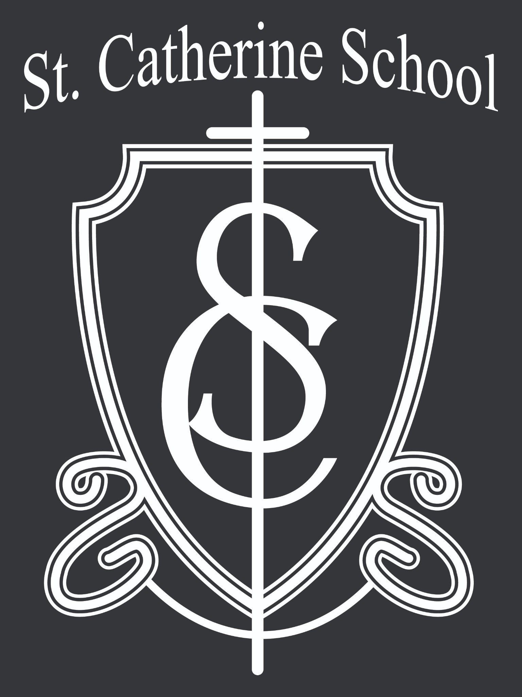St. Catherine Spotlight
The May Crowning Mass was such a beautiful liturgy, and it was wonderful to see so many of our St. Catherine School students involved in the Mass ministries. Students helped by carrying the gifts, crowning Mary, leading the welcome, assisting with prayer petitions, and serving in the music ministry.
It was truly a joy to watch our school community come together in faith to celebrate our Lord and Savior, Jesus Christ. Moments like these are a powerful reminder of the beauty of Catholic education and the importance of helping our students grow not only academically but also spiritually.
The 5th and 6th graders also did such a wonderful job with their States and Countries presentations. I was incredibly proud of the work each student put into researching, preparing, and presenting their projects. They represented themselves and our school very well.
A special thank you to Mrs. Ihry for the tremendous amount of work she puts into this project each year and for helping students present their best selves. Thank you as well to Mr. Will Blunck for being the “man behind the curtain” and for assisting with the technology that helped make the presentations run smoothly.

Stay Connected with St. Catherine School
📍 Address: 540 3rd Ave. NE, Valley City, ND 58072
Email: nicholas.lee1@k12.nd.us
📧
Phone: 1-701-845-1453

📞
Website: www.stcatherine.k12.nd.us

🌐
📘 Follow Us on Facebook: St. Catherine School on Facebook

“Inspiring excellence through faith, learning, and service.”

