Mrs. Graham’s Class Schedule
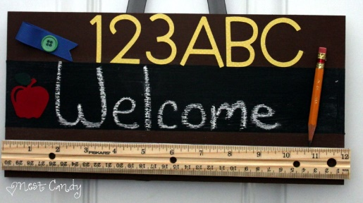
7:30-8:00 Breakfast/ Character Education
8:00-8:30 3rd SOAR Time (RTI Math)
8:30-9:30 3rd Grade Math
9:30-10:00 3rd Grade Science
10:00-10:45 Physical Education
10:45-11:00 3rd Grade Science continues
11:00-11:20 Lunch
11:20-12:05 3rd Grade Technology
12:05-12:10 Transitional Time
12:10-12:40 2nd Grade SOAR Time (RTI Math)
12:40-1:40 2nd Grade Math
1:40-2:10 2nd Grade Science
2:10-2:30 2nd Grade Technology
2:30-2:45 Snack
2:45-3:00 Pack Up/ Load Buses

