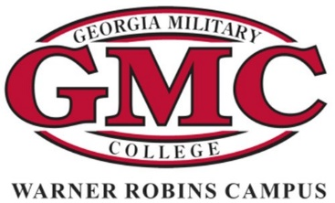

Georgia Military College
Warner Robins Campus

ETHICS BOWL TEAM SCHOLARSHIP
2022-2023

NOTE: IDEAL CANDIDATES ARE CURRENT OR FORMER MEMBERS OF HIGH SCHOOL DEBATE TEAMS. ACADEMICALLY STRONG STUDENTS ARE ALSO ENCOURAGED TO APPLY.

NAME:
Last First Middle

MAILING ADDRESS:

CITY: STATE: ZIP:

TELEPHONE:
Daytime Evening

E-MAIL ADDRESS:

Name of High School and Date of Graduation:

High School GPA:
Years of Debate Team Experience:

Major Area of Educational Interest:
(Please list area even if not fully decided.)

Please complete this application and submit it in one of the following manners:

Mail or submit in person to: Georgia Military College 801 Duke Avenue
Warner Robins, GA 31093 Attn: Scholarships

Email to:
Ms. Sara Jeffords sjeffords@gmc.edu
Ms. Heather Van Atta hcapshaw@gmc.edu
Ms. Elizabeth Self eself@gmc.edu

Scholarship application deadline: August 12, 2022

Upon receipt of this scholarship, student is agreeing to be a participant on the GMC-Warner Robins Ethics Bowl Team.

Applicants must place in ENG 101 to be eligible for this scholarship.

