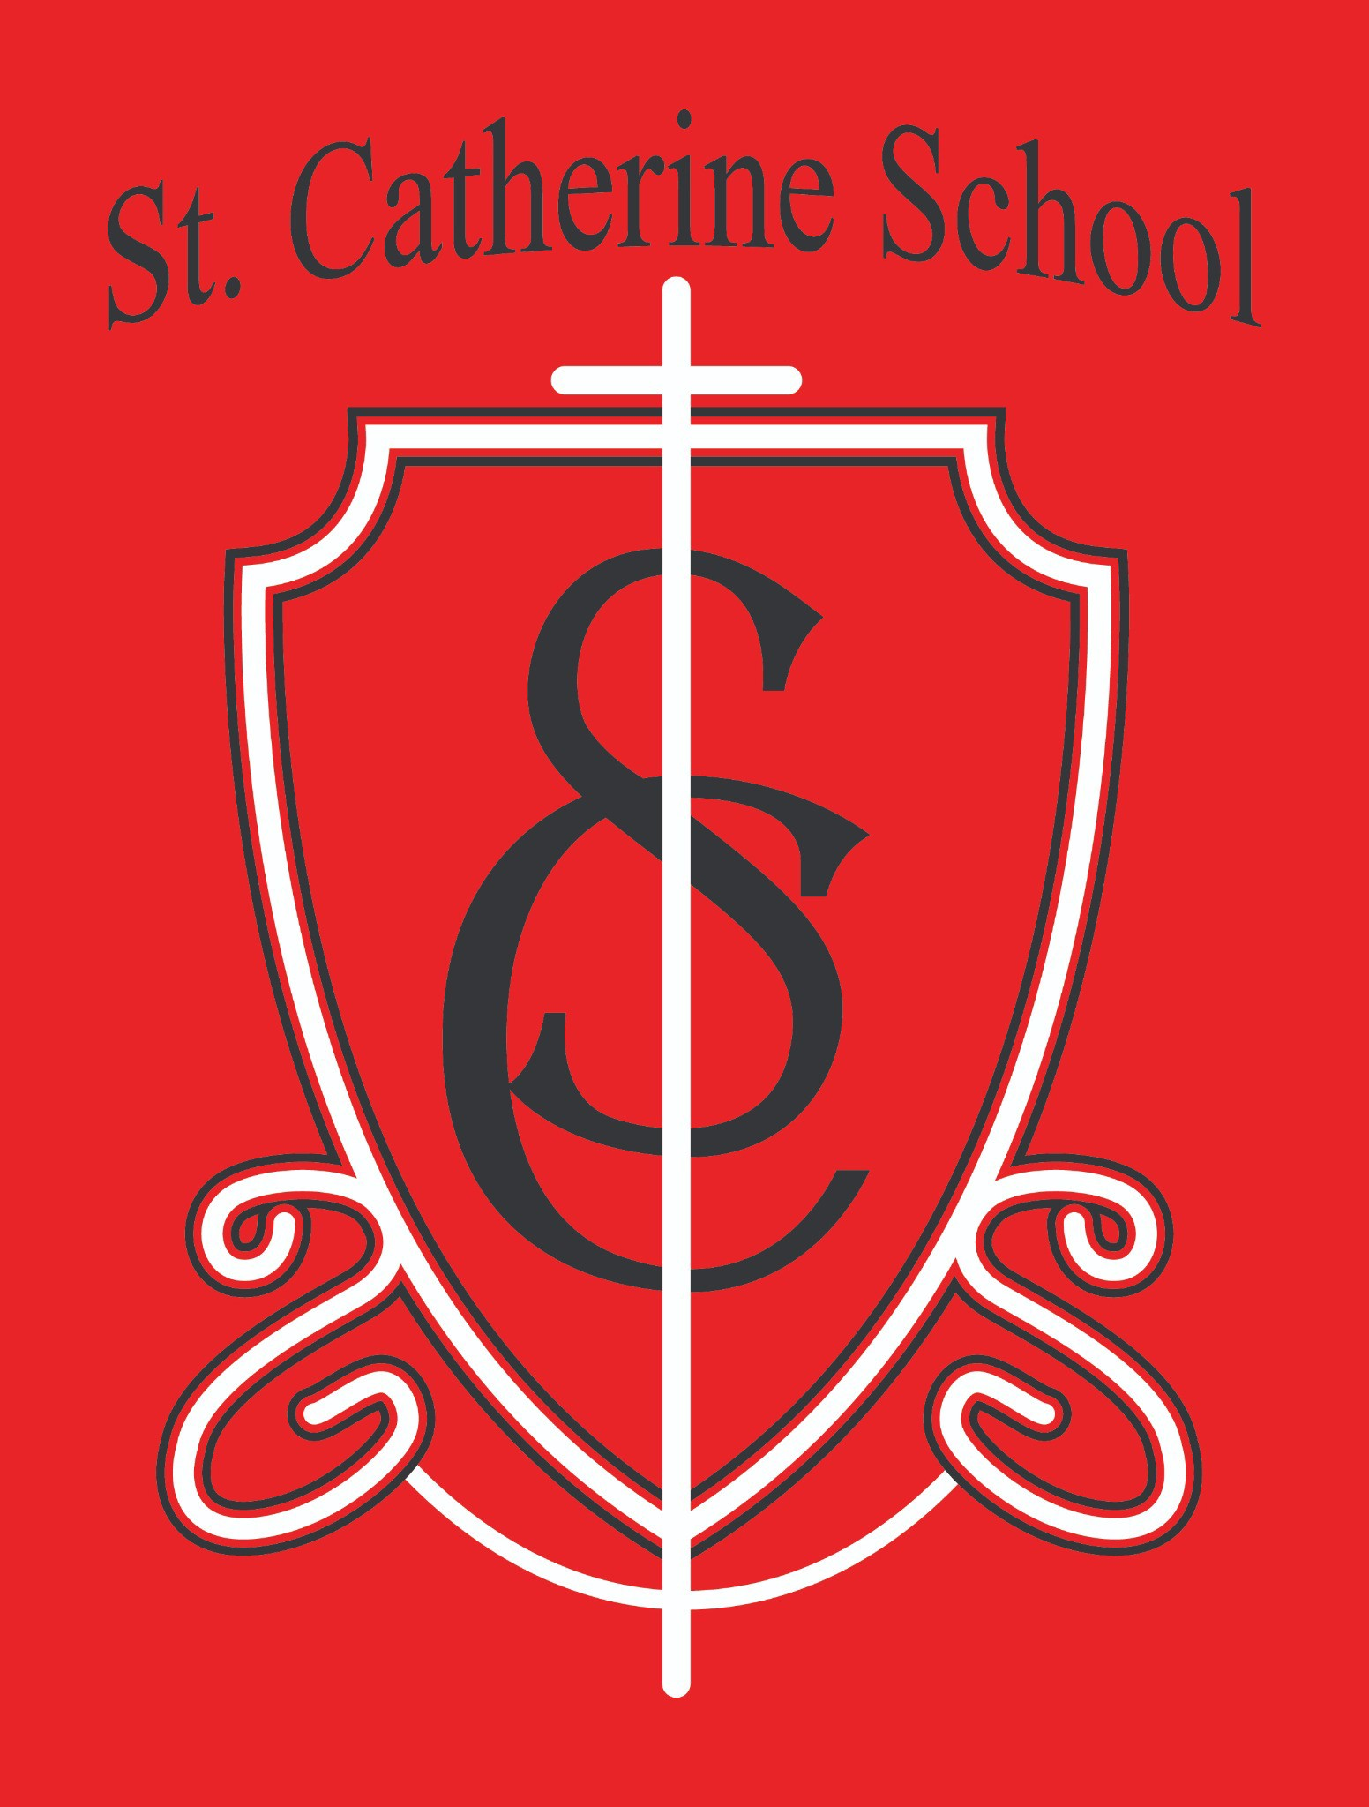

**St. Catherine School Weekly Newsletter (Week of April 21- 25)**

[**https://www.stcatherine.k12.nd.us/parents**](https://nam02.safelinks.protection.outlook.com/?url=https%3A%2F%2Fwww.stcatherine.k12.nd.us%2Fparents&amp;data=05%7C02%7CTerra.Giesen%40k12.nd.us%7C0fe6ae74acbf4aef65d308dd8441f396%7Cdbbf782acef14af186c81f9201061db6%7C0%7C0%7C638812141027390107%7CUnknown%7CTWFpbGZsb3d8eyJFbXB0eU1hcGkiOnRydWUsIlYiOiIwLjAuMDAwMCIsIlAiOiJXaW4zMiIsIkFOIjoiTWFpbCIsIldUIjoyfQ%3D%3D%7C0%7C%7C%7C&amp;sdata=OROHWFfyotfaN4v63XJOM8tI87wygw6p6OP7tEX2uU4%3D&amp;reserved=0)

# Principal's Message

As we move through the Easter season and into the final months of the school year, I am filled with a sense of **gratitude that overflows**.

There is so much to be thankful for:

**Teachers** who continue to bring **joyful spirits and dedication** to their classrooms even in the busy month of April.

The start of **hiring quality staff** for our **Little Saints Childcare Center**, laying a strong foundation for future generations.

The incredible **generosity of our parishioners and school families**, who continue to support our mission with prayers, gifts, and encouragement.

**Enrollment meetings** this week for the new childcare facility, where I have been blessed to meet excited families ready to join our community.

And so much more!

Our upcoming schoolwide **Virtue Focus** (April 21–May 2) is **Gratitude**, a strength of the virtue **Justice**. Gratitude means **acknowledging blessings and expressing thankfulness**.

We look to **Blessed Solanus Casey** as our model of gratitude—someone whose entire life was a testament to trusting God’s goodness and giving thanks in every circumstance. *"One of them, realizing he had been healed, returned, glorifying God in a loud voice."*

— *Luke 17:11–19*

In the coming weeks, students will be encouraged to foster gratitude through activities like

**morning gratitude journals**, **sharing daily blessings**, and **writing thank-you notes**. I truly believe that through the prayers and generosity of our community, **St. Catherine**

**School** is being positioned to serve families **from birth through grade 6 for many years to come**. Your support breathes new life into our mission and strengthens everything we do.

As we prepare for the final stages of opening **Little Saints Childcare**, we will be **painting the childcare classrooms and school staircases the weekend of May 3rd and 4th**, ahead of new flooring installation.

If you are able to **donate even an hour or two** of your time to help paint or assist with setup tasks, **please call the school office**. Every helping hand makes a difference, and we would be **grateful beyond words** for your assistance as we prepare for this exciting new chapter!

### Thank you for walking this journey with us.

**Reminders**

### Spring Music Program – Thursday, May 8 at 6:30 PM

🎶

The time is here! We cannot wait for our students to share what they have been learning in music class!

📅 **Date:** Thursday, May 8, 2025

🕕 **Doors Open:** 6:00 PM

📍 **Location:** St. Catherine School Gym

**Arrival:** Students should meet their teachers **on the gym bleachers by 6:25 PM**.

�

**Note:** Please keep your child's jackets and belongings with you during the program.

🧥

### Dress Code:

Nice shirts – Fun and spring-colored (no spaghetti straps or crop tops) Jean pants or jean capris – No rips or holes

Closed-toe shoes – No sandals, crocs, or flip flops

Ladies may wear dresses with leggings or tights if preferred.

Please avoid noise-making accessories, light-up objects, sweatshirts, and hoods.

Questions? Contact **Ms. Alexis Busch** at [Alexis.A.Busch@k12.nd.us](mailto:Alexis.A.Busch@k12.nd.us).

📧

📎 A copy of the concert information is attached.

### RSVP for May Crowning Mass and Guest Lunch

🌸

Our **May Crowning Mass** will be held on **Thursday, May 1st at 10:30 AM**. Following Mass, we will have a **Guest Lunch** for visitors and families!

**Please RSVP** to **Ms. Giesen** in the office if you plan to attend the Guest Lunch.

📧

### Tuition Assistance – TAP Application Reminder

💰

Tuition assistance applications for the **2025–2026 school year** are now open through **FACTS Grant & Aid**.

### 📅 Deadline: May 15, 2025

[Apply Here](https://nam02.safelinks.protection.outlook.com/?url=https%3A%2F%2Fonline.factsmgt.com%2Fsignin%2F414FV&amp;data=05%7C02%7CTerra.Giesen%40k12.nd.us%7C0fe6ae74acbf4aef65d308dd8441f396%7Cdbbf782acef14af186c81f9201061db6%7C0%7C0%7C638812141027417416%7CUnknown%7CTWFpbGZsb3d8eyJFbXB0eU1hcGkiOnRydWUsIlYiOiIwLjAuMDAwMCIsIlAiOiJXaW4zMiIsIkFOIjoiTWFpbCIsIldUIjoyfQ%3D%3D%7C0%7C%7C%7C&amp;sdata=3rSlhajrCyRCBSgceJ8OL5jbDPH99hK58W2LDTM%2FRLw%3D&amp;reserved=0)

🔗

Questions? Please contact the school office.

### Save the Date – 6th Grade Graduation Mass

🎓

Our **6th Grade Graduation Mass** will be held on **Tuesday, May 20 at 9:30 AM** in

the church.

### Last Day of School – Wednesday, May 21

📅

Mark your calendars! The final day of the 2024–2025 school year is **Wednesday, May 21**.

Virtue Focus: Justice – Gratitude (April 21–May 2) ✝

Gratitude means **acknowledging blessings and expressing thankfulness**.

We look to **Blessed Solanus Casey** as our model for living out gratitude with trust and joy.

*"One of them, realizing he had been healed, returned, glorifying God in a loud voice." – Luke 17:11–19*

Students will focus on gratitude practices such as **morning gratitude journals, sharing blessings, and writing thank-you notes**.

## Childcare & Academic Opportunities

### Childcare Hiring – Join Our Team!

🧸

We are hiring **Lead Teachers, Assistant Teachers, and Float Staff** for **St. Catherine Little Saints Childcare**, with **part-time and full-time positions** available.

Apply by sending your **resume, cover letter, and three professional**

📧**references** to **Beth Nadelin** at [beth.nadelin@k12.nd.us](mailto:beth.nadelin@k12.nd.us).

### Summer Tutoring – Exploring Interest

📚

We are exploring **summer tutoring** for students entering **grades K–6** next year. Tutoring will be open to **all families**, not just currently enrolled students.

Interested? Email **Mr. Lee** at [nicholas.lee1@k12.nd.us](mailto:nicholas.lee1@k12.nd.us).

📧

### Little Saints Childcare – Wishlist & Sponsorship Opportunities

🍼

We are working to furnish our infant room with **8 commercial-grade cribs**—**and 6 have already been sponsored** thanks to the incredible generosity of our parish and school families!

Stay tuned for the release of our **Amazon Wishlist** and opportunities to sponsor rooms or needed supplies.

💬 Questions or want to help? Contact [nicholas.lee1@k12.nd.us](mailto:nicholas.lee1@k12.nd.us).



**St. Catherine Spotlight**

All the work that has been completed downstairs! Pictures to come next week. The spaces are being transformed. A big thank you to Bridgetown Builders, RJ’s Plumbing, Hi-Line Electric, LaValle Flooring, Bakkegaard and Schell, and all the contractors and tradesman transforming our spaces!

Stay Connected with St. Catherine School

📍 **Address:** 540 3rd Ave. NE, Valley City, ND 58072

**Email:** [nicholas.lee1@k12.nd.us](mailto:nicholas.lee1@k12.nd.us)

📧

**Phone:** 1-701-845-1453

📞

**Website:** [www.stcatherine.k12.nd.us](https://nam02.safelinks.protection.outlook.com/?url=https%3A%2F%2Fwww.stcatherine.k12.nd.us%2F&amp;data=05%7C02%7CTerra.Giesen%40k12.nd.us%7C0fe6ae74acbf4aef65d308dd8441f396%7Cdbbf782acef14af186c81f9201061db6%7C0%7C0%7C638812141027438155%7CUnknown%7CTWFpbGZsb3d8eyJFbXB0eU1hcGkiOnRydWUsIlYiOiIwLjAuMDAwMCIsIlAiOiJXaW4zMiIsIkFOIjoiTWFpbCIsIldUIjoyfQ%3D%3D%7C0%7C%7C%7C&amp;sdata=7DOrpexI3qKEGBhPqMSqZaH2pI8JwgvDHIRcn%2BqOIGA%3D&amp;reserved=0)

🌐

📘 **Follow Us on Facebook:** [St. Catherine School on Facebook](https://nam02.safelinks.protection.outlook.com/?url=https%3A%2F%2Fwww.facebook.com%2Fst.catherineschoolvc%2F&amp;data=05%7C02%7CTerra.Giesen%40k12.nd.us%7C0fe6ae74acbf4aef65d308dd8441f396%7Cdbbf782acef14af186c81f9201061db6%7C0%7C0%7C638812141027453587%7CUnknown%7CTWFpbGZsb3d8eyJFbXB0eU1hcGkiOnRydWUsIlYiOiIwLjAuMDAwMCIsIlAiOiJXaW4zMiIsIkFOIjoiTWFpbCIsIldUIjoyfQ%3D%3D%7C0%7C%7C%7C&amp;sdata=svYlYVGhVnob5kA0dfx6NSzBCzIg9Hf%2FPUhe7v5QQ9E%3D&amp;reserved=0)

*“Inspiring excellence through faith, learning, and service.”*