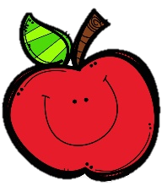
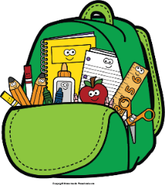
Mr. Marks’ Messages
November 11th-15th, 2024
Assessments
Thursday Assessments: vocabulary quiz, grammar quiz, weekly math quiz
Friday Assessments: Spelling Test, Reading Test, MathTopic 5 test
Reminders
- Wednesday November 13th- Progress Reports
- Friday, November 15th- Santa Pictures
- Please check your child’s binder daily for important information, homework, and their behavior chart.
Reading Story and Skills:  Story: In My Own Backyard  Phonics/Fluency:  /e/ spelled e, e_e, ee, and ea  Writing:  Informational writing  Text-Based Comprehension:  Sequence, inferences  Grammar/Language:  Singular/plural nouns |  | Vocabulary Words  - brook: a small stream  - plowed: turned over and cut through out  - settler: a person who comes to live in a new land or country  - mist: a cloud of tiny drops of water or other liquid that is in the air  - sheets: a thin, broad piece or surface of something  - haze: mist, smoke, or dust in the air  - grazed: to feed on growing grass  - skimmed: to move over lightly and swiftly  - blurry: dim or hard to see: unclear  10. pulsed: to beat or vibrate
Math  Topic 5  Lesson 4-7  Students will use various strategies to subtract within 100. We will complete the study guide for topic 5 on Thursday and Test on Friday. If the students are not ready to test by the end of the week, I will push the test back until the beginning of next week. |  |  |  | Social Studies/Science  Science:  We will begin our unit on National Holidays. This week we will focus on Veteran’s Day. We will also read a chapter book about Thanksgiving.
Spelling Words:
- real  - reel | - we  - eve |  | - steel  - steal |  | - creek  - creak | - knee  10. sleep

