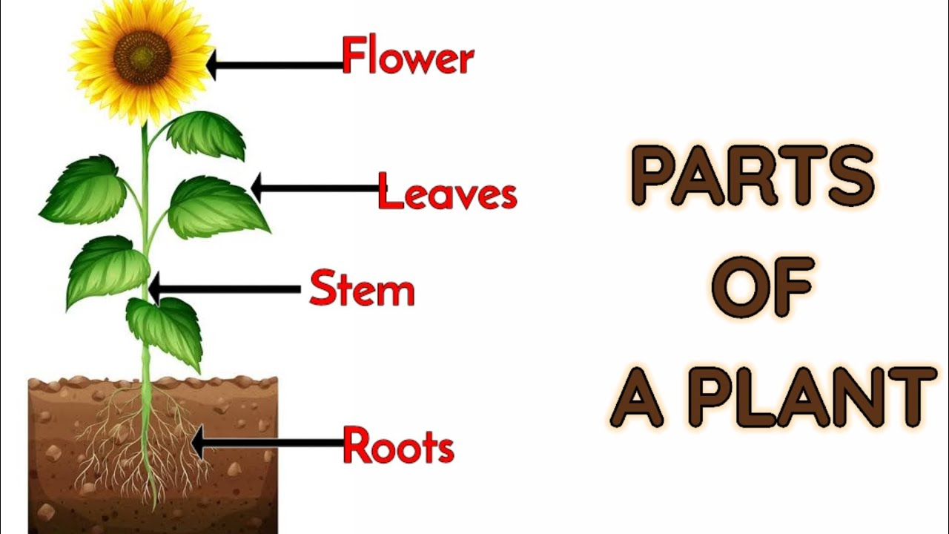

CLASS NEWS
Mrs. Williams
Date: April 20, 2026

Math: measurement unit

Science/Social Studies: plant life cycle

Upcoming Events:
April 17 – Interims will be in blue Friday folder
April 22 – visit Atlantic Union Bank – Family Futures
May 1 – Field Trip Permission slips and money are due
May 15th – Luray Caverns Field Trip

