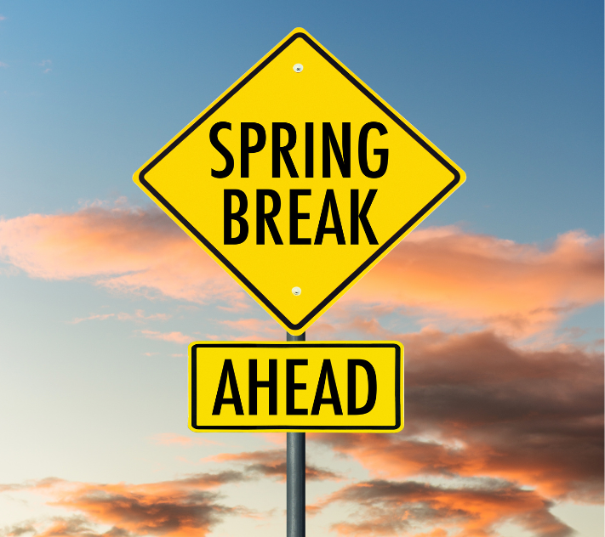
CLASS NEWS
Mrs. Williams
Date: March 23, 2026

Math: Geometric shapes and spatial reasoning

Science/Social Studies: continue unit on lifecycles

Upcoming Events:
March 26 – Bunny Bash Family Engagement Night 5:30 – 7:30
March 27 – Report Cards go home
March 30 - April 3 – Spring Break!
April 6 – No school for students – Professional Development

