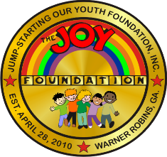

JUMPSTARTING OUR YOUTH (JOY) FOUNDATION,

INCORPORATED

**Post Office Box 6228**

**Warner Robins, Georgia 31095**

December 09, 2024

2025 Scholarship

To: All Applicants

RE: Scholarship Application Process

The Board of Directors of the JOYFoundation, Inc. is excited to offer two $1500.00 fine arts scholarships to deserving 2025 graduating seniors of the Houston County school systems during our **15th** Anniversary.

The JOY Foundation scholarships will be awarded to qualifying Houston County 2025 graduating seniors who plan to further their education at a college or university pursuing studies in the field of performing arts (such as theatre, dance, music, opera, music theatre etc.). Enclosed you will find the necessary information to complete the application process.

Thank you for your interest, and we look forward to receiving your application!

For additional information, please contact 478-442-4163 or 478-951-2037. The JOY

Foundation is a non-profit organization incorporated to empower the Middle Georgia community through cultural awareness and educational enrichment.

Sincerely,

**Yvonne King**

Yvonne King

Board Chair