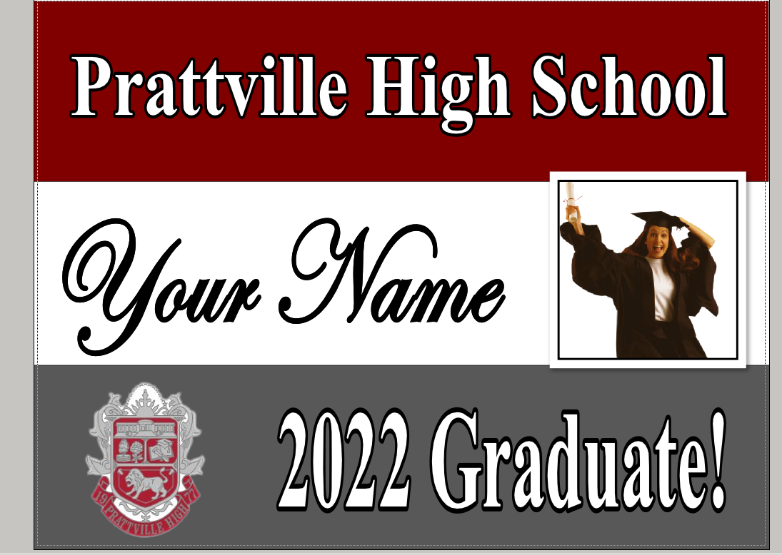
Your picture here!
Instructions: Please fill out the order form and return with payment.
Name:
(Please print/type and double check spelling.)
Cash Check #
Picture: *No filters on the picture. It should be in a JPEG or PNG file format.
Email to amy.reeves@acboe.net Subject: Senior Yard Sign Photo with your name. **********************************************************
Available to purchase from March 7th- May 20th in the Media Center.
Payment: Checks – made out to PHS Cash: Exact payment $30.00 ****NO change!
Please remit payment in an envelope with order form.

ALL SALES FINAL- NO REFUND or REPLACEMENTS
Not RESPONSIBLE FOR DAMAGE CAUSED BY WEATHER

