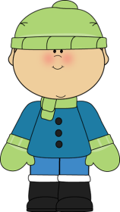
Mrs. Daniel’s Messages
September 27 - October 1, 2021
Reading Skills and Grammar (nouns) Tests: Friday
Spelling (r-controlled vowels) and Vocabulary Tests: Friday

Next Student of the Week (October 18-22): Elyeon
Wednesday, October 6: 1st 9 Weeks Ends
Friday, October 8 - Monday, October 11: Fall Break (NO
SCHOOL)
Tuesday, October 12: Report Cards Go Home

Reading Story and Skills:  Monday, October 4: Fall Make-  Up Pictures  Tuesday, October 5: 6:00 ZOOM  Family STEAM Night  Story: Tara and Tiree, Fearless Friends by Andrew Clements  Phonics/Fluency:  r-controlled vowels  (ar, or, ore, oar)  Text-Based Comprehension:  cause and effect,  summarize  Grammar:  nouns |  | Selection Vocabulary Words:  - brave – showing no fear of dangerous things  - slipped – slid without meaning to  - collar – a band that a dog wears around its neck  Vocabulary Words  (these words will be tested each week):  - break – to come apart or crack or split  - listen – to try to hear or take note  - family – a group of people joined together  - once – as soon as  - heard – took sounds in through the ear  - pull – to take a hold of and tug
Math  Place Value  This week, we will be working on place value. We will be finding the value of each digit within a number.  We will be doing a weekly assessment on Friday. |  |  |  | Social Studies/Science  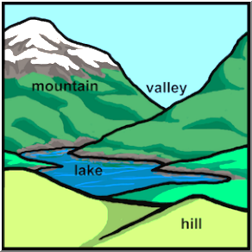  We will be studying  MAP SKILLS skills a this week  Social Studies.
Spelling Words: Students who correctly spell the bonus words get a small prize.
- hard  - born  - horse | - before  - more  - smart |  | - farm  - porch  - corn |  | - chore  - score  - part | ***BONUS***  - tarnish  - harvest  - ignore

