
MRS. Christina Maloney
TEXTBOOKS –
A textbook will not be issued HOWEVER, if you would like to check out a book for reference, you may. THEY DO NOT follow order of AP curriculum.
EMAIL: christina.maloney@hcbe.net
TEACHER Extra Help: T & TH Morning
ROOM: 2205

COURSE DESCRIPTION
Advanced Placement Precalculus is this full year course, where students explore all high school Precalculus topics as well as advanced Algebra and Geometry concepts. This class requires students to demonstrate fluent understanding of concepts and procedures, reason abstractly and quantitatively to solve problems, communicate reasoning, model with mathematics, and evaluate conclusions. As in all advanced level courses, students are expected to complete work according to given timelines, so they are prepared to move through the curriculum at the required pace. Students who successfully complete this course will be prepared for AP Precalculus Exam & Calculus I.

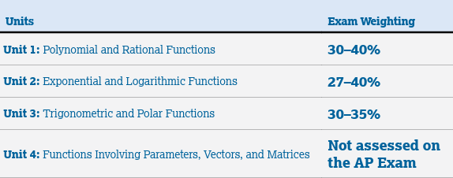
Second Semester
First Semester
***We will work on Unit 4 Material after spring break while we prepare for AP TEST. Those that take the final exam will be tested on Unit 4 material.***

GRADING POLICY: Per Houston County Board of Education policy, each student’s average will be calculated as follow:

- Major Assessments (Tests) = 45%
- Minor Assessments (Quizzes) = 20%
- Daily Work (Classwork/Homework Assignments) = 15%
- Final Exam = 20%
INFINITE CAMPUS: Student grades can be easily monitored by checking Infinite Campus regularly. Parents and students have access to Infinite Campus.

CANVAS: Students will use Canvas to access assignments, communicate with teachers and classmates, check grades, and keep track of important dates and announcements. It is expected for students to check Canvas DAILY. All notes & videos will be posted daily, along with AP resources.

HOMEWORK POLICY: To succeed in any math class, students must practice! Practice problems will be assigned daily. Students are expected to attempt each problem to receive full credit (100). If students have difficulty completing their practice work, they must reach out for help before the due date. Homework must be complete upon entering the classroom. If homework is not completed, a zero will be assigned.

Quizzes: Students should expect 2 – 3 a week taking 10 – 15 min. They will not be announced, and students will need to finish in the given time. Students must be prepared daily.

DELTAMATH POLICY: DeltaMath will be used throughout the year for additional practice, homework assignments, & quizzes. Students are expected to complete all assigned tasks by the due date to receive full credit. Assignments are designed to support mastery through repetition and immediate feedback, so students are encouraged to make corrections and retry problems as needed. Consistent use of DeltaMath will strengthen problem-solving skills and support success on the AP Exam.

CHROMEBOOK STATEMENT: “All students are issued a district-provided chrome book for instructional purposes, student engagement, and student learning. Chrome book use is at the direction and discretion of the classroom teacher.

TEST RETAKE POLICY: Students will be allowed to RETAKE 1 test a semester. Each test will be curved. To earn the curve, students must complete the REVIEW (before the test) and complete test corrections within the specific timeline provided.

TEST POLICY: Students need to put away all smart watches & phones during testing. Additionally, bookbags may be placed in front of the classroom for major or minor assessments.

MATERIALS: Students MUST be prepared daily by bringing to class with them their own personal materials, a Graphing Calculator is HIGHLY RECCOMENDED.

Absences & Make-up Work – Students are responsible for all work during an absence. PLEASE Make sure you understand when you have an NI, you are responsible for what we have done in class. Quizzes and tests MUST be completed immediately upon return and homework should be completed. It is YOUR responsibility to check CANVAS to see what you missed. An NI is not a FREE day. It is not the same policy as if you were out sick. Be responsible for your work.

AP EXPECTATIONS-
- College-Level Rigor: All AP courses are designed to be equivalent to an introductory college-level course in the subject, requiring a minimum of 6 hours of individual study time per week outside of class.
  - If notes are not completed during class, it is students responsibility to complete them at night on their own and come into class with questions.
- Deep Understanding: AP courses emphasize a deep understanding of concepts rather than rote memorization, encouraging critical thinking, analysis, and evaluation.
- Skill Development: Students are expected to develop college-level skills, such as close reading, analytical writing, problem-solving, and utilizing evidence to support arguments.

AP CLASSROOM POLICY: AP Classroom is a required part of AP Precalculus and will be used regularly for practice questions, videos, and progress checks to support learning and exam preparation. Students must complete all assignments by the due date and are expected to do their own work. Participation in AP Classroom helps identify strengths and areas for growth, and students are responsible for reviewing feedback and using it to improve. A College Board account is required to access the platform & take the AP test. KEEP TRACK of your password on TEST day you cannot access saved passwords. **YOU WILL HAVE AN AP CLASRROM ASSIGNMENT EVERY UNIT**

- “I understand that I, as an advanced placement student, am responsible for registering online for my exams. Failure to do so will mean that I am unable to participate in AP testing for this course during the current school year.”
- “The school is responsible for meeting College Board deadlines regarding testing registration. Once I have chosen to test/not test and submitted my registration through College Board website, I am responsible for any fees incurred should I later change my decision.”
AP Classroom CODES:  APPC 2- LWV6EY  APPC 3 – W9LNGG | AP CLASSROOM-  APcentral.collegeboard.org  1-888-225-5427  **teachers/admins CANNOT access your account
APPC 4 – JXYANJ  APPC 7 – 9NP9Z3 | 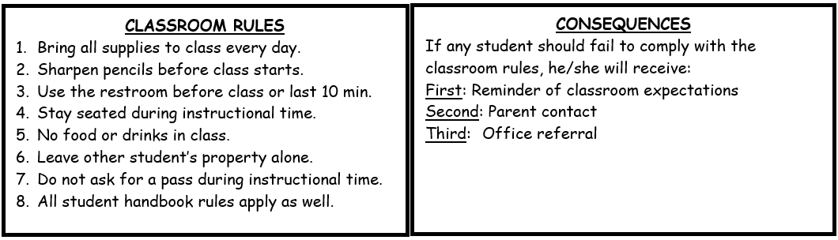

AP Precalculus
Mrs. Maloney

Please PRINT
Student Name ________________________________________ Period ______________

Primary Contact– If you want both parents/guardians contacted – add to bottom

Parent/Guardian Name__________________________________ Number ____________________________
Text: Yes ____ No _____

Parent/Guardian E-mail Address ______________________________________________________________

___________________________________ ___________________________________
Parent/Guardian Signature Student Signature

This year, we will use Apptegy Rooms to share class announcements, important updates, and reminders, as well as communicate with families. Please log in using the information provided by the school and enable notifications so you don't miss important information.

By signing above I acknowledge that I have received, read and understand all the objectives, student expectations, classroom rules and procedures, grading policy, disciplinary consequences, calculators, and tutoring information in the syllabus for the AP Precalculus course.

**Please Understand this is an AP Precalculus, UPPER-Level Math course. The class moves at a different pace; prerequisite and study skills are extremely important. Previous Math grades are not a reflection of success in AP Precalculus. Students will need to work hard and put in the effort to succeed. It is designed to prepare students interested in a STEM field for college or Calculus courses. **

Parent/ Guardian, please include your email address and the single best phone number at which to contact you between 7:30-3:30.

Please feel free to list any comments or any information you see as important. Please email me with ANY questions!
__________________________________________________________________________________

__________________________________________________________________________________

How to Succeed in AP Precalculus
AP Precalculus is a college-level course, but success is achievable. Students who are successful are not always the ones who understand everything immediately, they are the ones who consistently put in the effort. The following habits will help you be successful throughout the year.

Successful AP Precalculus Students...
- Complete homework consistently. Homework is where learning happens. Practice is essential to building mathematical understanding and confidence.
- Review your notes every day. Spend 10–15 minutes looking over what we learned while it is still fresh. A little review each day is much more effective than cramming before a test.
- Annotate your notes. Rewrite difficult ideas in your own words, highlight important concepts, add examples, and write questions in the margins.
- Use outside resources when you get stuck. Don't stop learning because you're confused. Use:
  - AP Classroom videos
  - Teacher-posted videos and resources
  - YOUTUBE!!!! Reputable online videos or websites – search topic
    - EX. The Organic Chemistry TUTOR
- Ask questions. If something doesn't make sense, ask during class, after class, during tutoring, or by email. Chances are someone else has the same question.
- Come to class prepared. Bring your charged calculator, notebook, pencils, and any assignments needed for class.
- Stay organized. Keep notes, quizzes, and assessments in order. You'll be surprised how often you'll want to go back to previous material. (use dividers!)
- Don't let confusion pile up. Math builds on itself. If you don't understand today's lesson, tomorrow's lesson will be even more difficult. Seek help early.
- Correct your mistakes. Learning happens when you figure out why an answer was wrong. Review homework, quizzes and tests instead of simply looking at your grade.
- Study a little every day. Short, consistent study sessions are much more effective than trying to learn everything the night before a test.
- Memorize what needs to be memorized. Certain formulas, identities, vocabulary, and the unit circle require repeated practice until they become automatic.
- Show all of your work. Organizing your work helps you catch mistakes, earns partial credit, and prepares you for AP Free Response Questions.
- Be an active participant. Take notes, contribute to discussions, work with classmates, and engage in activities instead of simply watching.
- Take advantage of every opportunity to practice. Complete AP Classroom assignments, optional review problems, warm-ups, and corrections.
- Develop a growth mindset. It's okay not to understand something the first time. Learning challenging mathematics takes persistence.
- Take responsibility for your learning. I will teach, guide, encourage, and support you—but ultimately, your success depends on the effort you choose to put in each day.

Remember...
Success in AP Precalculus is not about being the smartest student in the room. It is about being the most consistent. Small daily habits create big results.

