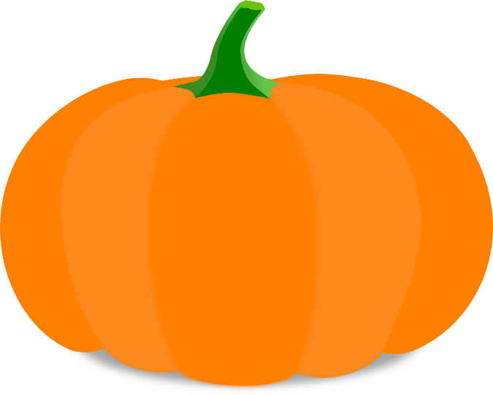
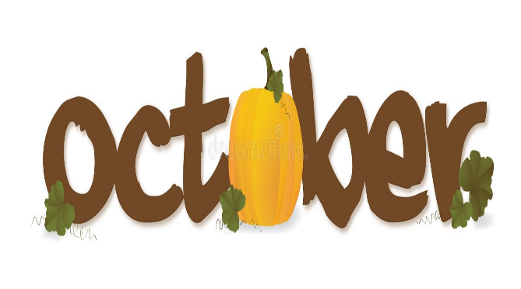
It’s Fall Y’all

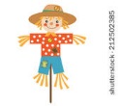

It is fall! We are so thrilled for fall to be here! We are excited for some fall weather. What an exciting and fun time of the year. Your kids are doing great and we are learning a lot.
During October, we will be learning about pumpkins, community helpers, and having some fun with Halloween! Every day, we are counting, reviewing letters, letter sounds and numbers. Towards the end of October, we will be scheduling conferences with you to talk about what your child is learning. Please make note the conference day will be sometime in November. We hope your children are sharing their experiences with you. We certainly are loving seeing each of them grow. We are very blessed.
Please work on the following items with your child.
Recognizing Uppercase /lowercase letters (Hh, Qq, Yy, Gg & Uu)
Recognize letters in your name
Write your name

Mark Your Calendar
Oct. 3rd – Special Snack $1.50/Spirit Day

Oct. 10th – ½ day for all students’ Pre-K dismisses at 11:00

Oct. 13th – No school/Fall Break

Oct. 20th – Pumpkin Patch Field Trip

Oct. 27th Red Ribbon Week
(Monday – Dress Disney)

Oct. 28 – 30 Pre-K Conference (No School for Pre-K)

Oct. 31st Fall Fun Day (details to come) Wear Costume)

