|  |  |
| --- | --- |
| You can’t build a Chimney from the Top  Dr. Joseph Winthrop Holley | 2024 SCHoLaRSHIP PACKAGE  Albany State University  National Alumni Association  Warner Robins Area Chapter  **Post Office Box 1253**  **Warner Robins, Georgia 31099**  **wracasunaa@gmail.com**  Gladys Bryant  Chairperson |

Contents

Warner Robins Area Chapter, Albany State University National Alumni Association 2

2024 ASU Scholarship 2

*Student Letter* 3

*Scholarship Application Form* 4

*Selection Criteria* 5

Albany State University (ASU)

National Alumni Association

Warner Robins Area Chapter

**Post Office Box 1253**

**Warner Robins, Georgia 31099**

Warner Robins Area Chapter, Albany State University National Alumni Association

*presents*

2024 ASU Scholarship

This is an opportunity for 2024 graduating seniors from Houston County and Peach County high schools to compete for one or more scholarships in the amount of $1000 for post-secondary education at Albany State University. The recipient will receive this award at the school’s annual Senior Honors Day, or an appropriate ceremony held by the local alumni chapter.

Final application submission date: Friday, March 29, 2024.

We encourage graduating seniors to contact your high school counselors to obtain an application package and receive mailing instructions or send a request for an application package to the email address listed below.

Our chapter’s 3-fold purpose in awarding this scholarship is to: (1) recognize graduating seniors for outstanding achievement, (2) provide assistance for continuance of exemplary schoolwork beyond secondary school, and (3) enhance interest in enrollment for further study at Albany State University.

Thanks to a future ASU Ram for your participation in the 2024 scholarship competition.



POTENTIAL. REALIZED.

Gladys Bryant, Chair

WR Area Chapter ASU National Alumni, Scholarship Committee

e-mail: wracasunaa@gmail.com

# *Student Letter*



# *Scholarship Application Form*

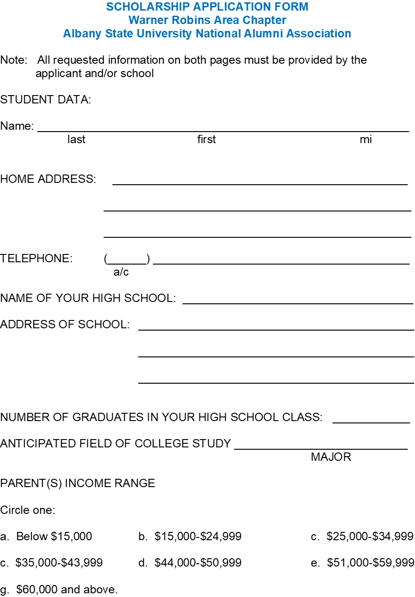

# *Selection Criteria*

**SCHOLASTIC ACHIEVEMENT**

GPA ________ of maximum ________

Class standing ________ of ________

**SAT/ACT test scores**

Verbal **________**

Math **________**

Written **________**

Combined ________

**EXTRACURRICULAR ACTIVITIES**

_______________________________________________________________________________________________________________________________________________________________________________________

**AWARDS/HONORS**

________________________________________________________________________________________________________________________________________________________________________________________________________________________

**FINANCIAL NEED**

_______________________________________________________________________________________________________________________________________________________________________________________

**ESSAY**

Write an essay explaining (1) why you would like to receive the scholarship, (2) what economic

need/benefit the scholarship would meet, and (3) what you as a unique and talented individual

can offer the institution.

**LETTERS OF RECOMMENDATIONS (2)**

(NOTE: Letters cannot come from family members)

**DEADLINE**

The completed application must be **postmarked** no later than Friday, March 29, 2024, if mailed.