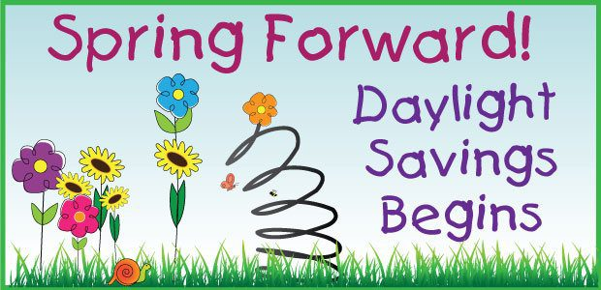
Reading News
Mrs. Williams
Date: March 9, 2026

Reading: Abraham Lincoln: The Great Emancipator

Word Study: sounds of ch/sh

Vocabulary:
character – a person’s traits
good sport – a person with good sportsmanship
unusual – not normal
popular – liked by many
evidence – facts or information that shows something is true
respected – admired by people for your quality or achievements

