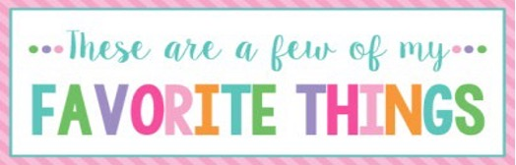

Name: | Julie Camp | T-Shirt Size: | Large
Birthday: | Aug. 27 | Monogram: | JCM
Favorite Color: | Blue | Favorite Flower: | Roses
Favorite Scent: | Lemon | Favorite Candy: | Reese’s PB Cups
Favorite Drink: | Lime Sparkling Water | Favorite Food: | Pizza
Favorite Snack: | Boom Chicka Pop Kettle Popcorn | Favorite Fruit: | Strawberries
Favorite Restaurant: | AC’s | Favorite Fast Food: | Chick-fil-A
Favorite Places to Shop: |  | Amazon, Target
Favorite Bath & Body Works Scent: |  | White Citrus, Lemon, Hello Beautiful
Things I Collect: |  | Not much of a collector
Favorite Author/Book Series for Personal Reading: |  | Lysa TerKeurst
Wish List for Classroom: |  | Erasers, Candy for Rewards, Snacks for kiddos

