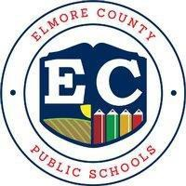ELMORE COUNTY BOARD OF EDUCATION

|  |  |  |  |
| --- | --- | --- | --- |
| 100 H.H. Robison | Phone: | 334-567-1200 | Richard E. Dennis, Superintendent |
| P.O. Box 817 | Fax: | 334-567-1405 | Jason M. Mann, CSFO |
| Wetumpka, AL 36092 |  |  |  |

# Annual Parent Notice

**Right to Request Teacher Qualifications**

# Coosada Elementary School School Year 2025-2026

Our school receives federal funds for programs that are part of the *Elementary and Secondary Education Act (ESEA),* as amended (2015)*.* Throughout the school year, we will continue to provide you with important information about this law and your child's education. Based on current education law, teachers must have earned State certification and licensure. State certification and licensure is the training required to be a teacher.

We are very proud of our teachers and feel they are ready for the coming school year. We are prepared to give your child a high-quality education. You have the right to request information about the professional qualifications of your child’s teacher(s) or paraprofessional(s). A paraprofessional provides academic or other support for students under the direct supervision of a teacher. If you request this information, the district or school will provide you with the following as soon as possible:

* if the teacher has met State certification and licensing requirements for the grade levels and subjects for which the teacher provides instruction;
* if state certification and licensing requirements have been waived (is not being required at this time) for the teacher under emergency or other temporary status;
* if the teacher is teaching in the field of discipline for which they are certified or licensed;
* if the teacher has met State-approved or State-recognized certification, licensing, registration, or other comparable requirements. These requirements apply to the professional discipline in which the teacher is working and may include providing English language instruction to English learners, special education or related services to students with disabilities, or both; and
* if your child is receiving Title I or Special Education services from paraprofessionals, his or her qualifications.

Our staff are committed to helping your child develop the social, academic, and critical thinking he or she needs to succeed in school and beyond. That commitment includes making sure that all of our teachers and paraprofessionals are highly skilled.

If you would like to request information about your child’s teacher(s) or paraprofessional(s), or if you have any questions about your child’s assignment to a teacher or paraprofessional, please contact Janice McKenzie Principal, at 334-285-0273.

Thank you for your interest and involvement in your child’s education. Sincerely,

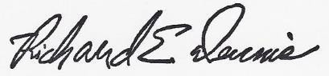

Richard E. Dennis Superintendent

***Every student empowered. Every student succeeds.***