First Grade Times
September 5, 2023

Classroom Studies:
Phonics: Digraph ck, Double consonants, Review spellings for /k/ sound
Spelling Words: hop, top, cop, log, hog, dog, hot, lot, cot, job
High Frequency Words: Review words
Reading Stories: “The Tale of Peter Rabbit” “All Stories Are Anansi’s”
Grammar Skill: Nouns that name people and things
Math: Near Doubles, Facts with 5 on a Ten-Frame, Add in Any Order, Count Back to Subtract
Math Vocab Words: Near Doubles fact, Count Back
Homework:

** Please remember to practice the fluency story nightly that is in the front sheet protector of your child’s Eagles Folder. Reading it once or twice for one minute each time is adequate.
Tuesday:
- Math-Practice Page
- ELA-Fluency Passage, Homework Book, Spelling Words
Wednesday:
- Math-Practice Page
- ELA-Comprehension Page, Fluency Passage, Spelling Words
Thursday:
- Math-Practice Page
- ELA-Fluency Passage, Reading Sheet, Spelling Words

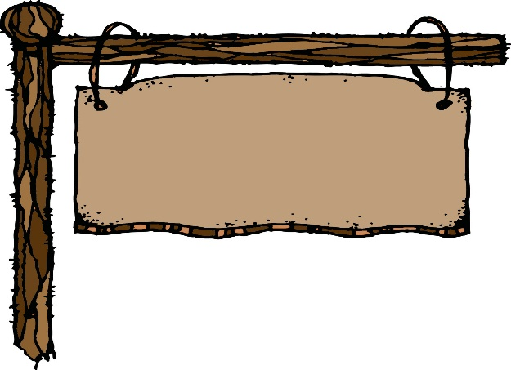
Classroom News:

  - Thanks to all who supported the BPO and our school during the shirt fundraiser!!

  - Scholastic Book Club Flyers went home last Thursday. Orders can only be placed on-line. The deadline to order on-line will be September 13th.

  - There will be no new tricky word flash cards this week. Review words that have been sent earlier this year.

  - We are thrilled to get our first graders started on AR. If your child has not brought home an AR book, be looking for one over the next couple of weeks. We start a few new ones every couple of days. This allows us an opportunity to sign them in and teach them how to independently take tests. This new reading opportunity is always one of the students’ favorites because they are reading for fun. Please remember to stick a note on your child’s book or in the book stating that he/she is ready to take an AR test. We also ask that students keep the book for two nights before they take a test. Once they get familiar with testing and reading to comprehend; we lift the two night requirement.

  - Gumball Friday’s: Students may get gumballs out the gumball machine for a quarter each.

  - Fall Pictures will be Friday, September 15.

- Calendar of Events:

September 13……………………………………….Scholastic Book Orders Due

September 15……………………………………..….Fall Picture Day
September 26………………………………..……….Back to School BBQ at
Broadview

Have a great week!!
Mrs. Boswell & Miss Basham

