

Houston County High School Course Syllabus
Principles of Accounting I

Instructor Contact Information Office Hours/Tutorials
Diane Byington email: diane.byington@hcbe.net 7:20 a.m. – 7:50 a.m.
Room #705 phone: (478) 988-6340 3:00 p.m. - 3:30 p.m.
Tutoring available by appointment

Course Title: Principles of Accounting I

Course Description:
- Principles of Accounting I is a skill-level course that is of value to all students pursuing a strong background in business, marketing, and management. Using financial information, students will learn how to make decisions about planning, organizing, and allocating resources using accounting procedures. Performing accounting activities for sole proprietorships and corporations following Generally Accepted Accounting Procedures (GAAP) are included in the course. Students analyze business transactions and financial statements, perform payroll functions, and evaluate the effects of transactions on the economic health of a business.
- Careers in the accounting industry will be explored throughout this course. Employability skills are integrated into activities, tasks, and projects throughout the course standards to demonstrate the skills required by business and industry. Competencies in the co-curricular student organization, Future Business Leaders of America (FBLA), are integral components of the employability skills standard for this course.

**Students enrolled in this course will have successfully completed Introduction to Business & Financial Literacy**

Business Accounting Pathway Courses Must Be Completed in the Order Listed Below:
*Introduction to Business & Technology (1st Level)
*Financial Literacy (2nd Level)
*Accounting I (3rd Level)

Students who complete the Business Accounting Pathway will be eligible to test and earn the following industry recognized credential:
* Business Financial Management Certificate - NOCTI (National Occupational Competency Testing Institute)

First Semester Second Semester
Unit 1: Role of Accounting in Society Unit 9: Accounting for Receivables
Unit 2: Introduction to Financial Statements Unit 10: Inventory
Unit 3: Analyzing and Recording Transactions Unit 11: Long Term Assets
Unit 4: The Adjustment Process Unit 12: Current Liabilities
Unit 5: Completing the Accounting Cycle Unit 13: Long Term Liabilities
Unit 6: Merchandising Transactions Unit 14: Corporation Accounting
Unit 7: Accounting and Information Systems Unit 15: Partnership Accounting
Unit 8: Fraud, Internal Controls, and Cash Unit 16: Statement of Cash Flows

Students are highly encouraged to join Future Business Leaders of America (FBLA). FBLA is co-curricular with all Business and Computer Science classes (Standard FIN-BII-12). This means students will complete FBLA activities and assignments, that are integrated into each unit, as part of their grade. To become an active member of FBLA, students will fill out a membership application, pay $30 annual dues, (includes a T-shirt), and attend monthly meetings. Active FBLA members are eligible to compete in region and state competitions

Course Materials Needed:
Students will access all course materials through Google Classroom and Canvas LMS (Spring)

Computation of High School Grades:
Grades will be calculated for each of the following components to determine a numerical grade:

Daily Assignments 15%
- Standards-based Instructional Tasks:
  - Classwork, instructional tasks, observations
Minor Assessments 20%
- Standards-based Instructional Tasks:
  - Formative quizzes, and instructional tasks with rubrics
Major Assessments 45%
- Standards-based Instructional Assessments:
  - Unit Tests, Unit Projects, Research papers, Research presentations
Final Exam 20%

Final Numeric Grade

Term | Report Name | End of Grading Period
S1 | 6 Week Progress | September 13, 2023
S1 | 12 Week Progress | November 2, 2023
S1 | End of Semester | December 20, 2023

Term | Report Name | End of Grading Period
S2 | 6 Week Progress | February 20, 2024
S2 | 12 Week Progress | April 10, 2024
S2 | End of Semester | May 22, 2024

Make-up Assignments:
- Students who miss classwork, tests, or examinations from an excused absence shall complete the missing work within five school days after he or she returns to school.

- Any assignments or projects given prior to days of absence are due immediately upon the first day of a student’s return. However, in extenuating circumstances, this may be extended.

- It is the responsibility of the student to determine what they have missed and to complete all missing assignments within five school days for full credit.

Late/Missing Work Procedure:
Assignments will not be accepted after the progress report cut-off dates:
- (9/13/23, 11/2/23, 12/20/23, 2/20/24, 4/10/24, 5/22/24).
- A late penalty of 5 points per day, for up to five days, may be implemented.

Make-up Work After Absences:
Students shall make up work missed during absences for any of the following reasons:
A. Participation in school-sponsored activities such as field trips or other designated events
B. Personal illness
C. Medical requirements
D. Family illness
E. Death of a family member
F. Observance of a religious holiday
G. Orders of government agencies
H. Hazardous conditions
I. Suspension (ISS and OSS)

Students are responsible for all make-up work from excused absences.
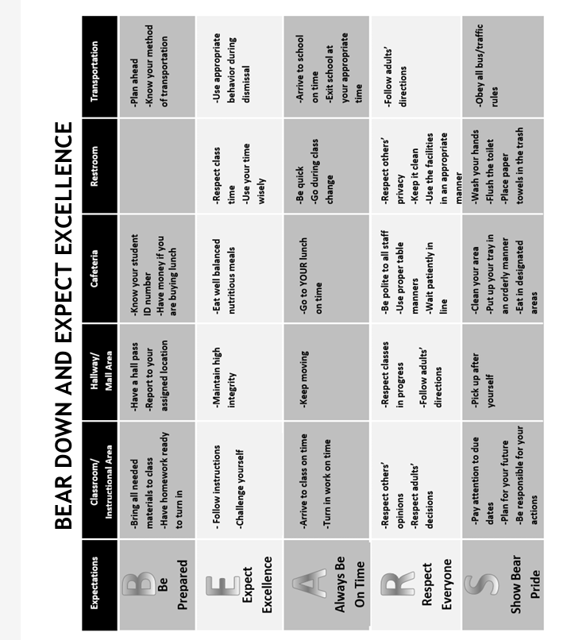
Classroom Norms and Behavioral Expectations

- The Houston County Code of Conduct applies to all students.

Cheating/Plagiarism Procedure:
Any student suspected of cheating/plagiarism will be assigned discipline in accordance with the student handbook.

Classroom Internet Acceptable Use Policy:
Use of the Internet must be in support of education and research and consistent with the educational objectives of the Houston County School System. The use of the Internet is a privilege, not a right, and inappropriate use will result in cancellation of those privileges. Any student user not complying with the Houston County School System Internet Acceptable Use Agreement shall lose Internet privileges for a period of not less than one week.

*Disclaimer: This course syllabus serves as a general outline of the expectations and responsibilities of students; all information contained in the course syllabus is subject to change. Any changes will be announced, and a revised syllabus shared with students and their parents/guardians.

By completing this form, you acknowledge that you have read and understand the class expectations, course details, and policies and will adhere to the procedures needed to be successful in the Accounting I classroom.

- I understand the Accounting I Course Syllabus is located on the Google Class files page.
- I understand I may request a paper copy of the syllabus.
- I have reviewed the syllabus with my child, and we are aware of the grading procedures, expectations, and other course requirements.
- I understand the criteria for his/her grading determination.

Parent/Guardian Signature Date

Parent’s E-Mail Address Parent’s Daytime Phone #

I agree, to the best of my ability, to fulfill my commitment as a student.

Student Signature Date

***An electronic copy of the syllabus is on the Google Classroom files page and my Website - A hard copy will be provided upon request***

