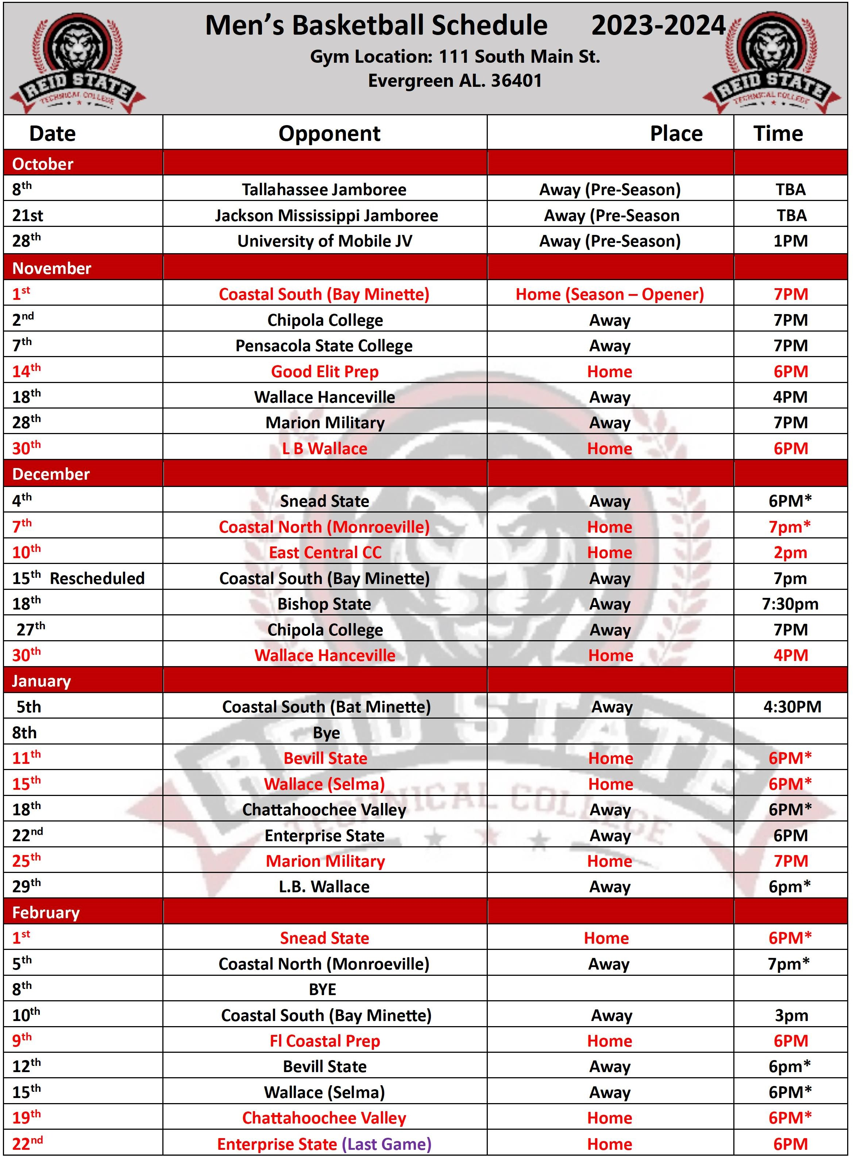
*Conference Game D-2
Home games (13) Away games (15)

