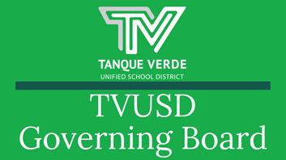
Governiing Board Meetiing Summary March 9, 2022

To start the March 9, 2022 Governing Board Meeting, Board Members were delighted with a presentation by Agua Caliente Elementary School Students from Mrs. Goeprich and Mrs. Tompkins classes, who presented their Science Fair Class Projects. Their project presentations may be viewed here:

Aquaponics

Dogs vs. Humans, which has the cleanest mouth?

Student Board Member Report

Student Board Member, Lainie Radomsky, presented the Student Board Report, which focused on activities and events at Agua Caliente Elementary and Tanque Verde High Schools.

Congratulations to the many students who were recognized for their accomplishments in Lainie’s report! The report may be seen here.

Superiinttendentt’’s Reportt

Dr. Scott Hagerman presented updates to the Board on the following items:

Pima County Updates- COVID levels have decreased substantially and are continuing to move rapidly in a downward direction. Pima County has changed the measurements and categories as seen in the report. We are currently at the Moderate level. The following guidance was issued by Pima County on March 7, 2022:
Schools

1. Will report all suspected or confirmed positive cases of COVID-19 to PCHD. 2. Will report any suspected outbreaks of 3 or more cases.



Pima County Health Department

1. Will conduct case investigation and contact tracing on reported school cases.

2. Will investigate any suspected outbreaks and notify schools when an outbreak is identified.
3. Will provide technical assistance and education regarding mitigation measures in coordination with school staff.

20 X 2020 Plan Data - TVUSD is one of two Pima County school districts which have met the Arizona 20 by 2020 Plangoal. As a reminder, the amount of money we received did not allow us to make this goal, TVUSD made additional investments to meet this goal. We have increased teacher salaries by 20.3%. We continue to invest in teacher salaries in support of student learning as our priority.

Logo Update- At the Board’s request, the logo designs are being taken to the ACES, TVES and EGJH Site Councils and a survey is being conducted at each of the schools. The survey closing date is March 11th. We will bring the data to the next board meeting.

Planning for 22-23

AZ OnTrack - Grants for summer programs

Staffing Update - We continue to fill positions for SY 2022-23.

Budget Planning - Health Insurance costs will be reported at an upcoming board meeting.

The report may be seenhere.

New Hiires & Promottiions ffor tthe 2022-2023 Schooll Year!!

Congratulations to the following TVUSD Administrators:

Greg Miller - Director of Operations, TVUSD Beth Egan - EGJH Principal
Kyle Brady - EGJH Assistant Principal - New Hire

Welcome to the following New Teachers for the 2022-2023 School Year! We are excited to have you on our TVUSD Team! (Positions approved from January - March 2022)

George Guerrero - TVHS Spanish Teacher Matt Collins - TVHS Math Teacher Stephanie White - Teacher position TBD
Craig Bal - TVHS CTE Teacher - Agriculture Science Matthew Harris - TVHS Band Teacher
Jordan Hamilton - EGJH Social Studies Teacher Brandon Wingert - TVHS Biology/Computer Science Natasha Hakim - TVHS Biology Teacher
Alexandra Cherny - TVES Teacher Michelle Beagle - ACES Teacher Emily Richart - ACES Teacher
Mai Ly - ACES Teacher
Maricruz Pedroza - EGJH Computer Science/STEAM Teacher Payton Gubser - TVHS School Counselor

Behaviior and Code off Conductt

Beth Egan - EGJH Assistant Principal, Gary Lewis - TVHS Assistant Principal, and Tiffany Hodge - Director of Student Services, presented information on discipline data, the current Code of Conduct, the proposed changes to the Code of Conduct, and discussed the significance of violations of the Code of Conduct.

There was data shared and the recommendations for changes to the Code of Conduct to reflect an optimum balance of expectation, consequences, and restoration for our students within our culture of “Learning with Accountability.” The proposed changes were made based on feedback from the Administrative Leadership Teams. The proposed changes will be reviewed by the Admin Team and the Site Councils before being recommended.

The Goals of the Code of Conduct are as follows:

● TVUSD strives to create a culture of learning with accountability for students who choose not to follow the code of conduct.
● Ensure a balance between being restorative and assuring the quality of education for all students.

Specific language was added regarding telecommunication devices, which is detailed in the report.

Their report may be viewedhere.

Sttudentt Learniing Updatte

Dr. Scott Hagerman presented an update on Student Learning to the Board, which included a review of the Four Guiding Questions through which we support and impact student learning:

1. What do we want students to know and be able to do? 2. How do we know if students have learned?
3. How do we respond when students don’t learn?

4. How do we respond when students have learned?

Dr. Hagerman shared information regarding our professional learning environment and how we continue to focus on student learning in an appropriate and timely manner to maximize impact and effectiveness. We have been focusing on the first two questions in our initial work, and are now moving into questions three and four with a focus on learning enrichment and interventions.

For more detailed information, Dr. Hagerman’s report may be viewedhere.

Important Dates & Informatiion

Fri. March 11th - End of 3rd Quarter/Grading Day NO SCHOOL Mon. March 14th - Fri. March 18th Spring Break NO SCHOOL
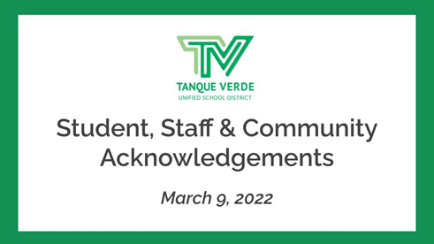
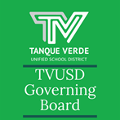
Wed. April 13th - Governing Board Meeting, 6 p.m. at TVES Library Wed. April 20th - Interim Grading Day (K-8 ER) (9-12 Full day) Wed. April 27th - Governing Board Meeting, 6 p.m. at TVES Library

District Events Calendar March 2022

Next Governiing Board Meetiing Date:

The next Regular Meeting of the TVUSD Governing Board will be held on Wednesday, March 23rd at 6:00 p.m.) We have returned to in-person meetings as of March 2022. A Call to the Public is held at the first Regular Meeting of each month.

Board Meeting Agendas and Minutes

TVUSD Board Meeting Livestream Link

Student, Staff & Communiity Acknowlledgments
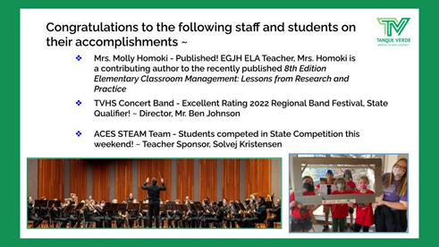
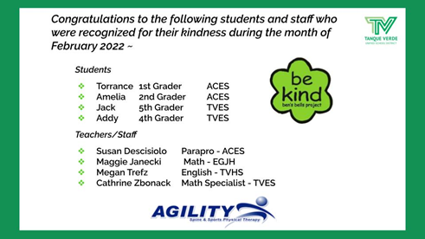
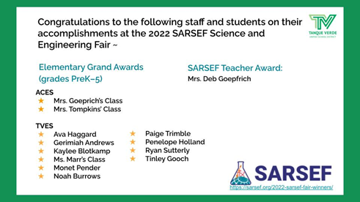
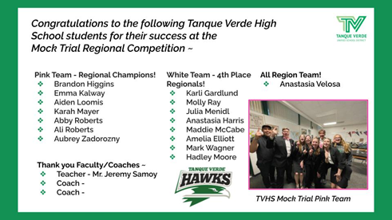
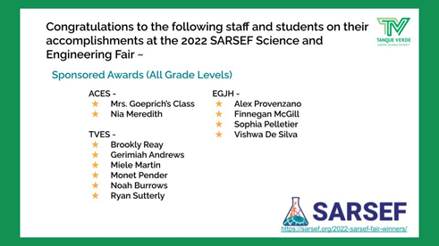
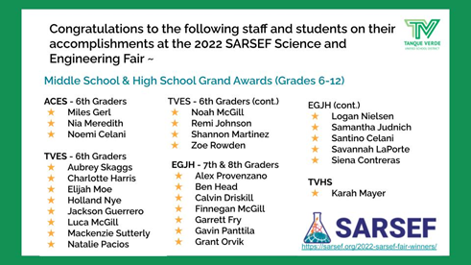
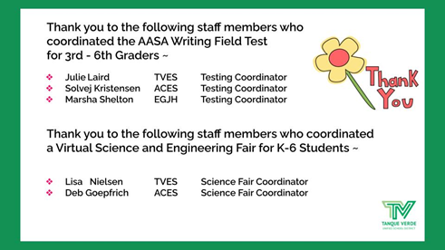

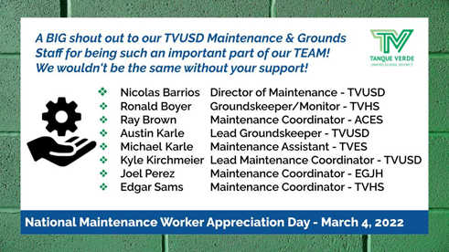
Connect wiith us
Visit our website

