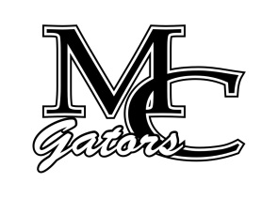School Council Agenda
August 24th, 2022

Chairperson – Andy Gentry Vice Chairperson- Secretary-

Other Members:

Student Council Members:
President -
Vice President -
Co-Secretaires -

Welcome/ Introductions
New Business
Elections- 2 teachers , 4 parents

Next Meeting- October 2022

