

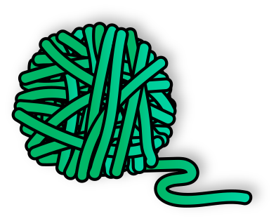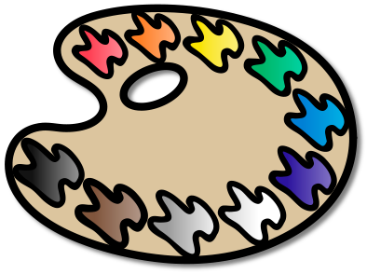





**Welcome to Art!**  This class is a hands-on course that teaches the elements and principles of art and incorporates them with problem solving and art history. Students will begin developing observational and technical skills in various mediums. All physical artworks will be returned to the student at the end of the semester or in May if they have 1 or more artworks entered in one of our many art shows across the county/state.

**Required for Art Class:**

Students must have a pencil every day in art. The following supplies will be at each table for them to use. If they prefer, they may bring their own supplies in a pencil storage container.

|  |  |  |  |  |  |  |
| --- | --- | --- | --- | --- | --- | --- |
| Pencils | Markers  Sharpies | Colored Pencils | Color Markers | 12” Ruler | Erasers | Hand held Pencil Sharpener |

**Classroom donations:**

If you would like to donate to the art classroom: permanent markers, Copic markers, gel pens, facial tissue, liquid hand soap, pencils, erasers, or Ziplock bags. Any art supplies are appreciated!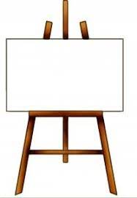

**Student Requirements:**

*to follow classroom FIERCE behavior expectations

*to be on task and try their best on each assignment

*to clean up after themselves

*to complete and turn in assignments on time

*to respect each other and not make fun of anyone’s drawing ability

*to have fun in the art room and think creatively

*to stay in their seat at their assigned table

*Not to write or draw on their table

**My Grade:**

A 90-99 -I followed ALL directions.

-I attempted ALL techniques introduced.

-My work is neat and complete.

B 80-29 -I followed SOME directions.

-I attempted SOME techniques.

-My work could be neater and may be incomplete.

C 70-79 -I followed LITTLE TO NO directions.

-I attempted little to no techniques.

-My work is not neat and is incomplete.

F 0-69 -I did NOT follow directions.

-I did not attempt any techniques.

-My work is very messy and half or more is incomplete.

**Grading Policy:**

All requirements for assignments will be posted on google classroom. Student work will be assessed based on a rubric. Assessment of student work will be based on meeting the standard, creativity, neatness, punctuality of assignment, originality, effort and following directions.

|  |  |  |  |  |
| --- | --- | --- | --- | --- |
| **Grade** | **Major** | **Minor** | **Daily** | **Final** |
| **6th** | 40% | 30% | 25% | 5% |
| **7th** | 40% | 30% | 20% | 10% |
| **8th** | 40% | 30% | 15% | 15% |

**Please sign and return:**

I, the undersigned, hereby acknowledge the receipt of the course expectations for the 2023-2024 school year.

Student Name (please print):__________________________________ Date: _______

Parent/Guardian Name (please print):___________________________ Date: _______

Parent/Guardian Signature:___________________________________ Date: _______

Contact Number: ( ) _____ - _________

Email: ________________________________________________________________ **\**Photos of classroom progress will be posted on the Bonaire Middle School Art Facebook page\****