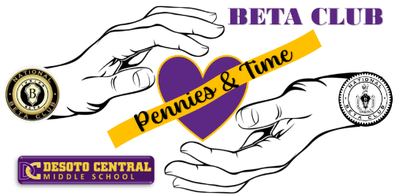
Treats for Heroes
DCMS Beta Club will be providing Pennies & Time Service Opportunities throughout the year. The first of these is Treats for Heroes to honor our first responders. We will be assembling baskets with treats and delivering them to a few local police and fire stations.
We are requesting individually packaged items in bulk preferably. 1 -2 hours can be received for this Service Opportunity depending on the items you bring.
Items must be turned in by Wednesday, October 18.
We will assemble baskets at 7:15am on Wednesday, October 25 in the library. Limited to 12 students.
Delivery date is TBD.
A sign-up sheet will be provided to assemble baskets and another to deliver baskets. Sign-up sheets will be posted on the Beta table.
Here are some ideas for treats to send:
- Mini Chips Bags
- Beef Jerky or Turkey Jerky
- Granola Bars
- Peanuts
- Gum
- Individual Coffee Packets
- Candy or Chocolate Bars
- Trail Mix
- Fruit gummies
- Water flavor packets
- Cookies

