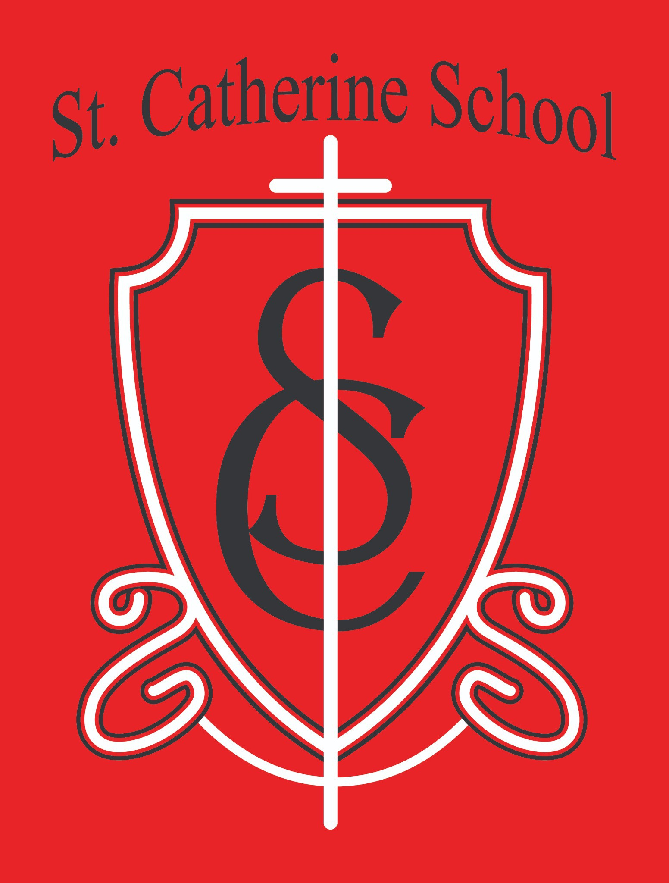

**St. Catherine School Weekly Newsletter (Weeks of April 7-18)**

[**https://www.stcatherine.k12.nd.us/parents**](https://nam02.safelinks.protection.outlook.com/?url=https%3A%2F%2Fwww.stcatherine.k12.nd.us%2Fparents&amp;data=05%7C02%7CTerra.Giesen%40k12.nd.us%7C3a1fff4bcf924f27828d08dd7ea01e5a%7Cdbbf782acef14af186c81f9201061db6%7C0%7C0%7C638805948389297714%7CUnknown%7CTWFpbGZsb3d8eyJFbXB0eU1hcGkiOnRydWUsIlYiOiIwLjAuMDAwMCIsIlAiOiJXaW4zMiIsIkFOIjoiTWFpbCIsIldUIjoyfQ%3D%3D%7C0%7C%7C%7C&amp;sdata=DysYLqvyMcEl2rdU%2FSS5CaYk9ER4ZfXCDQEK0zGTEsE%3D&amp;reserved=0)

# Principal's Message

As we approach Easter, I’ve found myself reflecting on the beautiful ways our school and parish live out our identity as a **community of faith first and foremost**. One of the most moving examples of this will take place at the **Easter Vigil**, where **five individuals** will be fully received into the Catholic Church.

These candidates have spent the past year in **OCIA (Order of Christian Initiation of Adults)**—formerly known as RCIA—engaged in a journey of prayer, study, and spiritual discernment. What makes this so powerful is that they are **choosing** to live the Catholic faith fully—embracing the Sacraments and stepping forward in a life rooted in Christ.

What makes it especially meaningful for me is that **each one of these individuals is connected to our school**. One of the candidates is even **my own spouse**, which has added a very personal and grace-filled dimension to this season of Lent and preparation.

A quote I return to often captures this spirit beautifully:

*“Evangelization occurs when people are so ablaze with the fire of God’s love that they cannot help but witness to and share their faith with others. Evangelization*

*happens by the way we live God’s love in our daily life; by the love, example, and support people give each other; and by the ways parents pass faith on to their children. The Catholic school is, in essence, an evangelizing ministry, guided by the Holy Spirit, and faithful to the continuing mission of Jesus Christ, ‘I came that they may have life, and have it to the full.’”*

Please join me in praying for these candidates as they prepare to take this sacred step. Thank you for being part of a community where **faith, love, and mission come to life each day**.

# Reminders

### Spring Music Program – Thursday, May 8 at 6:30 PM

🎶

Students will showcase their music class learning! The program will be held in the gym, with **doors opening at 6:00 PM**. Students should meet their teacher on the bleachers by **6:25 PM**.

**Dress code**: fun spring-colored shirts (no spaghetti straps or crop tops), jean pants/capris (no holes), and closed-toe shoes (no sandals, crocs, or flip flops).

🎽

Questions? Contact **Ms. Alexis Busch** at [Alexis.A.Busch@k12.nd.us](mailto:Alexis.A.Busch@k12.nd.us).

📧

📎 A copy of the concert info is attached to the email.

### Thank You from Mrs. Gulka

📚

A heartfelt thank you to everyone who helped celebrate **National Librarian Week**! Mrs. Gulka felt truly appreciated, and it was a special way to honor her dedication to our students.

### No School – Good Friday & Easter Monday

✝

In observance of Holy Week and Easter, there will be **no school on Friday, April 18 and Monday, April 21**.

School resumes on **Tuesday, April 22**. Have a joyful and blessed Easter!

### Tuition Assistance – TAP Application Reminder

💰

Tuition assistance applications for the **2025–2026 school year** are now open through **FACTS Grant & Aid**.

### 📅 Deadline: May 15, 2025

[Apply Here](https://nam02.safelinks.protection.outlook.com/?url=https%3A%2F%2Fonline.factsmgt.com%2Fsignin%2F414FV&amp;data=05%7C02%7CTerra.Giesen%40k12.nd.us%7C3a1fff4bcf924f27828d08dd7ea01e5a%7Cdbbf782acef14af186c81f9201061db6%7C0%7C0%7C638805948389320105%7CUnknown%7CTWFpbGZsb3d8eyJFbXB0eU1hcGkiOnRydWUsIlYiOiIwLjAuMDAwMCIsIlAiOiJXaW4zMiIsIkFOIjoiTWFpbCIsIldUIjoyfQ%3D%3D%7C0%7C%7C%7C&amp;sdata=hWYd%2BCLFKzsa%2BJ43iLX0ouHlyeCS1Aw2RzbFsvWWrQ0%3D&amp;reserved=0)

🔗

Questions? Please contact the school office.

### Save the Date – 6th Grade Graduation Mass

Our **6th Grade Graduation Mass** will take place🎓on **Tuesday, May 20 at**

**9:30 AM** in the church.

### Last Day of School – Wednesday, May 21

📅

Mark your calendars! The final day of the 2024–2025 school year is

### Wednesday, May 21.

Virtue Focus: Fortitude – Patience (April 7–18) ✝

Our schoolwide virtue focus is **Patience**, a strength of the virtue **Fortitude**. Patience means **responding to difficulties calmly and waiting with grace**.

We look to **St. Teresa of Calcutta** as our model, whose quiet strength and enduring love changed lives.

*“Be patient, therefore, until the coming of the Lord.” – James 5:7–8*

This week, we are encouraging students to practice patience—especially during transitions—and to recognize that virtue is often built in the **small, quiet moments** of each day.

Daycare & Academic Opportunities

### Daycare Hiring – Join Our Team!

🧸

We are hiring **Lead Teachers, Assistant Teachers, and Float Staff** for **St. Catherine Little Saints Childcare**, with **part-time and full-time positions** available.

Apply by sending your **resume, cover letter, and three professional**

📧**references** to **Beth Nadelin** at [beth.nadelin@k12.nd.us](mailto:beth.nadelin@k12.nd.us)

### Summer Tutoring – Exploring Interest

📚

We are exploring **summer tutoring** for students entering **grades K–6** next year. Tutoring will be open to **all families**, not just currently enrolled students.

Interested? Email **Mr. Lee** at [nicholas.lee1@k12.nd.us](mailto:nicholas.lee1@k12.nd.us)

📧

### Little Saints Childcare – Wishlist & Sponsorship Opportunities

🍼

We are working to furnish our infant room with 8 commercial-grade cribs—

**4 have already been sponsored**! Thank you for your generosity. In the coming days, we’ll release an **Amazon Wishlist** and offer opportunities to sponsor rooms or specific items.

💬 Questions or want to help? Contact [nicholas.lee1@k12.nd.us](mailto:nicholas.lee1@k12.nd.us)

# St. Catherine Spotlight

This past week, I had the privilege of accompanying our **5th and 6th grade students** to the **Chrism Mass at St. Mary’s Cathedral in Fargo**—a liturgy rich in beauty, tradition, and meaning.

The **Chrism Mass** is a deeply unifying celebration of our Church, where the **bishop blesses the holy oils** used throughout the year for **Baptism, Confirmation, Holy Orders, and Anointing of the Sick**. It’s also a time when **priests from across the diocese renew their vows**, recommitting themselves to their vocation.

To witness this sacred tradition through the eyes of our students was incredibly moving. They represented **St. Catherine School with reverence and maturity**, and I was so proud to stand beside them. I hope this experience planted seeds in their hearts—of **gratitude for our priests**, of **deeper connection to the sacraments**, and perhaps even a quiet **discernment of their own vocation**.

Also worth celebrating—last week, I completed the **Instructional Coach Academy through ND RISE**, a state initiative focused on building **instructional leadership capacity** across North Dakota. This training included **over 60 hours** of work in **high-impact coaching practices**.

I’ve been fortunate to pair this experience with my **action research for the University of Mary**, which is focused on identifying **sustainable instructional coaching models** for **Catholic and small, rural schools**—two communities with many shared challenges and strengths.



This work is part of my journey toward earning a **Master’s degree in School Administration and Leadership**, which I’m on track to complete in **Spring 2026**. I’m grateful to be learning and growing in service to our mission here at **St. Catherine School**.

Stay Connected with St. Catherine School

📍 **Address:** 540 3rd Ave. NE, Valley City, ND 58072

**Email:** [nicholas.lee1@k12.nd.us](mailto:nicholas.lee1@k12.nd.us)

📧

**Phone:** 1-701-845-1453

📞

**Website:** [w](https://nam02.safelinks.protection.outlook.com/?url=https%3A%2F%2Fwww.stcatherine.k12.nd.us%2F&amp;data=05%7C02%7CTerra.Giesen%40k12.nd.us%7C3a1fff4bcf924f27828d08dd7ea01e5a%7Cdbbf782acef14af186c81f9201061db6%7C0%7C0%7C638805948389335496%7CUnknown%7CTWFpbGZsb3d8eyJFbXB0eU1hcGkiOnRydWUsIlYiOiIwLjAuMDAwMCIsIlAiOiJXaW4zMiIsIkFOIjoiTWFpbCIsIldUIjoyfQ%3D%3D%7C0%7C%7C%7C&amp;sdata=VNQZ7wyDyuLY2zBtFhCGA%2Fz9%2FPliPehVzf2sxotiz18%3D&amp;reserved=0)

🌐

[ww.stcatherine.k12.nd.us](https://nam02.safelinks.protection.outlook.com/?url=https%3A%2F%2Fwww.stcatherine.k12.nd.us%2F&amp;data=05%7C02%7CTerra.Giesen%40k12.nd.us%7C3a1fff4bcf924f27828d08dd7ea01e5a%7Cdbbf782acef14af186c81f9201061db6%7C0%7C0%7C638805948389335496%7CUnknown%7CTWFpbGZsb3d8eyJFbXB0eU1hcGkiOnRydWUsIlYiOiIwLjAuMDAwMCIsIlAiOiJXaW4zMiIsIkFOIjoiTWFpbCIsIldUIjoyfQ%3D%3D%7C0%7C%7C%7C&amp;sdata=VNQZ7wyDyuLY2zBtFhCGA%2Fz9%2FPliPehVzf2sxotiz18%3D&amp;reserved=0)

📘 **Follow Us on Facebook:** S [t. Catherine School on Facebook](https://nam02.safelinks.protection.outlook.com/?url=https%3A%2F%2Fwww.facebook.com%2Fst.catherineschoolvc%2F&amp;data=05%7C02%7CTerra.Giesen%40k12.nd.us%7C3a1fff4bcf924f27828d08dd7ea01e5a%7Cdbbf782acef14af186c81f9201061db6%7C0%7C0%7C638805948389352920%7CUnknown%7CTWFpbGZsb3d8eyJFbXB0eU1hcGkiOnRydWUsIlYiOiIwLjAuMDAwMCIsIlAiOiJXaW4zMiIsIkFOIjoiTWFpbCIsIldUIjoyfQ%3D%3D%7C0%7C%7C%7C&amp;sdata=NNW5nXioyOnDxE%2BR00SyGsHAOYlJFqpoLVYuS82BQss%3D&amp;reserved=0)

*“Inspiring excellence through faith, learning, and service.”*