Ms. Black’s Second Grade Class Weekly Newsletter
September 5-8,2023

Ms. Black’s Second Grade Class Newsletter  September 5-8,2023  Leader in Me!  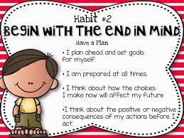 | What We are Learning  This week will be continuing the getting starting lessons for our new reading series (Open Court).  See Attachment  Continue topic 2  Monday- Labor Day  Tuesday-2.4 I can make arrays with equal rows and equal columns  Wednesday- 2.5 I can model problems using equations, drawings ,and arrays  Thursday- Math on Topic 7  Friday:  Science: Incorporated into open court reading (The Bats, Birds, and Beasts).  Social Studies: Student will learn about Loyalty .
Things to Remember  Labor Day: September 5, 2022  Check your child’s folder nightly for important papers or practice reading and math sheets.  I encourage you to go over about 5 to 10 second grade words nightly. | Major Grade- Topic 2 math test- September 7, 2023  Minor Grade Reading Fluency – September 8, 2023
s

