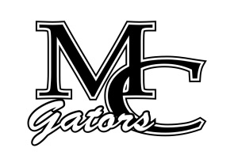School Council Agenda
December 13th, 2022

Chairperson – Andy Gentry Vice Chairperson- Patrick Chiappetta Secretary- Michelle Starley

Other Members: Sydney Howard, Jennifer Zoumberis, Marcell Ausborn, Suzanne Ganas, Carey Bassett

Student Council Members: Angelina Park, Miranda Aguilar, Zoey Cunningham

Welcome/ Introductions
Old Business – Minutes
New Business

Principal Report – MAP, Exams, Athletics, band Concert, Retirement
Teacher Report
Counselor Report
Student Report
Parent Report

Next Meeting- March 2023

