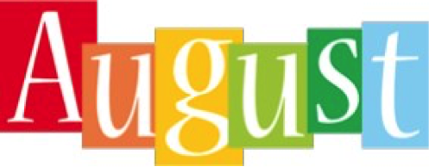

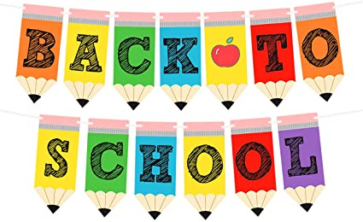

What an exciting time this will be for you and your child. Mrs. Amy and I are thrilled about welcoming each and every one of you to PLES and Pre-K. This will be a year of FUN, Making Friends, Singing, Drawing, Painting, Creating and Playing TO Learn! We hope that you will ENJOY it as MUCH as we will! During the month of August, we will be getting acquainted with the school rules and discovering colors and shapes. Also, we will explore the topic, “All About Me” where we learn about your child and family.

We will also work on literacy and math skills. We appreciate your participation in your child’s education. Please work on the items listed below with your child.

**Identifying First & Last Name**

**Colors**

**Shapes**

**Mark Your Calendar**

**August 9th First Day of School**–

**August 14th** Monday - Wear Red

**August 15th** Tuesday - Wear Blue

**August 16th** Wednesday – Wear Yellow

**August 17th** Thursday - Wear Green

**August 18th** Friday - Wear Orange

**August 21st** Monday - Wear Purple

**August 22nd** Tuesday - Wear Brown

**August 23rd** Wednesday Wear Black and White

**August 24th** Thursday - Pink and Gray

**August 25th** Friday – Wear Your Bulldog Shirt (All About Me Poster Due)***

**Upcoming Events**

**September 4th Labor Day (No School)**

**September 12th – Open House 6:00 p.m.**

**Reminders**

**Daily** – Mark your Child’s Binder to verify how they are eating Breakfast & Lunch

**Daily** – Send your Child a Bag with Snack, Drink, & a filled Water Bottle (Labeled with your Child’s Initials or Name)

**Weekly** – Send your Child a Blanket or Towel for Nap

Please send your child a change of clothes to keep in our classroom.