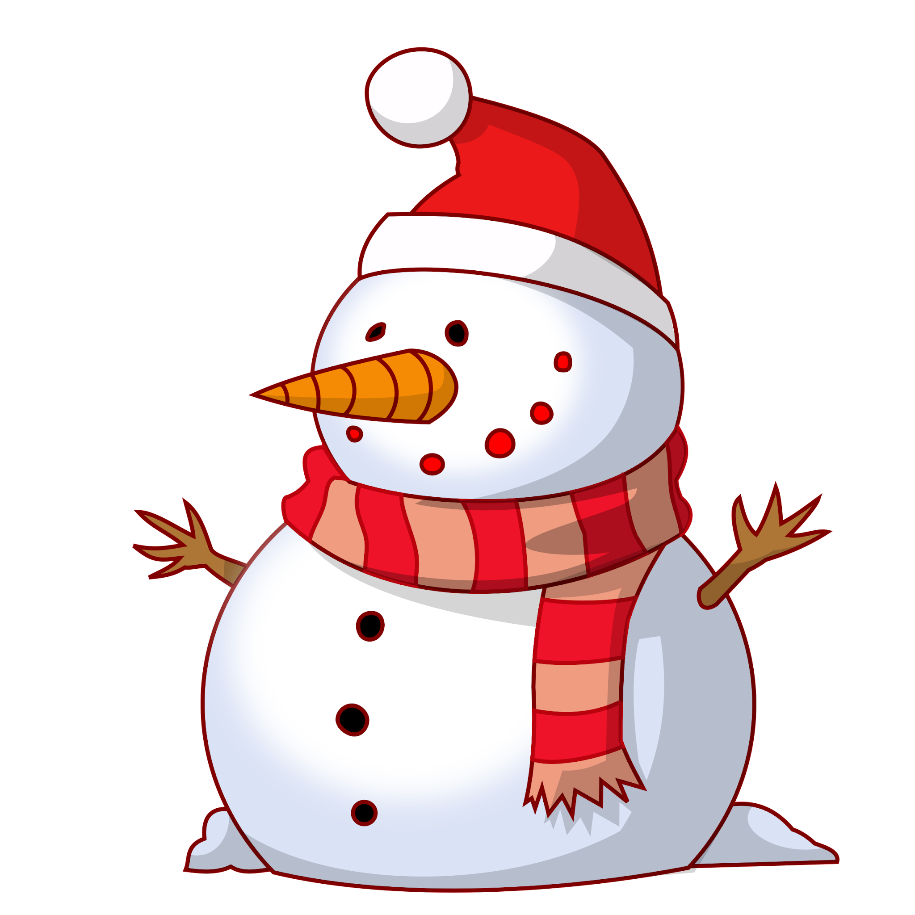
Mrs. White’s Newsletter
January 19th -January 23rd

Upcoming Events
Monday, January 19th- Martin Luther King Jr. Day (No School)
January 26th and 27th- Practice ACAP Tests (Reading and Math)
Friday, January 30th- Second Grade Musical (8:30 in the Lunchroom)

Vocabulary Words  Unit 3. Lesson 4  blared result sources value movement  **only study these on the vocabulary sheet** |  | Reading
  This week we begin Open Court Reading Unit 3, Lesson 4  Story of the week: The Langston Times  Genre: Realistic Fiction/Informational Text | Phonics: /s/ spelled ce, ci, cy and /j/ spelled ge and gi  Comprehension: Compare and Contrast  Writing: Narrative writing  Grammar: commas (items in a series)
Math  Topic 12:  Using standard and nonstandard units of Measurement  (Review and Test)  Students will estimate and measure accurately using appropriate tools. Students will use standard and nonstandard units to measure various objects. |  |  |  |  | Spelling Words:  Unit 3 Lesson 4:  age peace pencil magic ice  spicy face gem circus large
Science/Social Studies:  Science: We will continue through a unit on weathering, erosion, and other changes to the Earth’s surface. Students will complete inquiry activities to discover how the Earth changes over time. | Assessments:  Thursday:Topic 12 Math Test  Friday: OCR 3.4 Reading Test and Spelling Test;Math weekly spiral quiz

Reminders:
- Please be sure to join Parentsquare. This will be my main tool for communication.
- Please send back blue folders with signatures each week.
- Please study spelling and vocabulary with your student each night.

