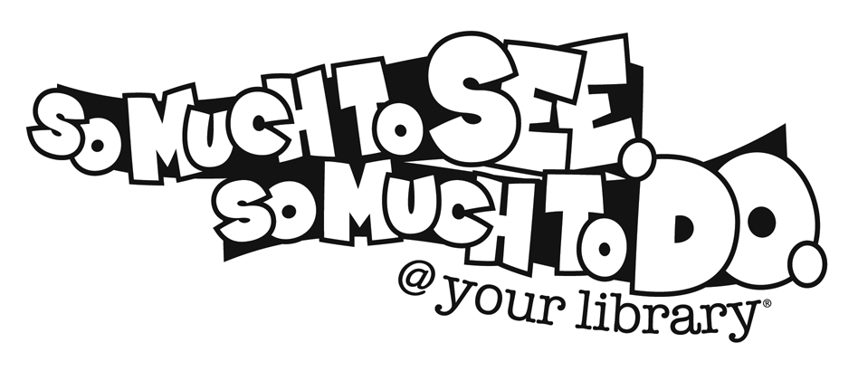
1. Find a chapter book with an author whose last name begins with “R”. Write the title of the book and the author’s name.

2. Name a type of book located in the Reference section of the Children’s area. What kind of information can you find in it?

3. What does the letter “B” mean in call numbers found in the Children’s nonfiction area?

4. Name two websites you can get to from the library’s webpage http://livingstonjrhigh.al.schoolinsites.com/?PageName='Library.

5. What do the numbers mean on the spines of the books in the nonfiction section of the Children’s area?

6. What is the title of your favorite book? Who is the author? Is it available in audio book format?

