WC Elementary Breakfast and Lunch Menu

Choice of Milk Served Daily
FF Chocolate
1% Low Fat White
FF Skim
Water offered Daily

Offered Daily
BREAKFAST: Fruit & Juice
LUNCH: Salad

Condiments Served upon request
Ketchup, Mustard, Mayo, Honey Mustard & Ranch

This institution is an equal opportunity provider.

No School
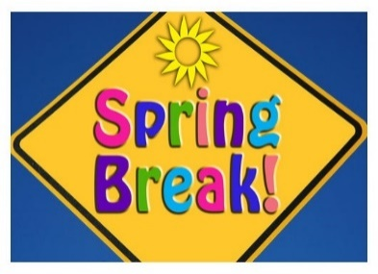
BREAKFAST: Cereal Kit LUNCH: Popcorn Chicken - Broccoli & Cheese - Lima Beans - Fruit - Roll
BREAKFAST: Combo Bars LUNCH: Sloppy Joe w/Bun - Side Winders - Carrots & Celery - Fruit
BREAKFAST: Sausage & Biscuit LUNCH: Pizza Calzone - Salad - Corn - Fruit
BREAKFAST: Smoothie LUNCH: Corn Dogs - Hashbrowns - Bake Beans - Fruit
BREAKFAST: Pretzel & Cheese Sauce LUNCH: Chicken Leg - Mashed Potatoes - Green Beans - Roll - Fruit
BREAKFAST: Cereal Kit LUNCH: Chicken Patty w/Bun - Broccoli w/Cheese - Cooked Carrots - Fruit
BREAKFAST: Breakfast Bars LUNCH: Veg. Beef Soup - Grilled Cheese - Salad - Fruit
BREAKFAST: Oatmeal Rounds LUNCH: Pepperoni Pizza - Corn - Carrots & Celery - Fruit
BREAKFAST: Smoothie LUNCH: Turkey w/Gravy - Mashed Potatoes - Green Beans - Fruit - Roll
No School
BREAKFAST: Cereal Kit LUNCH: Chicken Tenders - French Fries - Salad - Fruit - Roll
BREAKFAST: Apple Fritters LUNCH: Ground Beef Nachos - Tortilla Chips - Pinto Beans - Salsa - Fruit
BREAKFAST: Bacon w/Roll LUNCH: Pizza Crunchers - Corn - Carrot & Celery - Fruit
BREAKFAST: Smoothie LUNCH: Meat Loaf - Mashed Potatoes - Lima Beans - Roll - Fruit
BREAKFAST: Poptart LUNCH: Shredded Turkey w/Bun - Potato Salad - Fresh Veggies w/Dip
MENU SUBJECT TO CHANGE due to availability
BREAKFAST: Cereal Kit LUNCH: Pork Patty - Mashed Potatoes - Green Beans - Roll - Fruit
BREAKFAST: Honey Bun LUNCH: Hot Dogs w/Bun – Tator Tots – Cole Slaw - Fruit
BREAKFAST: Pretzel & Cheese Sauce LUNCH: Cheese Pizza - Corn - Salad - Fruit
BREAKFAST: Smoothie LUNCH: Lunchables - Chips - Carrots w/Dip - Fruit
BREAKFAST: Breakfast Pizza LUNCH: Spaghetti w/Meat Sauce – Toss Salad – Garlic Bread - Fruit

