

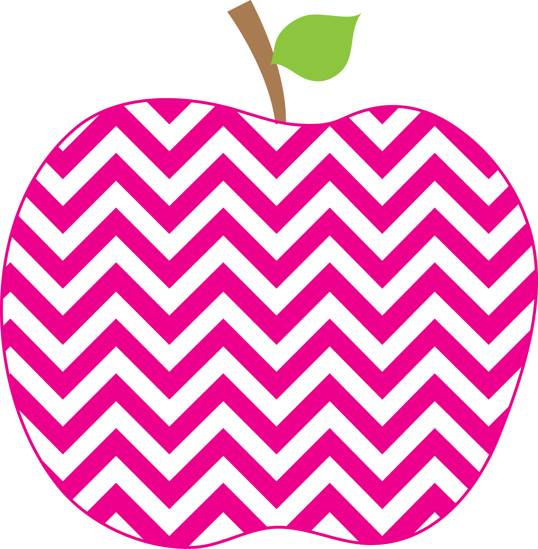



E. Robinson Weekly
Ms. E

August 11, 2025

Reading:
Phonics Skills:
*Letter Recognition
*Letter Sounds
*Short and Long Vowels
*Rhyming

High-Frequency Words:
see, the, is, up,
have, there, a , I

Writing:
*Writing the letters of the alphabet
*Alphabet Book

Math:
*Addition to 10

Social Studies/Science- All about Me and My Classroom

This Week’s Focus:
Star Apple of the Week:
Each student will get an opportunity to be the Star Apple of the Week. You will find this information in the binder. We will begin this on September 2nd.
* Your child is bringing home his/her APPLE Binder today. Please check the APPLE Binder each day for homework and sign the daily behavior sheet located in the back.

Friday, August 29th Spirit Day
Special Snack

Thursday, September 12th Fall Pictures

Reminders:
Important Reminders:

