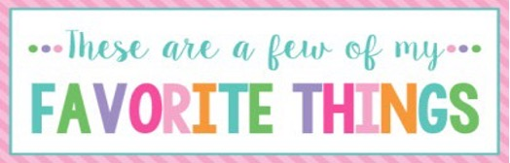
Name: | Shannon Casey | T-Shirt Size: | Large
Birthday: | August 27 | Monogram: | SBC
Favorite Color: | Purple/pink | Favorite Flower: | Pink roses
Favorite Scent: | Apple or pear | Favorite Candy: | Snickers
Favorite Drink: | Water or Alani’s | Favorite Food: | Taco’s
Favorite Snack: | Kettle corn Popcorners | Favorite Fruit: | Honey crisp apples
Favorite Restaurant: | Chili’s | Favorite Fast Food: | Taco bell
Favorite Places to Shop: |  | Amazon, Target and Walmart
Favorite Bath & Body Works Scent: |  | Anything fruity…no florals or linens
Things I Collect: |  | Bumble bee’s
Favorite Author/Book Series for Personal Reading: |  | John Grisham, Jodi Picoult
Wish List for Classroom: |  | Therapy sensory toys/Mindfulness activities

