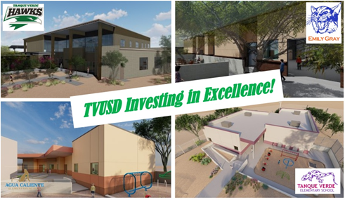

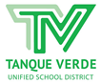
Tanque Verde Diistriict News & Viiews
The llattestt news and iinfformattiion ffrom TVUSD!!

Editor's Note ~ In this Fall 2021 Edition of the Tanque Verde District News & Views, we are pleased to present a message from Superintendent Hagerman, as well as the latest news and information from TVUSD. Returning to our quarterly electronic News & Views format gives us the opportunity to highlight our schools, teachers and students, and bring special interest stories from around the district. In this issue, we are focusing on New Construction Projects, Tanque Verde High School, Emily Gray Jr. High School and Tanque Verde Community Preschool! Thank you for your continued support and interest in TVUSD!

Superiintendent''s Message - Fallll iis iin the aiir!

Octtober 7,, 2021

Dear TVUSD Families,

Fall is finally in the air, and the Tanque Verde area is showing signs of the changing seasons! We were very happy to welcome families for our Open House events at our schools in August, and the Parent Teacher Conferences held in September allowed families a time to meet with teachers one on one to stay informed about their child’s progress. The high school and junior high school athletics programs are now in full swing, and the elementary schools are gearing up for their fall family events. We invite you to support your children and their


schools by participating in the many school events that are held throughout the fall and into the holiday season.Sttudentt llearniingWe are approaching the 2021-22 school year with our focus directly on student learning with urgency and intention. All educators are working as collaborative teams to support and respond to student learning needs, as identified by the AzM2 assessments and additional student achievement information assessed by classroom teachers.AzM2 is Arizona’s statewide achievement assessment for English Language Arts (ELA) and Mathematics. Notably, TVUSD was the only district which showed an increase inELA scores, and achieved the second highest ELA scores in the state of Arizona. We have identified a need for more focus in mathematics as our priority for the current school year.The AzM2 assessments are done in the spring for grades 3-8. Each district has Test Coordinators who manage the administration of the tests at their school sites. Individual student scores are assessed and Family Score Reports are then sent to the families of individual students. The student, school and district achievement levels are reported to the district, generally at the beginning of the next school year.SaffettyWe continue to take measures to support student and staff safety on campus. To help protect unvaccinated children, we continue to strongly recommend that masks are worn when indoors on our school campuses. More detailed information is available on the TVUSD Safe Return to In-Person Learning Plan webpage.The current CDC recommendation is for the universal wearing of masks indoors by teachers, students, staff members and visitors in K-12 schools, frequent handwashing and use of hand sanitizer, and continued social distancing to the extent possible. It is strongly recommended that all eligible individuals be vaccinated against COVID-19.Weekly updates on the status of COVID-19 in our schools appear on the district’s dashboard, located on the COVID-19 Information Page. Notices are sent in instances where individuals may have been in close contact with a COVID-19 positive person, and quarantine recommendations continue under the direction of the Pima County Health Department.Consttructtiion UpdattesA district groundbreaking ceremony was held in September, in celebration of the construction starts at all campuses! The District Offices and High School Administrative Offices have moved into temporary locations for the fall, and site preparations are underway at all four schools. More detail is provided in the Fall issue of the Tanque Verde News and Views.In closing, we look forward to seeing you at our schools this fall, where we continue working to support students in safe, welcoming and supportive learning environments.~ Working TOGETHER to create pathways to success for all students.All my best,Dr. Scott Hagerman


REMINDER! IT''S ALMOST FALL BREAK!

No Schooll Gradiing Day - Octt.. 8tth
Fallll Break Octtober - 11tth - 15tth

Have a saffe and enjjoyablle break!!

TVUSD Investiing iin Excellllence!

The Tanque Verde Unified School District is pleased to provide our community with an update on the 2020 Bond Projects.

“The construction taking place in TVUSD has been a long time coming,” stated Susan Fry, Governing Board President at a September groundbreaking event. “We have dreamed of adding space to our campuses, but we have never had the funding to do it. We are so grateful to our community for their support of our bond that will pay for much of the work taking place. We also appreciate the School Facilities Board for their support of our district, and the funding they have contributed to a number of projects across our campuses. We also thank our teachers and administrators who have been displaced during this time of construction. We know that the end result will be amazing, and we look forward to enjoying our new spaces.”

With TVUSD Voters’ support of the 2020 Bond Initiative, and $11,958,364 of AZ School Facilities Board funds, we have started construction on the following new facilities:

Tanque Verde High School Commons The new TVHS Student Commons building will be the site of four new flexible classroom spaces, student collaborative space, the Athletic Department, the Counseling & Guidance Center, and the High School Administrative Offices.

Tanque Verde High School New Science Labs
Tanque Verde Elementary School Kindergarten Building
The new TVES Kindergarten Building will house four new classrooms with restroom facilities and appropriately outfitted indoor and outdoor learning environments for our young learners.

TVUSD Superintendent, Dr. Scott Hagerman, opened the groundbreaking celebration by acknowledging the many individuals who have played significant roles in the approval, design and planning processes, including the Arizona School Facilities Board, Estimating Plus LLC Project Management, Swaim Associates, and Lloyd Construction, Inc. and TVUSD school leaders, staff and community members. He remarked, “We are very fortunate to have members of our local community who are motivated to support the continued success of our school district. And equally important, we have had the continued interest and support of the Arizona School Facilities Board throughout this process.”

The TVUSD school construction projects are expected to be completed for the 2022-23 school year, barring any unforeseen delays such as materials shortages. Construction began with demolition projects over the summer, and continuing this fall, with the removal of the old Tanque Verde District Office (TVDO) building to make way for the new Emily Gray Jr. High School Fine and Performing Arts Building; the remodeling of the Tanque Verde High School (TVHS) Administration Building, to its future use

The new Science Labs will feature state-of-the-art equipment allowing students to practice higher-level scientific inquiry in well-equipped classrooms.

Emily Gray Jr. High School Fine & Performing Arts Building
The new EGJHS Fine & Performing Arts Building will provide more functional space for arts instruction, as well as improved acoustics and rehearsal, performance, and storage spaces for the performing arts. The new building will be located at the west end of the campus and will be entered through the EGJH courtyard, with additional access from the west parking lots for performances.

Agua Caliente Elementary School Kindergarten Building
The ACES Kindergarten Building will house three new classrooms with restroom facilities and appropriately outfitted indoor and outdoor learning environments for our young learners.
as the main TVDO building; and the removal of the TVHS Snack Shack and soon the relocation of the solar panel arrays, to make room for the new TVHS Student Commons and Science Laboratory/Classroom Building.

Tanque Verde Unified School District wants to thank you, our community, for your tremendous financial support. By aiding the District through the 2020 bond referendum, you are helping our schools provide the resources for students to excel in the 21st century. In return, TVUSD is committed to spending bond funds in an appropriate manner and to being transparent about this spending.

TVUSD has formed a Bond Oversight Committee to ensure appropriate oversight and transparency in the spending of bond funds. You may find more information about the committee and the bond projects on the district website here.

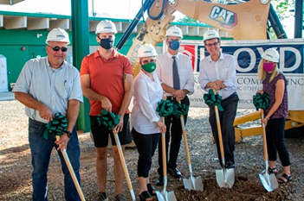
Please see Photo Gallery below for images from new construction projects.

Governing Board and Superintendent at the September Groundbreaking Celebration

October 6, 2021 Governiing Board Meetiing Hiighlliights

Sttudentt Learniing Updatte

Tiffany Hodge, Director of Student Services and Dr. Scott Hagerman, Superintendent presented information regarding the English Language Arts (ELA) curriculum adoption.

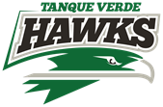

There are currently two main ELA curriculum materials in place, which are outdated and need to be replaced. We have brought in supplemental materials to help teachers with Dept. of Education approved curriculum which provide intervention and enrichment.

The October 6, 2021 TVUSD Governing Board Meeting included several presentations, with the primary focus being the Student Learning Update and information regarding the ongoing English Language Arts (ELA) curriculum adoption.

Sttudentt Goverrniing Boarrd Reporrtt

Student Governing Board Member, Lily Brummitt, presented information about school events at Tanque Verde Elementary and Emily Gray Jr. High School.

The detailed presentation may be viewed here.

Superriinttendentt Reporrtt Dr. Scott Hagerman
The Ed Plus Up revised applications were due on September 24th, and the Governor is expected to distribute In-Person Instruction Grant funds within the next two weeks. TVUSD does anticipate receiving funding soon. In other State news, Senator Kirsten Engel, who has represented our district in both the Arizona House and Senate has resigned her position in order to run for the U.S. Congress.
The process for the curriculum adoption for English Language Arts was discussed in detail. An ELA Adoption Committee has been formed to complete the process.

Key Points:

Curriculum must be viable for the classroom teacher.
The adopted curriculum should be at the right level of challenge and support to ensure all students learn at high levels.

The timeline for the adoption is proposed as follows:
October - Committee Meets November - Open Adoption Window
December - Whole Staff Feedback January - Final Vote

The detailed presentation may be viewed here.

The detailed presentation may be viewed
here.

TVHS Admiin Team Hiighlliight

In this edition of the Tanque Verde USD News and Views, we are highlighting the Tanque Verde High School Administrative Leadership Team, and the plans they have for this innovative, comprehensive high school on Tucson’s northeast side.

No stranger to Thanks to funding




innovation, TVHS Principal Dr. Amy Cislak actively seeks out and collaborates with business and university leaders in our community, and around the country, to create strategic partnerships that
benefit students. Due in part to these collaborative efforts, Dr. Cislak was named Arizona Education Leader Trailblazer of the Year by A for Arizona in 2018, a Southern Arizona 40 under 40 Awardee in 2018, and was the Principal of the Year in Tucson Unified School District in 2017. As a resident of the Tanque Verde Valley, Dr. Cislak is very pleased to be leading Tanque Verde
High School.

Dr. Amy Cislak realized during her college experiences that she “was put on this earth to be an educational advocate and leader.” She credits her experience as a D1 athlete as having “prepared her for life.” She began her teaching career at her alma mater, Canyon del Oro, leading the CDO softball program to state titles in 2007, 2008 and
2009. After teaching, coaching, and developing an International Baccalaureate Programme at CDO, Dr. Cislak served as the Principal at nationally ranked University High School for 5 years. As she completed her doctoral degree, she began work at Tanque Verde High School as the new principal in July of 2020, at a very challenging time during the COVID-19 pandemic.

Mr. Gary Lewis, now in his third year as the Tanque Verde High School Assistant Principal and Director of Athletics, has brought in powerhouse hires such as Coaches of the Year Adam Shingler (Girls Volleyball) and Jay
Dobyns (Football). A local athletic legend in his own right, Mr. Lewis was a standout basketball player at Tucson’s Sahuaro HS before playing Division I basketball at Texas A&M and completing his professional career in France. He
from A for Arizona, Tanque Verde High School recently welcomed Mr. Joel Bacalia for the 2021-22 school year to take the reins as the Assistant Principal of Curriculum and Instruction. Tanque
Verde High School Principal, Dr. Amy Cislak, says, "Mr. Bacalia is a curriculum and instruction guru and is excellent at implementing new academic programs as well as supporting outstanding instructional practices. His background in schools is diverse, and he builds outstanding relationships with teachers and students.”

"Tanque Verde High School is an exceptional place full of amazing educators and outstanding students. We are excited to provide this additional support to our new and returning faculty and staff so that we can continue to be one of the top comprehensive high schools in the state of Arizona,” stated TVHS Principal, Dr. Amy Cislak.

Mr. Joel Bacalia says he is “thrilled to join Tanque Verde High School,” where his primary duties will be supporting curriculum and instruction on campus. Mr. Bacalia will work to support program growth and enhancement at TVHS, including the new University of Arizona Honors College partnership and the growing college and career programs. Mr. Bacalia has dedicated the past 18 years to serving people of all ages through education. He taught English in Mexico and Spanish in Tucson, before his leadership positions of more than seven years as Assistant Principal at Pueblo and University High Schools. Mr. Bacalia also served last year as the Principal at University School before joining the leadership team at TVHS. Mr. Bacalia says, “I am a doctoral student, husband, father, and educational leader that loves people and loves to smile!”

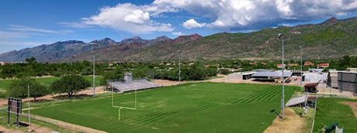
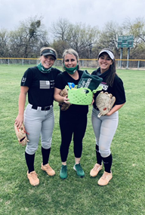
served as a long-time boys basketball coach at Sahuaro HS, Catalina Foothills HS and Tucson High, before joining the Tanque Verde High School team. "Mr. Lewis' legacy as an athlete, coach, and educator speaks for itself. He values positive and outstanding relationships with students to ensure that excellence is supported in all of our curricular and athletic programs. His keen ability to see and foster talent is an invaluable asset for our students and coaches on our campus," says Cislak.

Photo (right): Ava Roh (2022) Dr. Amy Cislak, Mia Casadei (2021) during 2021 Lady Hawks' Softball Season

New Tanque Verde High School Stadium Field

Cardiinalls Chariittiies parttners wiitth NFL Foundattiion tto proviide a $200K ffiielld iimprovementt grantt ffor Tanque Verde Hiigh Schooll

With a $200,000 field improvement grant received by Tanque Verde HS Principal, Dr. Amy Cislak from the Cardinals Charities in partnership with the NFL Foundation, the existing TVHS stadium field has been recrowned, and a new irrigation system added. In addition, a new practice field has been installed, allowing the main field’s condition to be preserved for the school’s home games.

“This is really a dream come true! Our football team just came off an exciting

that was carefully designed and procured by the best playing field experts in the world,” stated Dr. Amy Cislak, Principal of Tanque Verde High School, at the groundbreaking ceremony held in May.

You’re Invited! Tanque Verde HS Hawks vs. Santa Cruz HS
The next home football game will be held vs. Santa Cruz HS on Friday, October 22nd. Kickoff is at 7:00 p.m. Junior High Band Night, Senior Night and Homecoming will also be held! Please come out and support our TVHS Hawks! Tickets may be purchased up to a week in advance at: MSB Tickets Adult $6/Student $4 for single admission, no re-entry permitted.

undefeated season (2020) after years of being known as a struggling program. These new facilities will allow for our student-athletes to compete on a field

Emiilly Gray Jr.. Hiigh Schooll Sciience Departtmentt awarded SARSEF Top Miiddlle Schooll Award ffor 2nd Year Runniing!!

Congratulations to Emily Gray Jr. High School, and the many TVUSD students and their teacher sponsors who had great success at the 66th Annual Southern Arizona Research, Science and Engineering Foundation's 2021 Virtual Science and Engineering Fair! Nearly 3000 students were expected to compete. Finalists competed for over $100,000 of cash and prizes including scholarships.

This year's Top Middle School Award went to Emily Gray Jr. High School, for the second year in a row!

In the very competitive high school division, two Tanque Verde High School students, Emily Egnatoff and Karah Mayer, took top honors, and Karah Mayer was invited to compete as a finalist in the Regeneron International Science and Engineering Fair 2021.
For more information about Tanque Verde High School, please visit: Tanque Verde High School

Thank You Riincon Rottary

Thank you Rincon Rotary! The seventh grade students and science teachers at Emily Gray Junior High would like to thank the local Rotary Club for their generous $500 grant to purchase materials for our school.

The science department purchased wires, batteries, lumber, switches, electrical components, magnets, and magnet wire. These materials are being used to create several hands-on learning experiences for our 7th grade students exploring electrical currents, circuits, magnetism, and electromagnetism.

Student quotes about our circuit lab:

“The best part was that you got to interact with all the pieces and actually understand how circuits work.”

“The fact that I got to put together an electric circuit and figure out how the parallel and series circuits worked outside a diagram or photo.”

“The best part was feeling the accomplishment of building the parallel circuit after only 3 tries. We were very proud of ourselves.”

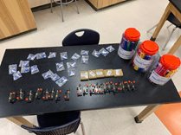
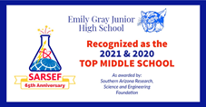

“The best part was making the light bulb light up because you feel like you did it.”

Several of our students had never built a circuit or worked with electricity
before. The materials from this generous grant created learning and memories for our students that will last a lifetime.

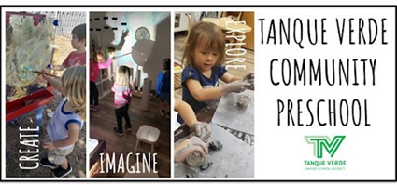
Submitted by Mr. Gregory Gaines, EGJH 7th Grade Science Teacher

Tanque Verde Communiity Preschooll

Diid you know? TVUSD started our first district preschool program after approval by the Governing Board in 2018?
The Tanque Verde Community Preschool (TVCP), now in its third year, provides growth and learning opportunities for both children with disabilities and their “typical peers” or students without disabilities. Special Education services are provided for preschool-aged children in an up-to-date facility for district residents who have a preschool aged child receiving services designated by an Individualized Education Plan (IEP). TVCP is located on the Tanque Verde Elementary School Campus, and has access to school resources and age-appropriate playground equipment.

IItt’’s allrready gettttiing a llott off attttenttiion!! TVCP Director and Teacher, Mrs.
Kristen Kvaran was recognized as one of two 2021 United Way of Tucson and Southern Arizona Literacy
Champions! Mrs. Kvaran led the opening of the preschool in 2019 after completing a study tour of the infant/toddler and preschool programs in Reggio Emilia, Italy. Kvaran has a Masters in Elementary Education with an emphasis in Early Childhood Education from Northern Arizona University. She also has experience and certification in special education and has taught preschool through third grade since 2005. She is a proud member of the Southern Arizona Association for the
Morre dettaiills aboutt Tanque Verrde Communiitty Prreschooll
The district preschool offers a developmentally appropriate, fee-based preschool program, affording an opportunity for an enriching preschool experience under our school district’s oversight. The preschool incorporates a creative, child-centered, play and inquiry-based program, which aligns with our K-12 educational program, and incorporates STEAM across the curriculum. Limited space is available.

There are currently two classrooms, both serving 3-5-year-olds in a mixed-age setting in morning/afternoon half-day sessions, with full and extended day options available. In each classroom, there is one (1) Lead Early Childhood Specialist, and one (1) Paraprofessional, maintaining a 1:9 ratio (max). A preschool director/special education teacher will serve the special education population.
For more information please visit the website here, or contact the Director, Kristen Kvaran, at 749-4244 X 3080.


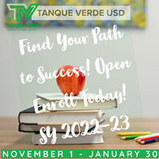
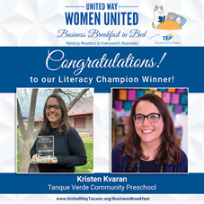
Education of Young Children (SAZAEYC), the North American Reggio Emilia Alliance (NAREA), and Tucson Children’s Project.

TVUSD ~ Your Student''s Path to Success! Open Enrollll Today!

The TVUSD Open Enrollment application window opens November 1, 2021. Please spread the word!Students who are currently enrolled, and attending Tanque Verde Schools through Open Enrollment, do not need to reapply! Please visit the website for more information:

TVUSD Open Enrollment Information

Open Enrollllmentt Applliicattiion Wiindow ffor tthe 2022-23 Schooll Year ::
November 1,, 2021 - January 30,, 2022

Updatted Octtober Eventts Callendar Liink

Important Dates:

Grading Day - Friday, October 8th NO SCHOOL Fall Break - October 11-15, 2021 NO SCHOOL
Open Enrollment Application Window Opens - Monday, November 1, 2021

Nextt Governiing Board Meettiing::

The next Regular Governing Board Meeting will be held on Wednesday, October 20, 2021 at 6:00 p.m. at the Tanque Verde Elementary School Library. Seating is
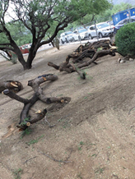
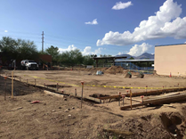
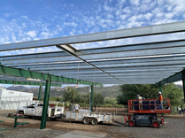
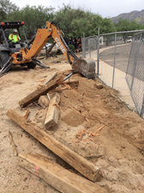
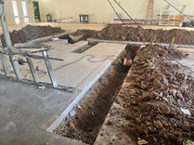
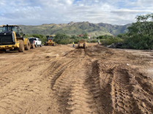
limited. The meeting will be livestreamed.

Board Meeting Agendas and Minutes

TVUSD Board Meeting Livestream Link

New Constructiion Photo Gallllery - October

TVHS Site Prep

TVHS Library/New Administration Building Interior Modifications

Agua Caliente Elementary School
TVHS Solar Panel Removal for Repositioning

Emily Gray Jr. High Site Prep for New Fine and Performing Arts Building

Agua Caliente Elementary School - Trees Salvaged from Site of New Building for use in Nature Trail

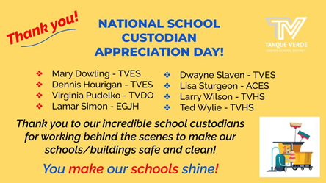
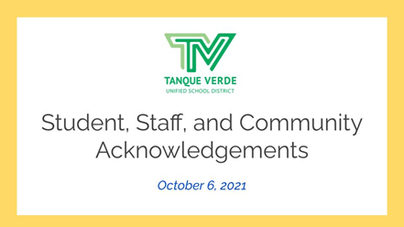
Kindergarten Building Site Prep Outdoor Learning Space Expansion Project

Student, Staff & Communiity Acknowlledgments
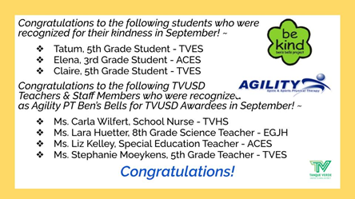
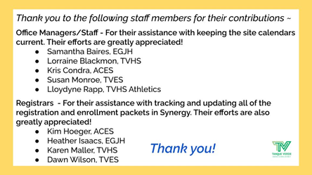
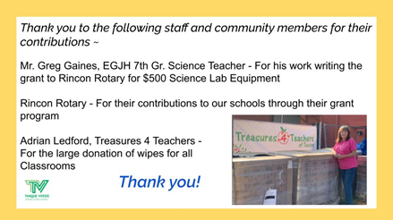
Connect with us
Visit our website

