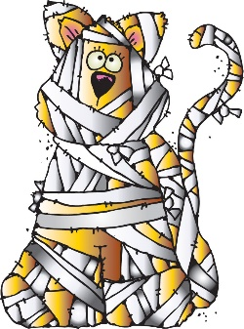
First Grade Times
October 2, 2023

Classroom Studies:
Phonics: Separated Digraph o_e
Spelling Words: chat, chip, chop, chin, chest, inch, lunch, punch, bunch, munch
Tricky Words: my, by, play, yellow, red, look, come, funny
Reading Stories: “Cinderella” “The Girl with the Red Slippers” “Billy Beg”
Grammar Skill: Common and Proper Nouns
Math: Critique Reasoning, Review-counting on, open number line, doubles, doubles plus, make 10 to add,
solving addition word problems with facts to 20

Homework:

Monday:
- Math-Practice Page
- ELA-Fluency Passage, Tricky Words, Spelling Words
Tuesday:
- Math-Practice Page
- ELA-Fluency Passage, Homework Book, Spelling Words
Wednesday:
- Math-Practice Page
- ELA-Comprehension Page, Fluency Passage, Spelling Words

Thursday:
- Math-Practice Page
- ELA-Fluency Passage, Reading Sheet, Spelling Words

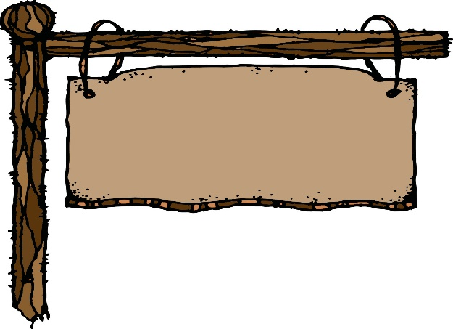
Classroom News:

  - Permission Slips for Walk-a-thon are due ASAP. They are in the information packet that was sent home.

  - The Walk-a-thon WINGS UP Theme Days are as follows
- Monday-twin day
- Tuesday-wear your favorite sports team’s shirt, jersey, or colors
- Wednesday-wear your brightest colors
- Thursday-school spirit day
- Friday-pajama day

  - The 1st Nine Weeks of School Grading Period Ends on October 16th

  - Report Cards will be distributed at Parent Teacher Conferences.

  - The Book It Program began on October 1st. You must record books on the Book It Reading Log in your child’s Eagles Folder.

  - You can record homework books, library books, AR books and any other stories you read with your child. When your child has 20 books listed on the reading log; he/she will receive a coupon for a free personal pan pizza at Pizza Hut. Students may only earn one pizza a month. Each book also earns them a sticker to put on their paper on the Book It tree. You can record more than 20 stories to earn additional stickers on the Book It tree.

- Calendar of Events: 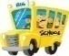

October 1……………………………………….………….Book-It Pizza Reading Program Began
October 5………………………………………..…………Walk-a-Thon
October 9-13……………………………………….………Fall Break
October 16…………………………………………………..End of 1st nine weeks
October 24…………….…………………………….……....Parent Teacher Conferences
October 24…………………………………………………..Report Cards Distributed

Have a great week!!
Mrs. Boswell & Miss Basham

