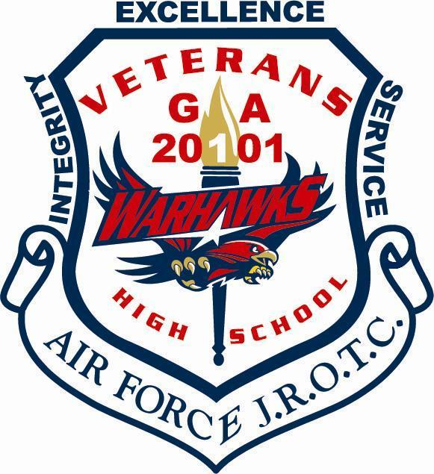
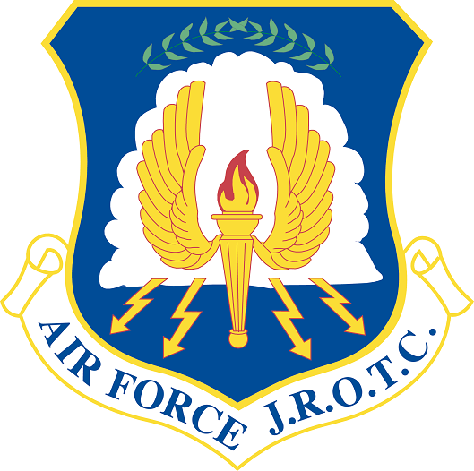
Veterans High School AFJROTC

AFJROTC I, II, III, IV Syllabus
SY 23-24

Instructors: Col Christopher Nick E-mail: christopher.nick@hcbe.net Phone: (478) 210-8225
SMSgt Steven Brooks E-mail: steven.brooks@hcbe.net Phone: (478) 210-8208
SMSgt Garrett Martin E-mail: garrett.martin@hcbe.net Phone: (478) 218-7567

AFJROTC Google Classroom Code: ub3a5yo
AFJROTC Management Google Classroom Code (Col Nick’s 5th Period Only): 75aehes

Department Philosophy: The Career Technology Education Department believes that education’s most important function is to provide all cadets with the skills needed for post-secondary education and careers. This is accomplished by providing interest-based programs that meet industry standards.

Course Description: In 2010, more than 2.3 million people served in the Armed Forces. More than 1.4 million were on active duty in the Armed Forces—about 562,000 in the Army, 323,000 in the Navy, 330,000 in the Air Force, and 202,000 in the Marine Corps. In addition, more than 858,000 people served in a Reserve capacity or in the Air or Army National Guard. Although many high school cadets enlist in the military, most others continue their education and enter the work world using the valuable leadership and self-discipline skills learned in the Junior Reserve Officers’ Training Corp (JROTC) program.
The mission of the Air Force JROTC program is to motivate young people to become better citizens. The program is dedicated to the growth of individual participants as cadets and persons. The JROTC program further aims to prepare cadets for life by providing a framework for qualities (skill, knowledge, and positive attitudes) that will help them succeed.
Satisfactory completion of the program at the secondary level can give the cadet skills to significantly contribute to success in careers in government, private industry, entrepreneurship, and non-profit organizations. It can also lead to advanced placement credit in the Senior ROTC program at an accredited college or university, or advanced rank in the armed forces. The military offers numerous credentials and licensing in many different and varied occupational fields.

Career Pathways:
28.01100 Aerospace Science 1: A Journey into Aviation History and Leadership I *
28.01200 Aerospace Science 2: Science of Flight and Leadership II *
28.01300 Aerospace Science 3: Exploring Space and Leadership III *
*Required for Pathway Completion

4th Year Cadets are selected/approved by AFJROTC Instructors:
28.01400 Aerospace Science 4a: Management of the Cadet Corps and Leadership IV or
28.01500 Aerospace Science 4b: Global Awareness and Leadership IV

Course Overview 1-4 a: The Aerospace Science portion comprises 40 percent of the course. In AS-1 (Aerospace Science/Aviation History), this is an aviation history course designed to acquaint the cadet with the historical development of flight and the role of the military in history.

In AS-2 (Aerospace Science/Science of Flight), this is a course where the cadets will explore the aerospace environment and the human requirements of flight. Cadets identify the basic facts and general principles of the atmosphere and the elements of weather.

In AS-3 (Aerospace Science/Exploring Space), this is a science course, which examines our Earth, the Moon and the planets, the latest advances in space technology, and continuing challenges of space and manned spaceflight.
In AS-4 (Aerospace Science/Management of the Corps), this is a fourth-year management course where the cadets manage the entire corps during their fourth year in the Air Force Junior ROTC program. This hands-on experience affords cadets the opportunity to put theories of previous leadership courses into practice. Planning, organizing, coordinating, directing, controlling, and decision-making will be done by cadets. They will put into practice their communication, decision-making, personal-interaction, managerial, and organizational skills.

Course Overview 1-4 b: The Leadership Education portion comprises 40 percent of the course.
In LE-1 (Leadership Education/Citizenship, Character, and Air Force Tradition), the cadets identify the history, mission, purpose, goals, objectives, and importance of the Air Force Junior Reserve Officer Training Corps (AFJROTC). Each cadet must adhere to established grooming standards by exemplifying proper wearing of the United States Air Force JROTC Uniform. Drill and Ceremonies is part of all Leadership Education courses.
In LE-2 (Leadership Education/Communication, Awareness and Leadership), this course stresses communications skills and cadet corps activities. Much information is provided on communicating effectively, understanding groups and teams, preparing for leadership, solving conflicts and problems, and personal development.
In LE-3 (Leadership Education/Life Skills and Career Opportunities), cadets will gain information that will help them decide which path to take after high school. They will gain information on how to apply for admission to college or to a vocational or technical school. Information on how to begin a job search is included for those cadets who decide not to attend further schools.
In LE-4 (Leadership Education/Principles of Management), this course provides exposure to the fundamentals of management. The text contains many leadership topics that will benefit cadets as well as provide them with some of the necessary skills needed to put into practice what they have learned during their time in AFJROTC.
JROTC Cadets I/II/III Cadets:
Course Schedule: Leadership Education 100/300 & Aerospace Science 300
Week 1  2-4 Aug | Introduction/Syllabus/Cadet Contract | Week 19  4-12 Jan | LE300 Chapter 2 Lesson 2
Week 2  7-11 Aug | Uniform Issue/Marching | Week 20  16-19 Jan | LE300 Chapter 2 Lesson 2 con’t
Week 3  14-18 Aug | LE100 Chapter 1 Lesson 1/2 | Week 21  22-26 Jan | AS300 Chapter 3 Lesson 1
Week 4  21-25 Aug | LE100 Chapter 1 Lesson 3 | Week 22  29 Jan-2 Feb | AS300 Chapter 3 Lesson 2
Week 5  28 Aug-1 Sep | LE100 Chapter 1 Lesson 4 | Week 23  5-9 Feb | LE300 Chapter 3 Lesson 1
Week 6  5-8 Sep | LE100 Chapter 1 Lesson 5 | Week 24  12-16 Feb | LE300 Chapter 3 Lesson 2
Week 7  11-15 Sep | LE100 Chapter 1 Lesson 6 | Week 25  20-23 Feb | LE300 Chapter 3 Lesson 2 con’t
Week 8  18-22 Sep | AS300 Chapter 1 Lesson 1 | Week 26  26 Feb-1 Mar | AS300 Chapter 3 Lesson 3
Week 9  25-29 Sep | AS300 Chapter 1 Lesson 2 | Week 27  4-8 Mar | AS300 Chapter 3 Lesson 4
Week 10  2-6 Oct | LE300 Chapter 1 Lesson 1 | Week 28  11-15 Mar | LE300 Chapter 3 Lesson 3
Week 11  16-20 Oct | LE300 Chapter 1 Lesson 2 | Week 29  18-22 Mar | LE300 Chapter 4 Lesson 1
Week 12  23-27 Oct | AS300 Chapter 1 Lesson 3 | Week 30  25-29 Mar | AS300 Chapter 4 Lesson 1
Week 13  30 Oct-3 Nov | AS300 Chapter 1 Lesson 3 con’t | Week 31  8-12 Apr | AS300 Chapter 4 Lesson 2
Week 14  6-9 Nov | LE300 Chapter 1 Lesson 3 | Week 32  15-19 Apr | LE300 Chapter 7 Lesson 1
Week 15  13-17 Nov | LE300 Chapter 2 Lesson 1 | Week 33  22-26 Apr | LE300 Chapter 7 Lesson 2
Week 16  27 Nov-1 Dec | AS300 Chapter 2 Lesson 1 | Week 34  29 Apr-3 May | AS300 Chapter 7 Lesson 1
Week 17  4-8 Dec | AS300 Chapter 2 Lesson 2 | Week 35  6-10 May | AS300 Chapter 7 Lesson 2
Week 18  11-15 Dec | AS300 Chapter 2 Lesson 2 con’t | Week 36  13-17 May | AS300 Chapter 7 Lesson 2 con’t

JROTC IV Cadets:
Course Schedule: Leadership Education 400 & Aerospace Science 400 (Specific Dates Above)
Week 1 | Introduction/Syllabus/Cadet Contract | Week 19 | AS400 Chapter 3 Lesson 1 & 2
Week 2 | Introduction to Marching/Uniforms | Week 20 | AS400 Chapter 3 Lesson 1 & 2
Week 3 | AS400 Chapter 1 Lesson 1, 2, & 3 | Week 21 | AS400 Chapter 3 Lesson 1 & 2
Week 4 | AS400 Chapter 1 Lesson 1, 2, & 3 | Week 22 | AS400 Chapter 3 Lesson 1 & 2
Week 5 | AS400 Chapter 1 Lesson 1, 2, & 3 | Week 23 | LE400 Chapter 3 Lesson 1 & 2
Week 6 | AS400 Chapter 1 Lesson 1, 2, & 3 | Week 24 | LE400 Chapter 3 Lesson 1 & 2
Week 7 | LE400 Chapter 1 Lesson 1 & 2 | Week 25 | LE400 Chapter 3 Lesson 1 & 2
Week 8 | LE400 Chapter 1 Lesson 1 & 2 | Week 26 | LE400 Chapter 3 Lesson 1 & 2
Week 9 | LE400 Chapter 1 Lesson 1 & 2 | Week 27 | AS400 Chapter 6 Lesson 1, 2, & 3
Week 10 | LE400 Chapter 1 Lesson 1 & 2 | Week 28 | AS400 Chapter 6 Lesson 1, 2, & 3
Week 11 | AS400 Chapter 2 Lesson 1 & 2 | Week 29 | AS400 Chapter 6 Lesson 1, 2, & 3
Week 12 | AS400 Chapter 2 Lesson 1 & 2 | Week 30 | AS400 Chapter 6 Lesson 1, 2, & 3
Week 13 | AS400 Chapter 2 Lesson 1 & 2 | Week 31 | AS400 Chapter 6 Lesson 1, 2, & 3
Week 14 | AS400 Chapter 2 Lesson 1 & 2 | Week 32 | LE400 Chapter 4 Lesson 1 & 2
Week 15 | LE400 Chapter 2 Lesson 1 & 2 | Week 33 | LE400 Chapter 4 Lesson 1 & 2
Week 16 | LE400 Chapter 2 Lesson 1 & 2 | Week 34 | LE400 Chapter 4 Lesson 1 & 2
Week 17 | LE400 Chapter 2 Lesson 1 & 2 | Week 35 | LE400 Chapter 4 Lesson 1 & 2
Week 18 | LE400 Chapter 2 Lesson 1 & 2 | Week 36 | LE400 Chapter 4 Lesson 1 & 2

TEACHER EXPECTATIONS

1. RESPECT yourself; your parents or guardians; school administrators, faculty, and staff; your fellow cadets; other students; your uniform; and the school.
2. Every cadet is expected to give their best effort every day in their AFJROTC class.
3. Cadets are always expected to be prepared for each day’s activities. This includes bringing notebooks, Chromebook (charged), pencil(s), and pen(s) with black or blue ink. It also involves having the proper PT gear and uniform on designated days.

CLASSROOM RULES

Cadets WILL NOT:
1. Chew gum, eat food, or drink beverages in the classroom, cadet area, or instructor office unless authorized by SASI or ASI in accordance with school policies
2. Wear hats or other headgear indoors during any cadet activity.
3. Talk when the instructor or a guest lecturer is talking unless recognized.
4. Participate in any form of "horseplay" or throw any objects inside.
5. Write on the whiteboard, or on any other visual aid without the instructor's permission.
6. Fail to store and secure book bags as directed by the SASI or ASI.
7. Sleep or put your head down on the desk unless authorized by the instructor.
8. Fail to address instructors, guest lecturers, or cadet officers when in uniform or in formation in or out of uniform as "Sir" or "Ma'am", by their rank, or as "Mr." or "Ms."
9. Enter instructor area or use telephones without permission
10. Be disrespectful, inconsiderate, threatening, dishonoring our core values, compromising personal integrity, or use vulgarity toward any teacher, visitor, or other student.

POINT BREAKDOWN

Major Assessments – 45% of overall grade: Uniform Inspection, Test, and upholding our core values.
Minor Assessments – 20% of overall grade: Projects, Quizzes, Drill and PT
Daily Work – 15% of overall grade: Classwork (Study Guide) and Quote/Vocabulary words of the week
Final Exam – 20% of overall grade

UNIFORM WEAR AND INSPECTION

1. Uniform Day is Monday!!! Cadets must wear the AFJROTC uniform all day except in classes requiring another uniform (PE, Drama). If Monday is a school holiday, then the uniform will not be worn for that week. If absent on Monday, the student will wear the uniform the next day they return to school.

2. Cadets will wear a PT Uniform (school issued Air Force PT shorts/sweatpants, Air Force PT shirt/sweatshirt, and appropriate athletic footwear (Not Crocs, slides, etc.) during PT every Friday. The penalty for not dressing out in the proper gear is a grade of “0” for that day even if you participate.

3. Cadets who miss three (3) uniform inspections and/or do not dress out for PT three (3) times will be in jeopardy of failing their AFJROTC class due to the weighted nature of these requirements and may be removed from JROTC.

PENALTY FOR LATE WORK
The late penalty for AFJROTC assignments (uniform inspections, classwork, projects, etc.) is:
1 day late – max score = 50%, 2 or more days late – will receive automatic 0%.
**Exception: If you are absent, assignment is due your first day back in class for full credit.
**Note** PT/Drill is not made up- If missed due to an excused absence it will be marked exempt

Extracurricular Opportunities:
There are several opportunities to serve the community, the school, and the Corps. These activities will be supervised and administrated by JROTC Instructors. Opportunities include Veterans High School Color Guard, Competitive Drill Team, Raiders Team, Summer Leadership School, Parade Participation, Fund Raisers and Community Service Projects, etc. These events will allow cadets an opportunity to earn awards, recognition, and advanced promotion in the JROTC program.
Community Service:
Community Service is the bread and butter of our program. It is how Congress measures our value to the community and our country. Therefore, each cadet is required to perform at least 12 hours of community service during the school year. Qualifying community service will be approved by the SASI and ASIs. All community service must be sanctioned by Headquarters AFJROTC, i.e., an individual cadet doing community service by themselves will not count. It must be planned as an AFJROTC sponsored group event. An AFJROTC instructor must be present for it to count.
NOTES
Cadets are expected to participate in three unit events during the year.

- Our unit Dining In – 15 November 2023, from 17:00 until approx. 21:00. Those who do not attend will be assigned a 4-page paper, the subject will be determined by the instructor staff.

2. March in the Warner Robins Christmas Parade on 2 December 2023. Those who do not attend will be assigned a 4-page paper on the AF Core Value of Service Before Self.

3. Our JROTC Annual Awards Ceremony on 25 April 2024 at 18:00 in the school auditorium. Family members of all cadets are encouraged to attend. Cadets who choose not to attend will be given an
alternate assignment of a 4-page paper on teamwork.

Google Classroom
To encourage blended learning, we will use Google Classroom to periodically post assignments and pass on information. Students should be familiar with how to navigate the online platform, communicate with their teacher, and submit assignments on time. If there are technology limitations, please notify the teacher.

Students must join the AFJROTC Google Classroom (code is at the top of syllabus). If your student does not have an individual Google account, then they will need to establish one.

Parents are encouraged to join Google Classroom for each of your students' classes. This allows parents to be active and integral in monitoring their students' progress. With a parent account you can monitor student progress, receive class notifications, and see class expectations.

Chromebook: All students are issued a district-provided chrome book for instructional purposes, student engagement, and student learning. Chrome book use is at the direction and discretion of the classroom teacher.

Cyberbullying: As defined by Dictionary.com, “the act of harassing someone online by sending or posting mean messages.” Please keep in mind that Google Classroom is designed to work as an extension of the classroom; therefore, anything done on the site through the access of a school course group code will be treated the same as if it were said aloud in the classroom. Inappropriate comments or use of the site can result in disciplinary action.

GROOMING STANDARDS: ALL CADETS MUST MEET GROOMING STANDARDS REQUIREMENTS BY WEDNESDAY, 9 AUGUST 2023. FOR ALL CADETS, THERE WILL BE A HAIR AND GROOMING STANDARDS INSPECTION ON THIS DATE AND FAILURE TO COMPLY WITH THIS INSPECTION MAY RESULT IN REMOVAL FROM THE AFJROTC PROGRAM.
DRESS AND APPEARANCE STANDARDS FOR AFJROTC CADETS:

Hair-male and female. Will be clean, well-groomed, present a professional appearance, allow proper wear of headgear, and conform to safety requirements. Will not contain excessive amounts of grooming aids (e.g., gel, mousse, pomade, or moisturizer) or appear lopsided. If applied, dyes, tints, bleaches and frostings must result in natural hair colors. Examples of natural hair colors are brown, blonde, brunette, natural red, black or grey. All Airmen are authorized to wear hair in a natural color regardless of their natural born hair color. Prohibited hair color examples (not all inclusive) are burgundy, purple, orange, fluorescent or neon colors. Wigs/Hairpieces/Extensions. Are authorized and will meet the same standard required for natural hair, be of good quality, fit properly, and comply with safety, functionality and professionalism. (Note: Extensions are still prohibited for males). Wigs/Hairpieces/Extensions will not be used to cover unauthorized hair styles.

Hair-Female. No minimum hair length, to a maximum bulk of 4 inches from scalp and allows proper wear of headgear. Hair will end above the bottom edge of collar and will not extend below an invisible line drawn parallel to the ground, both front to back and side to side unless pulled back and secured or worn in an authorized ponytail or equivalent or long braid(s). If hair is pulled back and secured behind the head, radius will not exceed 6 inches from the point where the hair is gathered (i.e., no more than 6 inches to the left and 6 inches to the right, 12 inches total width; and 6 inches protruding from where hair is gathered) and must allow for proper wear of headgear. One or two braids or a single ponytail or equivalent may be worn down the member’s back with length not extending below a horizontal line running between the top of each sleeve inseam at the under arm through the shoulder blades. The braid(s) or ponytail or equivalent cannot be worn over the shoulder or pulled in front of the body. They shall extend down the member’s back. Bangs, or side-swiped hair, may touch eyebrows but will not touch or cover eyes. When in doubt, assess correct length of hair with the Airman standing in the position of attention. See below for examples of female hair standards. Exception: While wearing the Physical Training Gear (PTG), long hair will be secured but may have loose ends and may extend below a horizontal line running between the top of each sleeve inseam at the under arm through the shoulder blades.

Hair accessories. Hair accessories. If worn, hair accessories (e.g., fabric scrunches, hairpins, combs, clips, headbands, elastic bands, barrettes, etc.) must match hair color. Black hair accessories are authorized regardless of hair color. Invisible hairnets are authorized; hairnet must match hair color. Hair must still comply with bulk and appearance standards. Headgear must fit properly. Headbands or fabric scrunches will not exceed two width. Ornaments are not authorized (i.e., ribbons, beads, jeweled pins).
Locs, braids, twists, micro-braids, french braids, dutch braids and cornrows are authorized. Locs are defined as portions of hair that have been intentionally or unintentionally fused together to form a loc or locs. A braid or twist is two or more portions of interwoven hair. If adding additional hair, it must be a natural-looking color (similar to the individual's hair color) and conservative (moderate, being within reasonable limits; not excessive or extreme). Multiple locs, braids, twists or cornrows may come together down the back in one or two braids or a single ponytail. Hair must not exceed length and bulk standard. Headgear must fit properly. All locs, braids and twists, when worn will be of uniform dimension, no wider than one inch, with natural spacing between the locs, braids, and twists and must be tightly interwoven to present a neat, professional and well-groomed appearance. When worn, multiple locs, braids, or twists shall be of uniform dimension, small in diameter (approximately ¼ inches), show no more than ¼ inch of scalp between the locs, braids, or twists and must be tightly interwoven to present a neat, professional appearance. A braid/twist must continue to the end of the hair without design and following the contour of the head, and may be worn loose or in a secured style within hair standards. Exception: Micro-braids or twists are not required to continue to the end of the hair. Unauthorized: Mohawk, mullet or etched design.

Hair-Male. Tapered appearance on both sides and the back of the head, both with and without headgear. A tapered appearance is one that when viewed from any angle outlines the member's hair so that it conforms to the shape of the head, curving inward to the natural termination point without eccentric directional flow, twists or spiking. A block with tapered appearance. cut is permitted Hair will not exceed 2 ½ inches in bulk, regardless of length and ¼ inch at natural termination point; allowing only closely cut or shaved hair on the back of the neck to touch the collar. Hair will not protrude under the front band of headgear. Cleanly s haven heads, military high all—and tight or flattop cuts are authorized. Prohibited examples (not inclusive) are Mohawk, mullet, cornrows, dreadlocks or etched shapes and/or design. Airmen may have one (cut, clipped or shaved) front to back, straight line part, not slanted or curved, on either side of their head, above the temple. Part will not exceed 4 inches length or ¼ inch width. Men are not authorized hair extensions. Unauthorized: Mohawk, mullet or etched design.

Sideburns. If worn, sideburns will be straight and even width (not flared), and will not extend below the bottom of the orifice of the ear opening. Sideburns will end in a clean-shaven horizontal line.

Mustaches. Male Airmen may have mustaches; however they will be conservative (moderate, being within reasonable limits; not excessive or extreme) and will not extend downward beyond the lip line of the upper lip or extend sideways beyond a vertical line drawn upward from both corners of the mouth

Fingernails. Male Airmen are not authorized to wear nail polish. If worn by females, nail polish will be a single color that does not detract from the uniform, nor can the nail polish be extreme in color. Some examples of extreme colors include, but are not limited to, purple, gold, blue, black, bright (fire engine) red and florescent colors. Do not apply designs to nails or apply two tone colors or multi-tone; however, whitetip French manicures are authorized. Fingernails must not exceed ¼ inch in length beyond the tip of the finger and must be clean and well groomed. Fingernails must not interfere with the performance of assigned duties. Fingernails must not hinder proper fit of prescribed safety equipment or uniform items.

Cosmetics. Male Airmen are not authorized to wear cosmetics. Female Airmen may wear cosmetics; however, if worn, they will be conservative (moderate, being within reasonable limits; not excessive or extreme) and in good taste. Eyelash extensions are authorized, however, extensions will be Airman’s natural eyelash color and will not exceed 14 millimeters in length. Eyelash extensions will not hinder wear of protective eye wear or any type of headgear. Female Airmen will not wear shades of lipstick that detract from the uniform, or that are extreme colors. Some examples of extreme colors include but are not limited to, purple, gold, blue, black, bright (fire engine) red, and fluorescent colors. Cosmetics will not be worn during field conditions.

Tattoos/Brands/Body Markings. For purposes of this instruction, a tattoo is defined as a picture, design, or marking made on the skin or other areas of the body by staining it with an indelible dye, or by any other method, including pictures, designs, or markings only detectible or visible under certain conditions (such as ultraviolet or invisible ink tattoos). A brand is defined as a picture, design, or other marking that is burned into the skin or other areas of the body. Body markings are pictures, designs, or other markings as a result of using means other than burning to permanently scar or mark the skin. Tattoos/Brands/Body Markings. (Unauthorized content/locations). Tattoos/brands/body markings will not be on the hands (except one ring tattoo on one finger on one hand), head, neck (anything visible above the open collar uniform), face, tongue, lips, eyes, and scalp.

Body Piercing/Ornamentation. In uniform: With the exception of earrings for women all members are prohibited from attaching, affixing, or displaying objects, articles, jewelry or ornamentation to or through the ear, nose, tongue, eye brows, lips, or any exposed body part (includes visible through the uniform).

Jewelry. Jewelry will be plain and conservative (moderate, being within reasonable limits; not excessive or extreme).

Earrings. Male Airmen are not authorized to wear earrings while in uniform or in civilian attire for official duty, but are authorized to wear earrings in civilian attire while off duty on a military installation. Female Airmen may wear small (not exceeding 6 mm in diameter) conservative (moderate, being within reasonable limits; not excessive or extreme) round or square white diamond, gold, white pearl, or silver earrings as a set with any uniform combination. If member has multiple holes, only one set of earrings are authorized to be worn in uniform and will be worn in the lower earlobes. Earrings will match and fit tightly without extending below the earlobe unless the piece extending is the connecting band on clip earrings.

Bracelets. Ankle bracelets are not authorized. Airmen may wear one bracelet around their wrist. If worn, the bracelet will be conservative (moderate, being within reasonable limits; not excessive or extreme) in design, no wider than ½ inch, gold or silver in color, and will not have any inappropriate pictures or writing. Medical alert/identification bracelets are authorized. If worn, medical alert/identification bracelets will be conservative and moderate. Bracelets will not be excessive or extreme, which is defined as plain, not drawing inappropriate attention. Gemstones/tennis bracelets may only be worn with the mess dress uniform. Bracelets espousing support for cause, philosophy, individual or group are not authorized (Exception: Traditional metal POW/MIA/KIA bracelets, which come in colors besides silver, bronze, or gold, remain authorized).

Watches. Must be conservative and only one can be worn around the wrist while in uniform, PTG, or civilian attire in an official capacity. Conservative examples (not all inclusive) are solid color black, brown, silver or gold. Prohibited examples are diamond covered, neon, bright colors, and bands that exceed 1-inch width.

Rings. Airmen may wear a total of no more than three rings; wedding sets count as one ring when worn as a set. Rings will be worn at the base of the finger, and will not be worn on the thumb.

Necklaces. Will not be visible at any time. If worn, will be concealed under a collar or undershirt.

EXAMPLES:

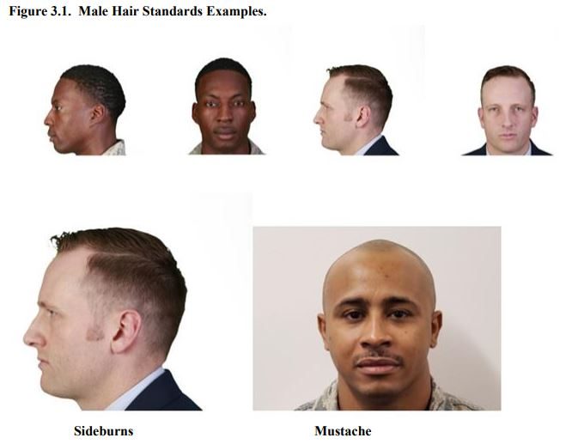
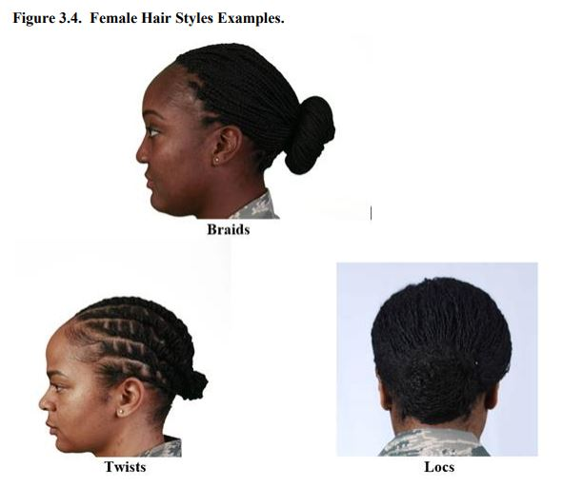

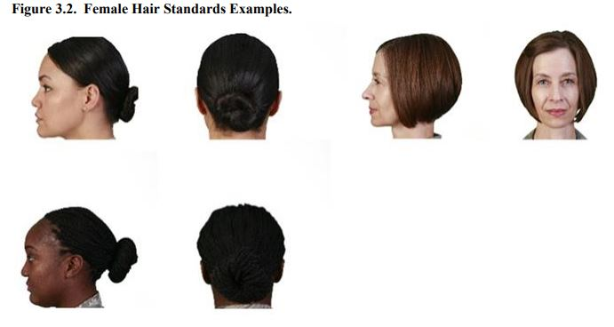
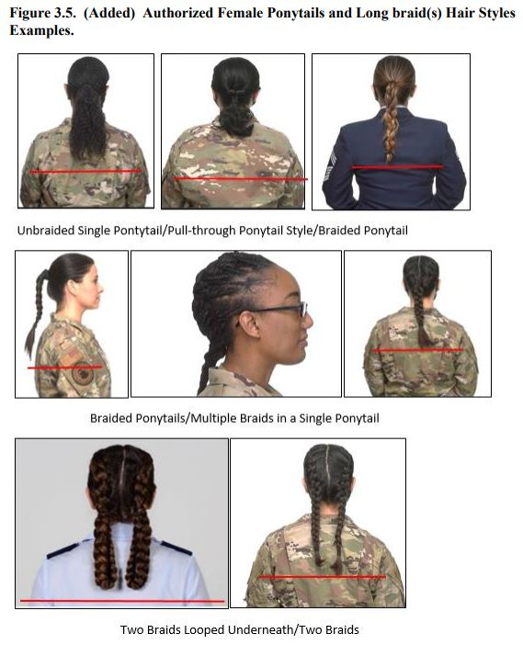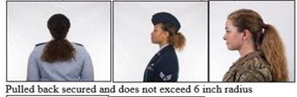
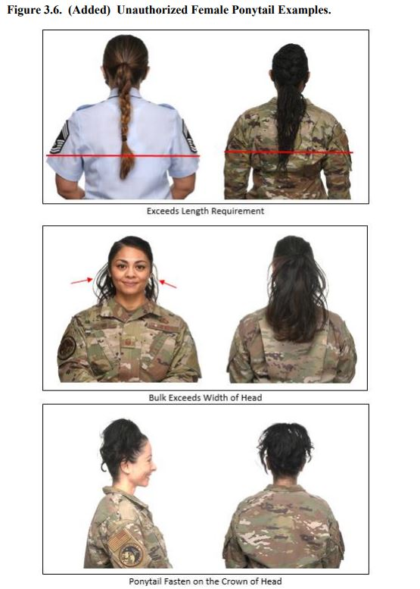

VETERANS AFJROTC UNIFORM INSPECTION

Discrepancy
HAIR Bizarre hair style/cut/color -100
Bulk/Grooming Standards not met -35
Unauthorized items (ie. barrettes/rubber-bands) -10
FACE Unshaven -40
Mustache -20
Sideburns -20
UNIFORM
SHIRT/BLOUSE - Dirty -20
Improperly tucked -10
Buttons unbuttoned/missing -5
TIE/TIE TAB- Missing/improper wear/dirty -10
RANK – Missing/improper wear -15
NAME TAG – Missing / Improper -20
RIBBONS/DEVICES – Missing / Improper -10
T-SHIRT – Not plain white/worn/V-neck -10
Dirty/showing -5
LIGHT-WEIGHT JACKET – Dirty -10
Not zipped (or buttoned) properly/Rank missing -10
BELT – Not worn -20
Improper wear/no gig line -5
TROUSERS/SLACKS – Dirty/wrinkled -20
SOCKS – Not worn/wrong color/type -10
SHOES – Not shined/dirty -20
JEWELRY – Non-compliance -20
NAIL POLISH – Unauthorized color - design -20
HAT – Not worn/dirty -20
UNAUTHORIZED ITEMS (Per item) -10
TALKING/MOVING IN FORMATION -25
STRINGS -5
UNIFORM NOT WORN ALL DAY -100
UNIFORM Not Worn -100
UNIFORM SCORE
Quote & Vocab

Inspection Date
All cadets will be inspected and graded on their personal appearance and wear of the uniform. Cadets will receive 0 to 100 points on their compliance with the uniform and personal appearance standards listed in AFJROTCI 36-2001, AFJROTC Uniform and Awards Guide, and the cadet guide. Uniform violations noted by instructors will be deducted from the uniform inspection grade anytime on uniform day. If uniform violations persist week after week without corrective action, deductions will double/triple.
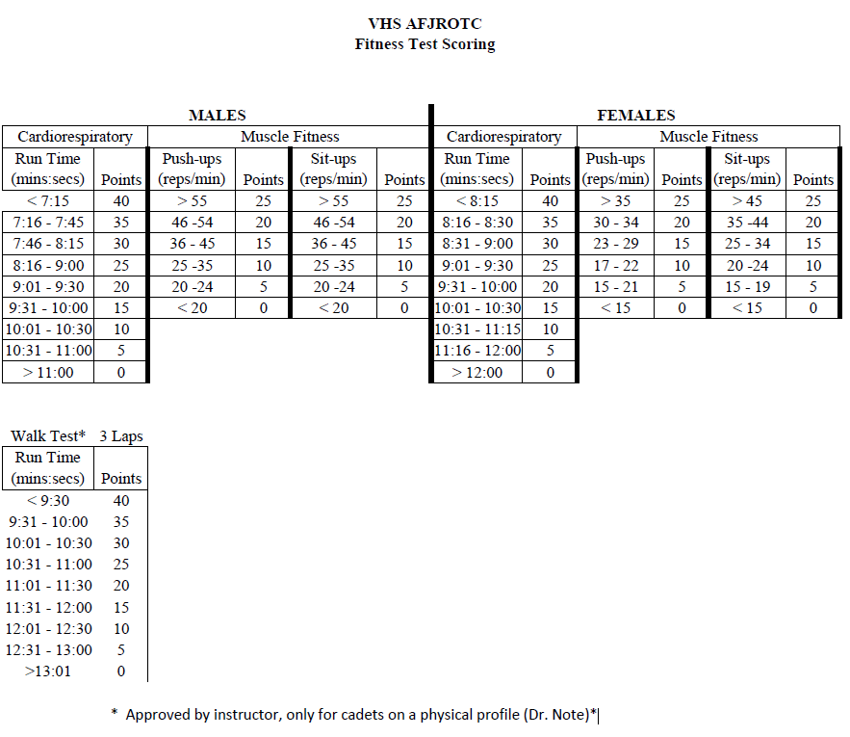

AFJROTC Student/Parent Signature Form

Students and Parents: Please review the course syllabus, grooming standards, and uniform care forms and initial to confirm your understanding of the objectives, requirements, and expectations for AFJROTC classes being taught during the 2023-2024 academic year.

_________ _________ AFJROTC is a voluntary student enrollment program. When a student does Student Initials Parent Initials not voluntarily agree to remain in the program the student must be removed
IAW the Veterans High School/Air Force Memorandum of Agreement.

_________ _________ We have read, discussed, and understand the course requirements,
Student Initials Parent Initials grading policies, classroom rules, teacher expectations, uniform
wear requirements, and mandatory events.

_________ _________ We have read, discussed, and understand are aware of the grooming
Student Initials Parent Initials standards, requirements, and expectations when wearing the AFJROTC
uniform and participating in or supporting AFJROTC events. NOTE: We understand that male haircuts must be tapered, not faddish, with a maximum of 2.5 inches in bulk or that female cadets’ hair (or sew ins or extensions) must have a maximum bulk of 4 inches if worn in a bun or will meet the current AFJROTC Cadet Operations Guide, Operational Supplement Chapter 7 and AFI 36-2903 hair standards and be a natural looking color similar to the individual’s natural hair color. We understand that failure to meet and maintain the standards will be cause for removal from the AFJROTC program.

_________ _________ We have read, discussed, and understand the guidelines regarding
Student Initials Parent Initials uniform care and wear and understand your responsibilities while
enrolled in the AFJROTC program.

_________ _________ We have read, discussed, and understand that all cadets are required to
Student Initials Parent Initials perform at least 12 hours of AFJROTC sponsored community service each school year. Failure to meet 12 hours of sponsored community service may result in removal from AFJROTC.

_________ _________ Late pick-ups make long service days even longer for the on-site instructor.
Student Initials Parent Initials Each cadet will be given a 20-minute grace period after the conclusion of the event to be picked up. If a cadet exceeds the 20-minute grace period of a pick-up on two occasions in each semester, that cadet will be deemed ineligible to volunteer for a service event within a 3-month period.

$40.00 activity fee to help defray the costs of programs that directly support cadet development. Cadets receive Corps T-shirt, entrance to Dining-In, and supplies for group events. Fee due 1 Sep 2023. Payments must be Cash or Check Payable to VHS AFJROTC.

Print Student Name __________________________________

Student Signature ___________________________________ Date _______________

Print Parent/Guardian Name__________________________________

Parent/Guardian Signature ___________________________________ Date _______________

Best method of parent contact (Circle One): Home Phone Cell Phone E-Mail
Parent/Guardian E-Mail Address_______________________________________________________

Parent/Guardian Cell Phone Number(s)_______________________________________________

Home Phone Number: ____________________________________________________

