PHONICS/READING | GRAMMAR/WRITING | MATH | SCIENCE/SOCIAL STUDIES
- Plurals: -s, -es, -ies  - Cause & Effect  - Story Structure | - Plural Nouns  - Begin Cursive Handwriting | - Fluently Add Within 100  - Addition & Subtraction Facts | - Landforms  - Identify Historical Figures and Inventors  - Matter: Solids, Liquids, & Gases
Mrs. Sharpe’s Class •Keisha.Sharpe@acboe.net
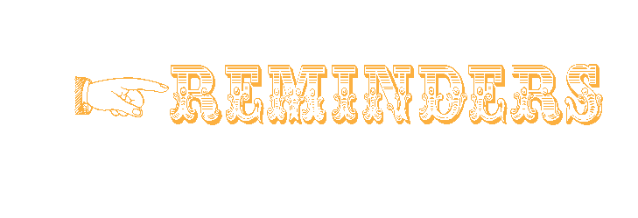

- lunch 7. switch
- lunches 8. switches
- story 9. baby
- stories 10. babies
- tune 11. note
- tunes 12. notes

BONUS WORDS Small treat given for correctly spelled bonus words.
brushes hobbies parties
If your child is a car rider in the mornings, be sure to get him/her to school before 7:45 to ensure he/she has time to eat breakfast before 8:00. Please send a bottle of water to school with your child daily. Also, allow your child to read for at least 20 minutes each night. Homework is due on Fridays.
Our school website is: pinelevelelem.com

The Bremen Town
Spelling Words
Look at what we are learning!

Ladies & Gentlemen!

Every Journey Has a Great Story!

- 10.21: Reading & Grammar Tests
- 10.22: Spelling & Vocabulary Tests
- 10.22: Math Test
- 10.22: Parent Picnic/Report Cards
- 10.25: Book Fair
- 10.25: Nerds Are Cool Day
- 10.26: Camouflage Day
- 10.27: Red Day
- 10.28: Mismatched/Crazy Outfit & Hair Day
- 10.29: Fall Fun Day/Wear Costumes

The Bremen Town Musicians
High Frequency Vocabulary Words
sign bought people
pleasant probably scared shall

October 18 , 2021

