Families with Children
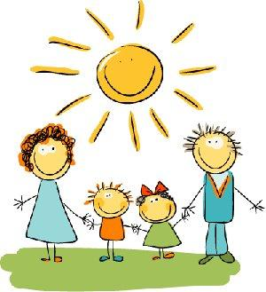
Birth to age 5

Join Us

in fun activities with
other parents and children

NEW 2022 SCHEDULE

Open house 9/26/22 from 4-6pm
There will be 9 classes once a month through out the school year for about an hour.
Classes will be held in the gym
at the Kelliher Old School.

Sponsored by Kelliher Early Childhood Family Education

For more information, contact:
Rachael Neft, 647-8286 ext. 1120 rneft@kelliher.k12.mn.us
Caitlin Johnson, 647-8286 ext. cjohnson@kelliher.k12.mn.us

Or follow Kelliher Early Childhood Family Education on Facebook

