**

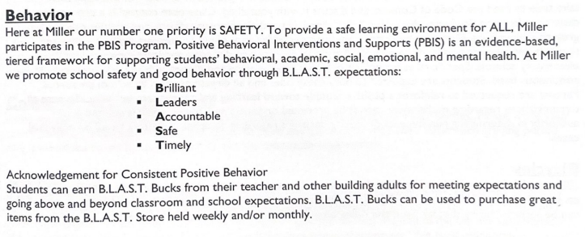

**Dojo in the Classroom**

**What it looks like…**

Teacher award positive and negative points in their classrooms. The points will be used for daily and/or weekly incentives.

**BLAST Bucks**

Students can earn Classroom BLAST Bucks (orange) from their teacher for good behavior or going above and beyond expectations.

Students can earn School BLAST Bucks (blue) from any adult for good behavior or going above and beyond expectations.

**BLAST Buck Store**

Students will be able to shop at the BLAST Buck Store several times throughout the year. Students will shop when they go to the computer lab during specials on designated dates.

**Common Language:**

**Voice Levels**

**PBIS Procedures**

PBIS Procedures

**BLAST Celebrations**

Students who meet expectation of no Major Office Referrals and no BUS referrals will be invited to attend.

**The parties will be quarterly and have fun different activities.**

**Common Language:**

**Voice Levels**

**At Miler…**

**We Keep the POSITIVE in PBIS…**

We acknowledge students for consistent positive behavior.

**There are expectations for all students, parents, staff, and settings.**

3 to 1 positive to negative ratio.

**Teachers are acknowledged for noticing positive student behavior.**

Direct instruction of expected behaviors will occur throughout the school year.

**Routines and the language of BLAST are consistent throughout the school.**

Students are rewarded for expected behavior by staff with BLAST BUCKS.

**Problem behavior will be responded to with consistent consequences that are focused on re-teaching the expected behavior.**

**MES**



**PBIS**

**Student & Parent Information**

**2024-2025**