Please review the study guide.

Apples & Farms

Adjectives

MATH:

We will continue topic 2 this week and then start topic 3 which is adding and subtracting to 20.

Week of Sept. 26

Spelling words

can kit click drill walk stall rock lick mall salt there call

High Freq. Words:

Call there

Contact Information

Email: Pamela.luker@acboe.net

Website: prattvilleprimary.com/pamelaluker

LANG. ARTS:

SS/SCIENCE:

READING:

Our Learning





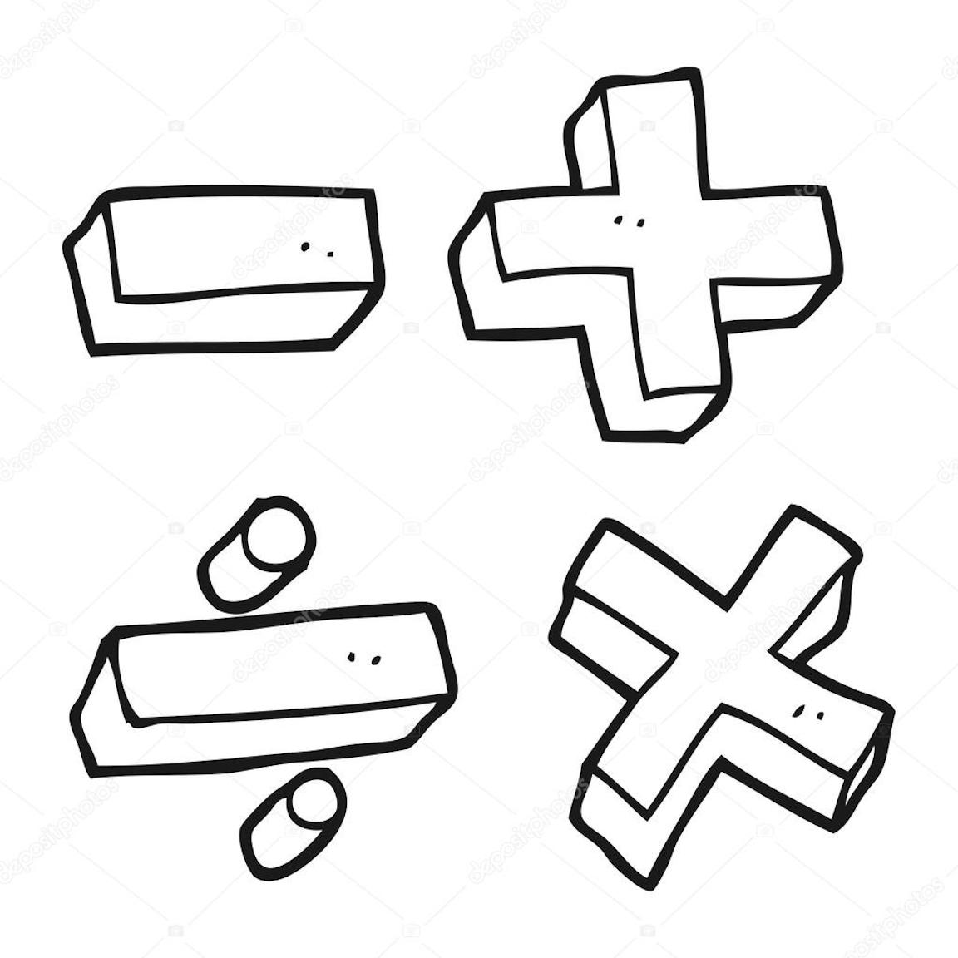



Upcoming Events

Sept. 28- fall pictures

Sept. 30- Spirit Day- bring a stuffed animal

Reminders

\* This week we will start spelling tests. The test will be given on Friday. One point will be deducted for each letter reversal and uppercase letter in the middle or end of the word. We will also have a dictation sentence on the test. This is where I call out a sentence and they have to write it.

\* this week we will also start taking a grade that will count as a daily grade in reading where they have to read words and sentences.

Mrs. Luker’s Class