Coffee County Pre-K Program
2023-2024 Parent-Student Handbook

Mrs. Tamara Morgan, Birth to Five Literacy/Pre-K Director

What is Georgia's Pre-K Program?
Georgia’s Pre-K Program launched in 1992 as a small pilot program by Governor Zell Miller. At the time, Georgia’s Pre-K served 750 four-year-old children in the state. Now, 30 years later, the lottery-funded program has laid a solid foundation for academic excellence and future success in the lives of more than 2 million children in Georgia.
Georgia’s Pre-K was the nation’s first state-funded universal preschool program for four-year-olds, and is a voluntary, no-cost program. Every four-year-old in Georgia is eligible for Georgia’s Pre-K Program regardless of parental income. The program continues to be nationally recognized for its success.

BRIGHT FROM THE START
MISSION & VISION STATEMENT

Mission
The Georgia Department of Early Care and Learning improves outcomes for children and families by strengthening early learning experiences in partnership with early education programs, professionals, stakeholders, families, and communities.
Vision
Every child in Georgia will have equal access to high-quality early care and education.

COFFEE COUNTY SCHOOLS
MISSION & VISION STATEMENT:

Mission
Destination Graduation for College, Career, and Life

Vision
Creating a stronger community through an equitable and excellent education for every student

Equal Educational Opportunities Policy:
The Coffee County School System does not discriminate on the basis of race, color, national origin, age, disability, or sex in its employment practices, student programs, and dealings with the public. It is the policy of the Board of Education to comply fully with the requirements of Title VI, Title IX, Section 504 of the Rehabilitation Act of 1973, the Americans with Disabilities Act and all accompanying regulations.

Coffee County School Beliefs

WE ARE COFFEE!

- Community - We foster and sustain strong community partnerships.
- Opportunity - We provide opportunities for all students to learn, thrive and succeed.
- Focus - We focus on raising student achievement and preparing our students for their futures.
- Fairness - We ensure all children have equitable access to the resources necessary for academic success.
- Ethics - We promote integrity and honest communication and maintain responsible stewardship of resources.
- Excellence - We pursue the highest standards in educational and operational performance.
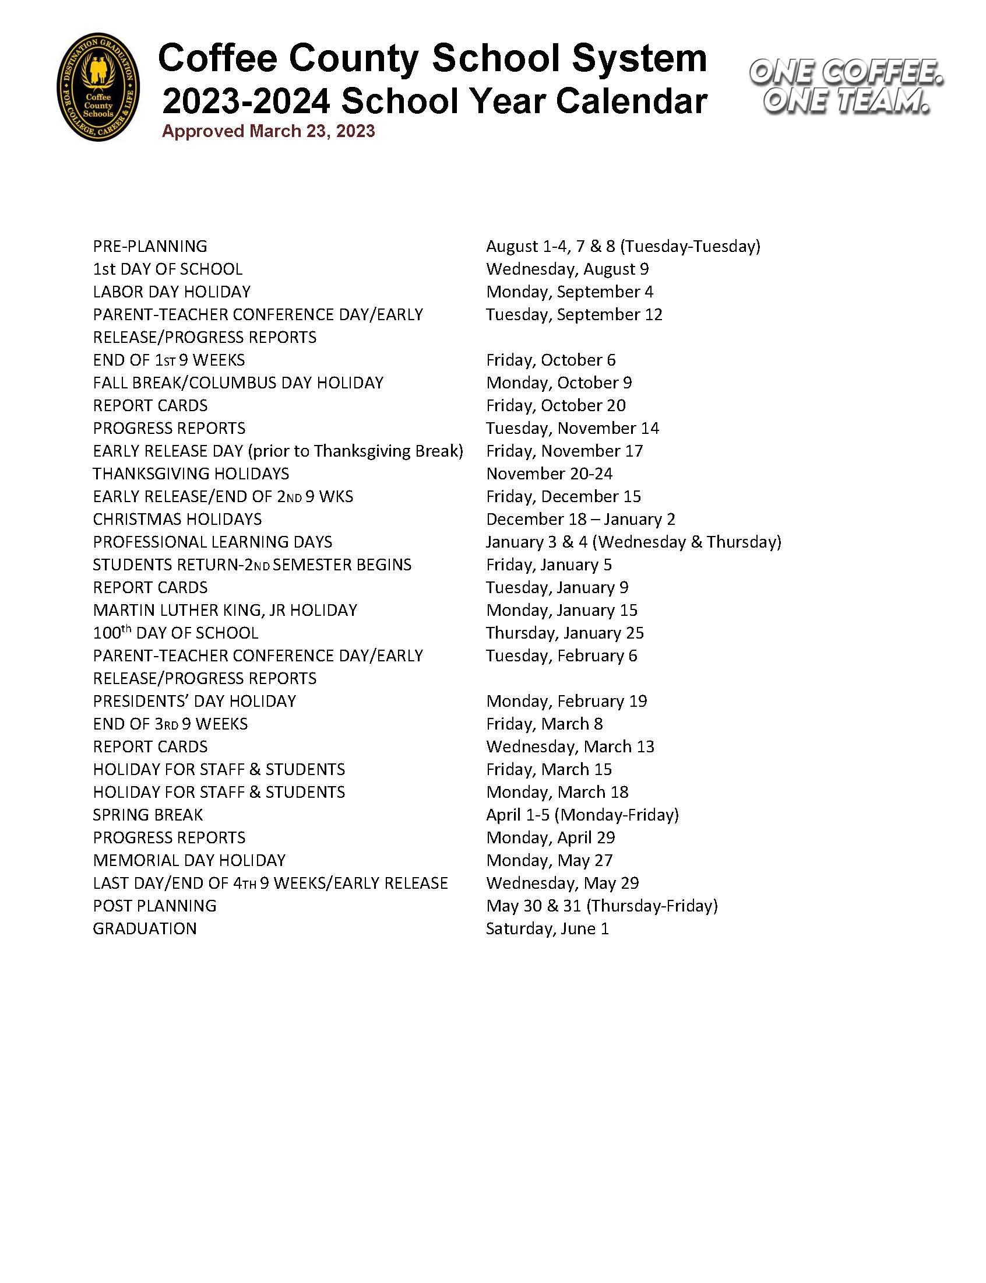
Note: The 2 conferences scheduled for K-12 students are not Pre-K Conference days. However, these days are Early Release days for all students.
Each elementary school will schedule one Pre-K Conference before Christmas Break and another before the end of the school year.
FY 24 Coffee County Pre-K Personnel
Birth to Five Literacy/Pre-K Director: Tamara Morgan
Pre-K Enrollment Contact: Cindy Carter

Pre-K Teachers and Assistant Teachers
Ambrose Elementary: Marnie Smith & Haley McReady
Erynn Hunkapiller & Blaze Shrouder
Broxton Mary-Hayes Elementary: Lorisa Smith & Kristy Bagley
Nikki Moorman & Kenya Killiebrew
Eastside Elementary: Jessica Morris & Beverly Palen
Mary Beth Sherrod & Amanda McSwain
Kendra Williams & Makayla Carlin
Indian Creek Elementary: Danae Mullis & Tamika Rozier
Emily Carver & Susan Wilcox
Whitney Burch & Kathy Miller
Nicholls Elementary: Winston Bagley & Kimber Thomas
Teacher Vacancy & Julie Southerland
Satilla Elementary: Lori Hamilton & Angie Holton
Melanie Summerlin & Jannie Tanner
Summer Wade & Roberta Stevens
West Green Elementary: Marisol Rivas & Brooke Lott
Lyric Moore & Debra McClendon
Westside Elementary: Martha Futch & Marsha Grantham
Hilary Rodriguez & Demie Ables
Caroline Ables & Dolores Teston

FY24 Coffee County Open House Schedule
Elementary Schools: Monday, August 7, 2023 from 3:00-6:00
Please attend Open House at the school where your child will attend.
Your child’s teacher will share important information that is specific to your school. Talk to your child’s teacher for a complete list of recommended school supplies: Mat – Kinder Plastic Mat, 2 towels needed or a Nap Mat that has a towel included (if possible, no sleeping bags); Complete change of clothes in a labeled Zip-Lock bag; Full-size backpack requested – Please bring these items labeled (with first/last name on each item of clothing) to Open House on 8/7.
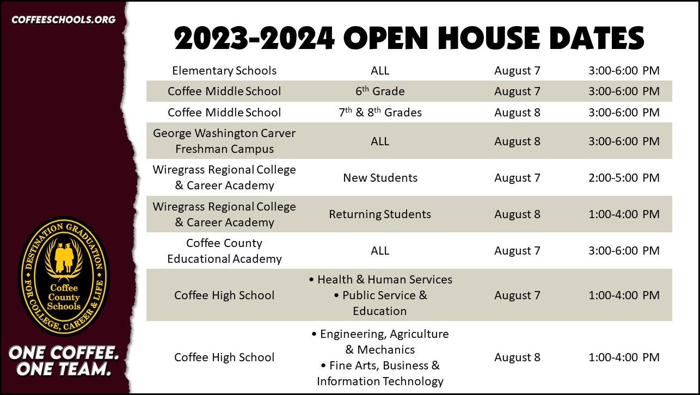

Parent Engagement
There will be many activities/events that your school will offer for you to be involved. Teachers will send home newsletters/calendars with info. Also, visit your school’s website as well as the county website for more information of how you can be an engaged parent☺
2023 Georgia Pre-K Week
This year we will celebrate over 30 years of Georgia’s Pre-K during October 2-6, 2023! Guest readers and many activities will be held during this week.

Dress Code:
Please refer to Coffee County’s Student Handbook for complete information for students’ dress code. Helpful info: Dress your child appropriately for the weather. Shorts should be worn under dresses. All body parts covered. Underwear is needed under clothing. Choose shoes/clothing (belts/jumpsuit) your child can fasten/unfasten by themselves. Please label book bags, lunch boxes, jackets, coats, etc. that your child brings to school.
Note: Please leave all toys at home unless requested by the teacher.

Also, note that Pre-K is an active learning environment with many hands-on learning activities. Please don’t be alarmed if your child’s clothes get a little dirty/soiled while playing, painting, drawing, etc.

Breakfast and Lunch
Coffee County Schools will be participating in the Community Eligibility Provision (CEP). This allows the School Nutrition Program to serve breakfast and lunch in our schools at no cost to students.
Students may bring lunch from home. However, we ask that you do not bring in or send food from “fast food” restaurants in the original wrapping. If you wish to bring in or send such food, please place it in a lunch box or bag. Also, please do not send drinks in cans or glass bottles for lunch. Please consider food items/packaging that is easy for your child to open independently.
Note: If students bring food from home, they may still get a lunch tray.
Very important: If your child has a food allergy, please let your child’s teacher and the nurse know. Also, medical documentation must be provided.
Special diet forms, menus, and other School Nutrition information can be found at coffeecountyschoolnutrition.org. Mobile menus are also available via the Web Menus app (Isite software).
Snacks:
The Coffee County School System provides our Pre-K students with a juice each day. However, parents are welcome to donate store bought snacks (no homemade food) to the classrooms.

School Safety
Keeping our students safe is very important to us. Safety measures within the Coffee County School System are:
- Required ID for student check-out
- Centegix System used for emergencies
- Exterior & interior doors are locked
- All visitors are buzzed in before entering the building
- Safety drills are scheduled throughout the year
- Coffee County School System officers are at each school

As a follow-up in keeping our Pre-K students and staff safe:
We understand that Pre-K children are very active and some children may take more time adjusting to school than others. However, we expect them to listen and follow directions as age appropriate in not harming themselves or others. Our staff have been trained in “Capturing Kids Hearts” – learning processes focused on social-emotional well-being, relationship-driven campus culture, and building positive student relationships.
Should your child cause excessive disruption or harm to himself or others, you will be contacted to take your child home from school for the remainder of the day. Additionally, a conference will be scheduled as soon as possible to discuss the concern and make a plan to help us solve the issue.
Repeated incidents of excessive disruption and/or harm are very serious. The teacher will keep documentation of the type of behavior, strategies used, and action taken by the Pre-K staff. We will work together to develop a plan to help your child as well as keep others safe.
If you are concerned about your child’s behavior, please let the teacher know. We will work with you and discuss behavior strategies as well as other resources that are available to help your child. It is our goal to provide a safe, healthy learning environment for all students and staff.

ATTENDANCE
Does my child need to come to Pre-K every day?
YES, Pre-K is a full day (6.5 hours per day), full week educational program. Your child is expected to attend school Monday through Friday for the full day. Bright from the Start, the Georgia Department of Early Care and Learning and the Coffee County School System, monitors the attendance of each Pre-K student. Excessive/Chronic unexcused absences and/or unexcused tardies may result in dismissal from the Pre-K Program.
We understand from time to time that students may need to miss school. If that occurs, a dated and signed note from parents/guardians and/or physician must be given to your child’s teacher or attendance clerk explaining the reason for the absence within three (3) days of returning to school. The teacher or attendance clerk will maintain a record of your child’s excused absences and retain all notes until the end of the school year. Without a note, the absence will remain unexcused. After five (5) handwritten parent notes, the school may require medical documentation/outside documentation in order to excuse an absence. If the school nurse sends your child home, it will be an excused absence.
Regular school attendance is a component to a child's academic success. A habit of attendance IS a school readiness skill. Along with social-emotional and readiness skills, consistent on-time attendance is a habit that lasts. Too many absences can cause children to fall behind in school. Missing 10% (or about 18 days) can make it harder to learn to read and be successful in school. Students who are chronically absent in Pre-K and Kindergarten may be less likely to read by 3rd grade.
Pre-K Student Attendance Procedures:
- After three unexcused absences, tardies, early checkouts, or late pick-ups (after 2:30 PM), parents/guardians will be contacted by your child’s teacher.
- After six unexcused absences, tardies, early checkouts, or late pick-ups (after 2:30), parents/guardians will receive a letter from the Pre-K Director.
- After ten unexcused absences, tardies, early checkouts, or late pick-up (after 2:30), parents/guardians will have a conference with the teacher, school administration, and the Pre-K Director to develop an attendance plan.
- If unexcused absences continue, the Pre-K Director will contact the Pre-K Consultant from Bright from the Start to discuss next steps. Note: possible disenrollment from the Pre-K Program may be an option
- Note: Per the Bright from the Start Handbook: “Consecutive Absenteeism Children - who do not attend class for 10 consecutive days without a medical or other reasonable explanation must be removed from the roster.”
What time can my child arrive at school? Elementary school students are to be at school before 7:30. If students arrive after 7:30, you will need to check in your child at the front office; students will be marked tardy after 7:30 if they are not in class. Please check with your child’s school to determine early drop-off/arrival times. Being on time for school is very important. Important learning occurs in the morning. Being on time helps your child have a better day.
May I pick up my child early from Pre-K? The Pre-K Program is a full day program (6.5 hours). Excessive early checkouts may result in dismissal from the Pre-K Program. We understand from time to time students may need to be picked up early, please let your child’s teacher know and follow your school’s early checkout procedures.
Note: If possible, please schedule any appointments after lunch, so students will be present at school for their regular learning day.
Research shows that children who attend quality preschool may have higher math and reading skills, are better prepared for kindergarten, behave better in class, and are more likely to graduate from high school and attend college. Pre-K provides a safe learning environment where your child can gain a sense of self, explore, play with peers, and build confidence.
Coffee County Pre-K is a great place to be!

Note: Parents may walk children to class the first two days of school. After that, staff will help children get safely to their classes.

What do I do if my child is sick?
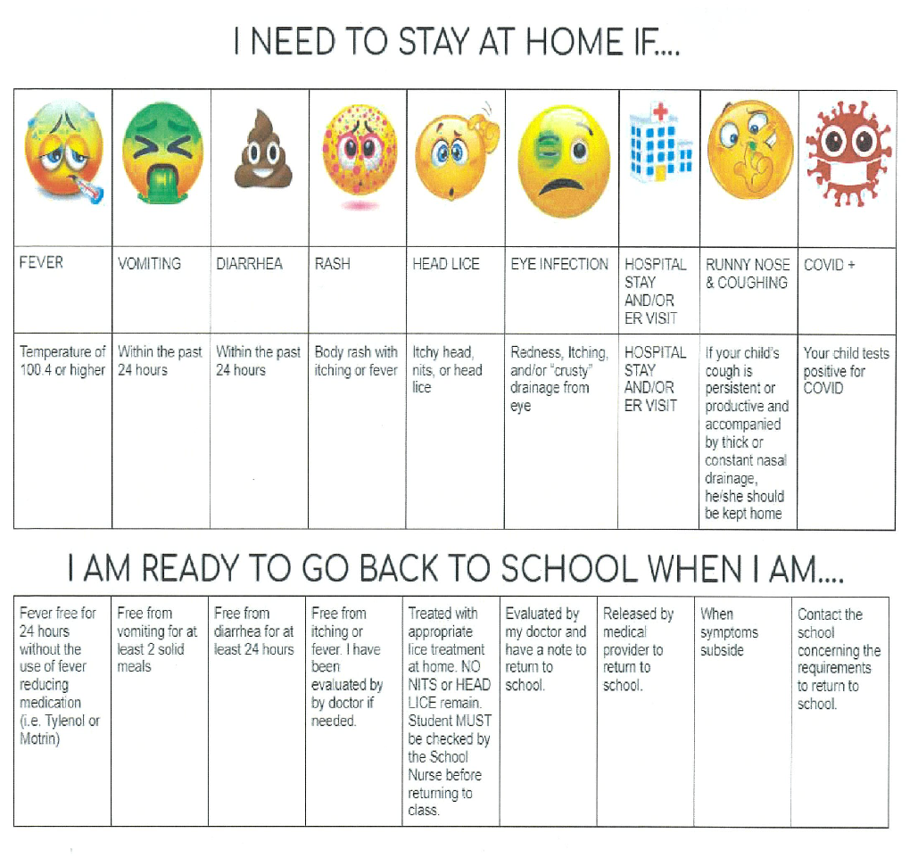

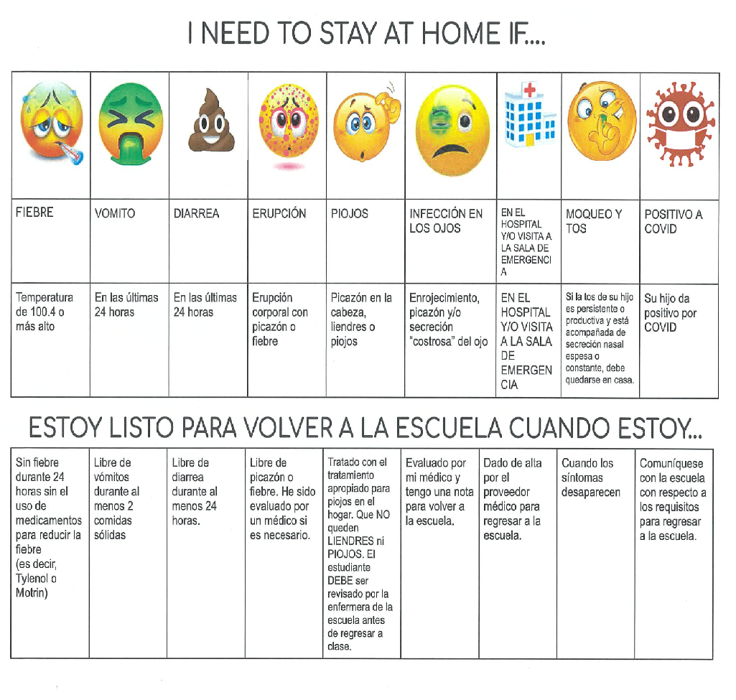

Medication
All students MUST complete a Locator Card for medication to be given. Medication is dispensed only when the proper form is filled out and on file with the school nurse. Prescription drugs must be in the original packaging. Also, medication must be taken to the nurse by you, the parent. Please DO NOT send any medication in your child’s book bag, with your child, or with an older sibling.

Head Lice
Please know when nits (eggs) or lice are found in your child’s hair, he/she will be immediately sent home with their personal belongings for treatment. Your child will be rechecked by the school nurse before returning to the classroom. Your child must not have lice or nits (eggs). The school nurse has information on how to treat your child and your home for lice.

A Day in Pre-K
An example of a daily schedule

7:00-7:30 Arrival/Morning Activities
7:30-8:00 Breakfast
8:00-8:10 Bathroom
8:10-8:30 Opening Activities:
Calendar
Large Group Read Aloud
Phonological Awareness – use Heggerty Instruction
8:30-8:45 Music and Movement
8:45-9:00 Large Group Read Aloud/Message Time/Activity
9:00-9:15 Small Group
9:15-9:25 Bathroom
9:25-10:25 Recess
10:25-10:40 Snack/Bathroom
10:40-11:40 Centers
11:40-11:55 Clean Up/Bathroom
11:55-12:25 Lunch
12:25-12:35 Bathroom
12:35-1:35 Rest Time
1:35-1:45 Large Group Activity
1:45-2:00 Closure
2:00 Dismissal

Pre-K Parent Updates
*Certificate of Immunization – DPH Form 3231 – All children attending Georgia’s Pre-K Program must have a Georgia Department of Community Health Certificate of Immunization. Children may register and begin attending before issuance of Form 3231. However, Form 3231 must be on file within 30 calendar days from the day your child starts the program. Expired certificates must be updated within 30 calendar days of the expiration date. Any child who does not have a completed certificate within the 30-calendar day period may not return to the program until a certificate is provided and is onsite.
Note: Immunization Exemptions: Georgia law allows for two types of exemptions from the immunization requirements: medical and religious. Medical exemptions are used when it is deemed medically necessary for the health of a child. A medical exemption must be marked on Form 3231. A letter from a physician, advanced practice registered nurse, or physician assistant attached to the certificate will not be accepted as a medical exemption. It must be marked on the certificate. Medical exemptions are valid for a one-year period. Families may object to vaccinations on religious grounds by filing an affidavit noting their objection. The only affidavit that may be used to register a religious objection to required vaccinations is the Georgia Department of Public Health (DPH) Form 2208. Religious affidavits must be notarized and kept on file. The affidavit does not expire
*Certificate of Vision, Hearing, Dental, and Nutrition Screening – DPH Form 3300 - All children attending Georgia’s Pre-K Program must have a Certificate of Vision, Hearing, Dental, and Nutrition Screening (Georgia Department of Public Health Form 3300). The vision, hearing, dental, and nutrition screenings reported on Form 3300 must have been conducted within 12 months prior to the start of the Pre-K Program.
Children may register and begin attending Pre-K prior to completion of these screenings and issuance of a Form 3300 certificate. However, the Certificate of Vision, Hearing, Dental, and Nutrition Screening indicating that children have completed these screenings must be on file within 90 calendar days from the day your child starts the program. A completed form includes a checked box and screener’s signature in each section. Any child who does not have a completed certificate within the 90-calendar day period may not return to the program until a certificate is provided and is on-site.

The Coffee County Pre- Kindergarten Program uses the state standards called GELDS (Georgia Early Learning and Development Standards). Go to the link below for details about those standards or for helpful information about literacy, readiness, and parent and family activities.
Georgia Early Learning and Development Standards (GELDS) www.gelds.decal.ga.gov
Alpha Skills – Approved Pre-K Curriculum by the state of GA- Thematic Units are five-day lesson plan sets with read aloud books, music CDs, and learning activities that are matched to GELDS, Head Start, and NAEYC Pre-K Standards.

*Five read aloud books or rhymes with matching activities each day *Evaluation that includes anecdotal notes and work samples

*Three music and movement activities each day *Two small group and independent activities each day

*Outdoor activities to extend learning during physical development time *Calendar time, snack time, closure time activities

*Work center activities matched to unit *Materials and activities to build each child’s vocabulary

*Evaluation that includes anecdotal notes and work samples

Alpha Skills Units
- Learning about Me at School 18. Children Around the World
- Colors, Shapes, & Time in the Everyday World I 19. Bird Migrations & Habits
- Colors, Shapes, and Time in the Everyday World II 20. Maps & Measures for Finding Treasures
- Farms Are Filled with Food and Animal Families 21. Music & Musicians That Make Us Move I
- A Nursery Rhyme is Mighty Fine! 22. Music & Musicians That Make Us Move II
- Autumn in Absolutely Awesome I 23. Spring Has Sprung I
- Autumn in Absolutely Awesome II 24. Spring Has Sprung II
- Keeping My Body Healthy and Safe 25. Authors, Illustrators, & Me! I
- Transportation-Cars, Trucks and Buses I 26. Authors, Illustrators, & Me! II
- Transportation-Trains, Boats and Airplanes II 27. Traits of Animals in All Environments
- People in Our Community 28. Our Nation Past & Present I
- Stores Differ From Each Other 29. Our Nation Past & Present II
- Creepy Crawlers 30. Summer Scholars: Transition to Kindergarten

How will my child be assessed?

Your child’s teacher will use the Work Sampling On-Line System from Bright from the Start: Georgia Department of Early Care and Learning (DECAL) for evaluating students. This assessment is on-going throughout the year and based upon observation of your child’s behaviors and activities during the school day. Teachers observe and record student performance. Another Pre-K Assessment that will be used to measure your child’s progress is the Individual Growth and Development Indicators (my IGDIs)

*Goal: Track Kindergarten readiness – to understand how your child is developing the academic, social, and behavioral skills necessary to thrive in the school environment.
*Will be administered in the fall and spring of the school year
*Your child will be assessed individually on-
- Picture Naming (oral language)

- Rhyming (phonological awareness)

- Alliteration (phonological awareness)

- Sound ID (alphabet knowledge)

- “Which One Doesn’t Belong?” (comprehension)

CHILD FIND
PUBLIC NOTICE
Coffee County School System Announces: Determines Eligibility for Special Education Services
The Coffee County School System offers comprehensive special education services to eligible students ages three through 21 years. Children from birth to age three with disabilities will be referred to appropriate agencies for services. Public school services include screening in the area of suspected disabilities, such as hearing, motor skills, speech, language and general development. Evaluations in the schools are provided for several areas of disabilities including learning disabilities, speech and language development, physical impairments, vision or hearing problems, intellectual disabilities, emotional and behavioral disorders, autism/pervasive developmental disorders, health problems or traumatic brain injuries. A Free Appropriate, Public Education (FAPE) with a full continuum of services is available for all eligible children enrolled in the Coffee County School System and for those students who are home schooled or enrolled in private schools and preschools, including religious schools. For more information concerning eligibility criteria and referral procedures, please contact the Office of Special Education at (912) 389-6753. The staff can answer questions or direct your call to the appropriate person. All referrals are considered confidential and services are provided at no cost. The parent, legal guardian or surrogate parent retains the right to refuse services and is provided with procedural safeguards under federal and state law.

For more information regarding Pre-K, please log on to
https://www.decal.ga.gov/bfts/Faq.aspx?cat=pre-k

