

**Kindergarten Grade Units of Study**

Engineering Design Process (Science and Engineering Practices)

Science Process Skills (Observations and Communication)

Directional Coding with Code and Go Mouse

Winter/Hibernation

Nursery Rhymes

Bugs and Insects

Quick Builds - Bridges

Mrs. Penny Buckley

pbuckley@dd4.k12.sc.us

STEM Lab Instructor

STEM Expectations

*Be Respectful - be kind, follow directions

*Be Responsible - follow classroom routines, use materials appropriately

*Be Ready to Learn - stay on task, try your best, stay positive

Don’t Give Up!

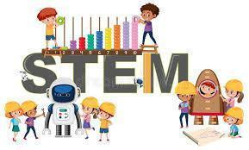

**Participation**

STEM activities will be assessed based on participation during STEM Lab.

*Being Respectful

*Being Responsible

*Being Ready to Learn

