2023-2024
Hickman County Schools
Parent and Family Engagement Policy/Plan
Revised: October, 2023
115 Murphree Avenue
Centerville, Tennessee 37033
https://hickmank12.org/

What is family engagement?
Family Engagement means the participation of parents and family members in regular, two-way, and meaningful communication involving student academic learning and other school activities including ensuring:
(A) That parents play an integral role in assisting their child’s learning.
(B) That parents are encouraged to be actively involved in their child’s education.
(C) That parents are full partners in their child’s education and are included, as appropriate, in decision-making and on advisory committees to assist in the education of their child
(D) The carrying out of other activities, such as those described in Section 1116 of the ESSA.
About the Parent and Family Engagement Policy
In support of strengthening student academic achievement, the Hickman County School System (HCSS) has developed this parent and family engagement plan; and guides the strategies and resources that strengthen school and parent partnerships in the district’s Title I schools. This plan will describe HCSS commitment to engage families in the education of their children and to build the capacity in its Title I schools to implement family engagement strategies and activities designed to achieve the district and student academic achievement goals.
When schools, families, and communities work together to support learning, children tend to do better in school, stay in school longer and enjoy school more. Title I, part A provides for substantive family engagement at every level of the program, such as in the development and implementation of the district and school plan, and in carrying out the district and school improvement provisions. Section 1116 of the Every Student Succeeds Act (ESSA) contains the primary Title I, Part A requirements for school and school systems to involve parents and family members in their children’s education. Consistent with Section 116, HCSS will work with its Title I schools to ensure that the required school-level parent and family engagement policies meet the requirements of Section 116(b) and each include, as a component, a school-parent compact consistent with Section 116(d) of the ESSA.

Jointly Developed
During the annual District Wide meeting in the Spring, the Parent Advisory Council was invited to participate and provide suggestions and ideas to improve this district parent and family engagement plan for the 2023-2024 school year. Additionally, each Title I school used its Family Engagement Team to review the district parent and family engagement policy before the end of the school year. Families are welcome to submit comments to their child’s school, which will be communicated to the District. All feedback received by July was included with the policy for review this school year.
In September, 2023, HCSS held its first meeting for the 2023-24 school year with the new Parent Advisory Panel. During this meeting, families also reviewed suggestions from the Spring meeting, student assessment data and discussed the District Improvement Plan that was approved in April, 2023, in addition to any comments or feedback received. The new Family Engagement Plan was developed for the 2023-24 school year. Each year, the district parent and family engagement plan is incorporated into the District Improvement Plan, which is submitted to the state in March for the upcoming school year.

Strengthening Our Schools
This year, the district academic coaches and Federal Programs Director will provide assistance and support to all Title I schools to ensure family engagement requirements are being satisfied and that family engagement strategies and activities are being implemented. Title I schools will receive notifications and resources from the district office, to assist with improving and strengthening family engagement.
In addition to frequent communication and school visits, the district will hold three family engagement meetings a year to review family engagement plans and activities.

Reservation of Funds
The HCSS will reserve 1 percent from the total amount of Title I funds it receives in the 2023-2024 school year to carry out the parent and family engagement requirements listed in this plan and as described in section 116 of the ESSA. Furthermore, the HCSS will distribute 90 percent of the amount reserved to Title I schools to support their local-level family engagement programs and activities. The district will provide clear guidance and communication to assist each Title I school in developing an adequate family engagement budget that addresses their needs assessment and parent recommendations.

Opportunities for Meaningful
Parent and Family Consultation

Input and suggestions from parents and family members are an essential component of the district and school improvement plans that are developed each year. All parents of students eligible to receive Title I services are invited to attend any of the meeting opportunities described in this section to share their ideas and suggestions to help the district, schools, and students to reach our student academic achievement goals.

District Family Engagement Meetings
October 3, 2023 - 8:30 am
January 23, 2024 - 8:30 am
May 7, 2024 - 8:30am
These meetings last no longer than an hour. Input on district wide initiatives and information on all schools.

Annual District Family Friendly Survey-February/March
Input on how your school is supporting all families.

District Strategic Plan - 2023-2024 School Year
The Tennessee Department of Education laid out goals and priorities for Tennessee’s students and a plan to reach these goals. We will be asking the questions: Where are we going in Hickman County? How are we going to get there?

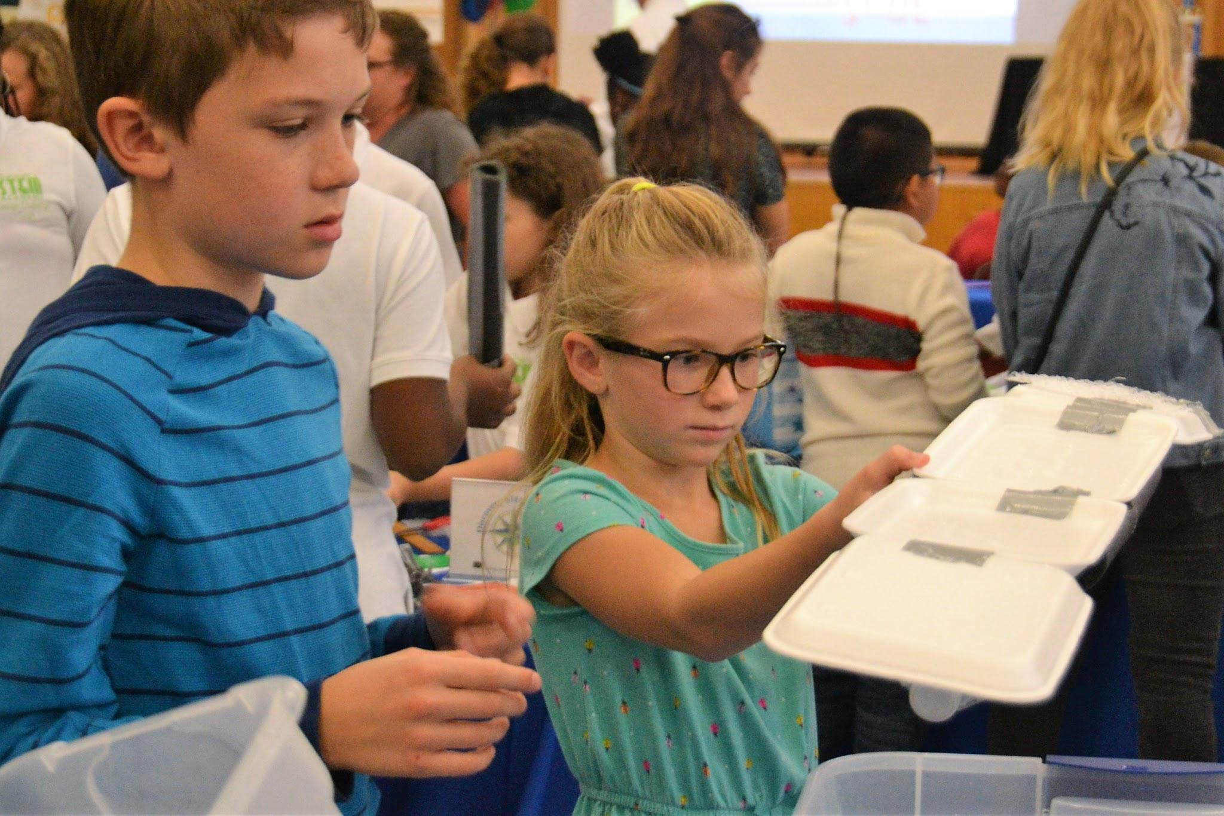
District School Improvement Plan - 2023-2024 School Year The district works to create a comprehensive District Improvement Plan that is developed annually by a diverse group of stakeholders to drive prioritization of the work and associated funding decisions to improve educational opportunities for all students. During the planning process, stakeholders are challenged to review various data points to identify the current needs of the district or school. Once the needs are identified, the planning team creates aligned goals, strategies, and action steps that align with the prioritized needs. All school improvement plans should be monitored regularly and revised based on students’ needs throughout the school year with input from the planning team.

Unable to attend these
Meetings mentioned above?
Please contact the Federal
Programs Director to
review the meeting
documents, minutes and
to leave your input.

Building Capacity
HCSS will build the schools’ and parents’ capacity for strong family engagement, in order to ensure effective involvement of parents and family members and to support a partnership among the Title I schools, parents, and community to improve student academic achievement through the following district-wide activities.

Of Parents:

HCSS will work as a district and through its Title I schools to provide assistance to parents in understanding state and district academic information connected to their student’s learning and progress, as well as information regarding the Title I program. HCSS will provide informational sessions for parents to gain knowledge about the challenging state academic standards, local academic assessments, as well as the required assessments for Tennessee students including alternative forms of assessment. The dates and locations for these sessions will be posted on the schools’ website and shared through each Title I school’s newsletter. HCSS has established a district wide family engagement committee composed of family representatives from each Title I school’s family engagement committee to provide advice on all matters related to family engagement in Title I, Part A programs. Community leaders and business partners will be invited to serve on this committee. The district will encourage collaboration and participation with community partners. HCSS will coordinate and integrate the district’s family engagement programs with the local preschool program and other federal and state funded preschool programs in the district by inviting faculty and staff from those programs to attend planning meetings focused on family engagement activities. In the spring, the elementary schools will host a Kindergarten Registration day so parents may tour the schools and receive information to help prepare them and their children for kindergarten.

Of School Staff:
To ensure that information related to district, school, parent programs, and activities is available to all parents, each Title I school is required to send home and post online information for parents and family members in an understandable language and uniform format. At the beginning of the year, school staff will be trained on parent notifications and resources to be sent home in parents’ native language where applicable, and provide interpreters at parent events. Information posted on the district website will be translated to the extent practicable. The district will also utilize school phone call systems, district and school websites, local news media, and other school message systems to post information for parents.

Parent and Family Engagement Evaluation
Each year, HCSS will conduct an evaluation of the content and effectiveness of this parent and family engagement plan and the family engagement activities to improve the academic quality of the Title I schools through an annual parent survey. Beginning in February, each Title I school will send home a survey and email a link to the survey for parents to provide valuable feedback regarding the parent and family engagement activities and programs. These surveys will also be posted on the district family engagement website for parents to complete. In addition to the annual survey, each school will have Leadership Meetings to facilitate group discussions to discuss the needs of families and to design strategies for more effective family engagement. HCSS will use the findings from the school meetings and the survey results to design strategies to improve effective family engagement, to remove possible barriers to parent participation, and to revise its parent and family engagement plan.

Accessibility
In carrying out the parent and family engagement requirements established by Section 116 of the ESSA, the district family engagement coordinator will communicate and collaborate with the Office of Student Services to ensure full opportunities for participation of parents with limited English proficiency, parents with disabilities, and parents of migratory children including providing information and school reports in a language parents can understand.

Adoption
This district wide parent and family engagement policy has been developed jointly and agreed upon with parents and family members of children participating in Title I, Part A programs as evidenced by the collaboration of parents, school, and district personnel at the district meeting.

District Community Team
Hickman County Schools invites all families to join the District Family Engagement Committee to share ideas and ways to involve others to build partnerships with school, families, and the community. The team will meet three times during the school year, but parents and family members can also submit ideas or suggestions at any school activities and meetings, as well as through email. If you would like to learn more about the District Family Engagement Committee, please contact Julia Thomasson at (931)729-3391 or julia.thomasson@hickmank12.org. We also welcome feedback through the survey below. It can be turned in to your child’s teacher or the school office.

District Committees
❏ Yes, I am interested and wish to join the District Family Engagement Committee
❏ Yes, I am interested in joining the District School Improvement Planning Committee
❏ Yes, I am interested in joining the District Strategic Planning Committee

Name: ______________________________________________________________________________________________________

Child’s Name, Grade Level, and School: __________________________________________________________________

Address: ___________________________________________________________________________________________________

Phone Number: ____________________________________________________________________________________________

Email Address: ____________________________________________________________________________________________

Share Your Thoughts
We want to hear from you! If you have any suggestions or if there is any part of this policy that you feel is not satisfactory with the district’s goals for academic achievement, please provide us with your comments in the space provided and leave this form in the front office:

Name (optional): ______________________________________

Phone Number (optional): _________________________________

Comments:
_____________________________________________________________________________________________________________________

_____________________________________________________________________________________________________________________

_____________________________________________________________________________________________________________________

