……

Mrs. Janes Newsletter
October 9-11, 2024

New

Reading:

- Review long i: (ie I y igh i_e)
- Fall Passage/Questions
- Stellaluna

Word Study
pie tie child kind sky dry high lime light bright

High Freuency Words
good many near off people right that two under very

Math
- Review Place Value/Greater than/Less than/Equal To
- Practice addition speed drill (Test Thursday)

Language:
- Handwriting
- Fall writing

Social Science:
- Scholastic News/Lady Liberty

this week’s focus

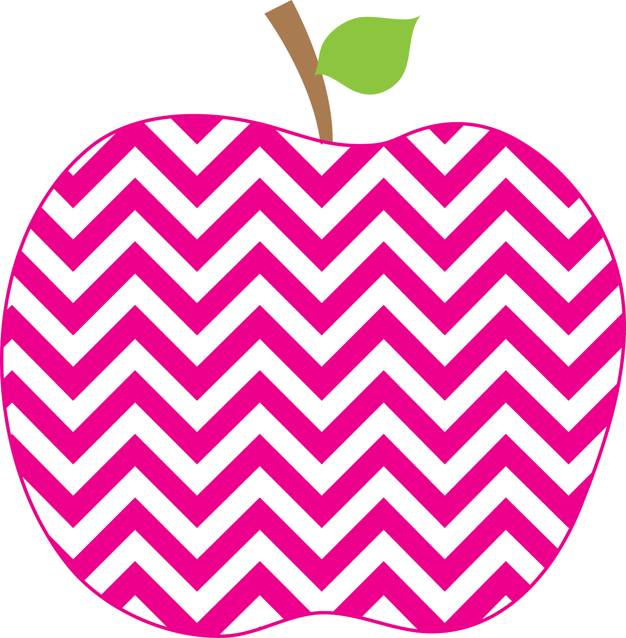


: (

Student of the Week
Josie

N/A
If you would like to send in student of the week treats for your child’s week, please send them in on Friday.
- PLEASE SEND EXACT CHANGE FOR SNACK. ($0.75 or $1.50) I do not have change to give back.
- PE 11:20-1205
- Lunch: 12:29-12:56
- Please label any money sent in (ex. Snack, field trip, etc.)
- Your child must wear tennis shoes or closed toe shoes to PE EVERYDAY!

Upcoming Events and Important Info

- 10/17-Report Cards
- 10/18-Thanksgiving Reservations due
- Please initial behavior calendar NIGHTLY!!!
- Please clean out your child’s folder nightly!

Reminders

Every Student Empowered, Every Student Succeeds

