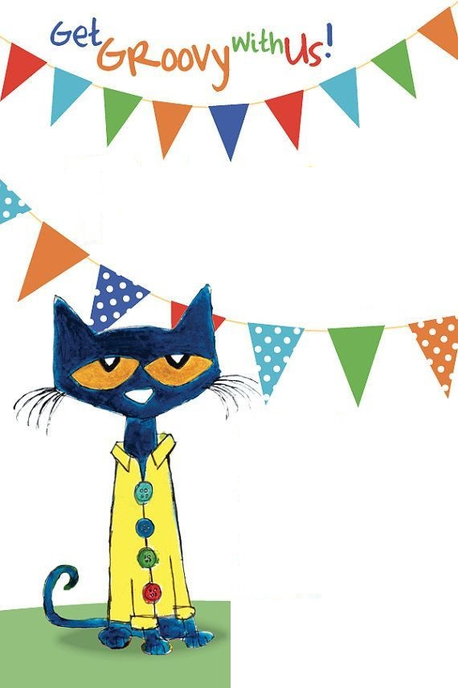

* Paper towels
* Baby wipes
* Tissues
* Lysol spray
* Colored copy paper
* Glade plug-ins (lavender, vanilla)
* Room spray (lavender, vanilla)
* Clorox wipes
* Command strips
* Hot glue sticks (large)
* Ziploc bags-all sizes

Ms. Allen’s

Wish List