|  |
| --- |
| GED/HSE 23 |
| GED Practice Set 2 |
| 13-24 Study Edition |

|  |
| --- |
| Kevin Adams |

1. Which expression and graph of the solution represents this inequality?

*The product of six and a number is greater than or equal to the sum of the same number and fifteen.*

1. (b) The “product of six and a number” is 6 times some number. Let stand for some number.

“is greater than or equal to” is represented by .

“the sum of the same number and fifteen” is ,

To solve, we need our variable alone on the left side of the inequality. First, we get rid of the positive on the right side.

2.(c) Set up the multiplication problem ignoring the decimals.

Now count the total number of places to the right of the decimal in our original numbers. There are four. There will be four places to the right of the decimal in our final answer.

The final zero is dropped!

3. () Ignore the negative signs *inside* the absolute value bars. The **absolute value** bars ask us the simple distance between the value and zero.

(a)



(b)



(c)



(d)



2. Without a calculator, multiply.

(a)

(b)

(c)

(d)

3.

4. *Without a calculator,* perform the following operations.

4.

5. (d)

6. (b) How much did the value of the house increase?

What percent of 140,000 is 60,000?

7. (a) If there are 7 red marbles and 11 blue marbles, then there are 7 red marbles out of 18 total marbles.

5. *Without a calculator,* evaluate the following expression.

(a) 2 (b) 4 (c) 6 (d) 8

6. Maria bought a house 5 years ago for $140,000.

Now, it is worth $200,000.

Rounded to the nearest tenth, what is the percent increase in the value of Maria’s house?

(a) 2.3%

(b) 42.9%

(c) 60%

(d) 233%

7. In a set of marbles, there is a 7:11 ratio of red to blue marbles. If there are 162 total marbles in the set, how many of them are red?

(a) (b)

(c) (d)

1. If , evaluate

1. (c) Use substitution.

If using a calculator, remember to put the in parentheses ***by itself***. Otherwise the calculator will give you the wrong answer, , which is option (a)

.

2. (d) Use distribution.

3. Problems that involve syncing up different cycles are really Lowest Common Multiple Problems.

Find the LCM of 2, 3, and 4.

Always start by listing the first few multiples of the largest value. The first one we come to that is also a multiple of the other values will be the LCM.

4, 8, 12.

12 is the lowest number that is evenly divisible by all of the values, so the LCM is 12.

If all three bells ring at 12 midnight, then the next time they all ring together will be 12 hours later, at 12 noon.

(a)

(b)

(c)

(d)

2. Which of the following expressions is the equivalent of

(a)

(b)

(c)

(d)

3. In the little town of St. Pietro, there are three church bells. The first bell rings every two hours. The second bell rings every three hours. The third bell rings every four hours.

If all three bells ring at 12 o’clock midnight, what time will it be the next time all three bells ring at the same time?

4. At a local coffee shop, Grace is hanging paintings for an art exhibit. On one wall, there is space to hang exactly two paintings.

4. (a) The magic word is **combination**.

Name all 5 things, and make a chart.

a b c d e

ab bc cd de

ac bd ce

ad be

ae

Now count the total: 10

5.

6. (d) We can’t have decimals outside the box. Move the decimal in both values 2 places to the right.

She has five paintings to choose from for this wall. How many different combinations of the five paintings does Grace have to choose from?

(a) 10

(b) 20

(c) 25

(d) 30

5. *Without a calculator*, match the following expressions with their evaluations.

6. *Without a calculator*, evaluate the following expression.

(a)

(b)

(c)

(d)

Mr. Patterson is an avid bird-watcher. Over the course of six days, he kept a tally of how many Golden-Cheeked Warblers he saw, and recorded the results in the table below.

1. The **median** is the *middle value in an ordered set*. First, order the set.

The exact middle of this set is between 4 and 5. We take their average.

2. (b) The **mean** is the *average value*. Add all of the values, and divide the sum by the number of values.

3. (b) Name the missing value . Then write the problem and solve for .

|  |  |
| --- | --- |
|  |  |
|  |  |
|  |  |
|  |  |
|  |  |
|  |  |
|  |  |

1. What was the median number of warblers Mr. Patterson saw over the six-day period? (Round to the nearest *tenth*.)

(a) 4.1 (b) 4.2

(c) 4.5 (d) 7.0

2. What was the mean number of warblers Mr. Patterson saw over the six-day period? (Round to the nearest *tenth*.)

(a) 4.1 (b) 4.2

(c) 4.5 (d) 7.0

3. Any bird-watcher who records a seven-day average of 4 warblers is eligible for a prize from the local birders’ club.

What is the minimum number of warblers that Mr. Patterson would need to spot on the seventh day to be eligible for the prize?

(a) 2 (b) 3

(c) 4 (d) 5

4. Subtract the following polynomial.

4. (c) Rewrite as an addition problem. Turn every term in the second polynomial into its **opposite**.

Now combine like terms.

5. (b) The figure illustrated is a cone.

The surface area of a cone is found by a formula.

Here, and

Substitute these values into the formula.

(a)

(b)

(c)

(d)

5. What is the surface area of the figure illustrated below?

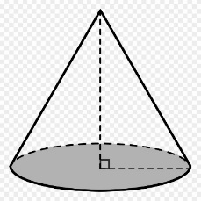

4 5

6

(a)

(b)

(c)

(d)

(Questions 1-3 refer to the chart.)

1. (d) First, we add all of the categories together to find the total:

Set up a proportionate ratio, and use cross-multiplication to solve for the percent.

Or, create a fraction and convert to a decimal. Express the decimal as a percent by moving the decimal point two places to the right.

2. (d) The chart indicates that the sales are in the *thousands* of dollars.

3. The median is the *middle value in an ordered set*.

The exact middle is between 3.5 and 4.25.

Take the average of the values.

Multiply by 1000.

Widgets And More, Inc. has recorded its monthly sales data for four categories in the chart below.

*Sales, in Thousands of Dollars*

1. Rounded to the nearest hundredth of a percent, what percentage of total sales do Toys represent?

(a) (b)

(c) (d)

2. What was the amount of total sales for the month reported?

(a) (b)

(c) (d)

3. What was the median amount of sales for the four categories?

(a) (b)

(c) (d)

4. Evaluate .

4. (c) This is a calculator use question.

Enter 361 into the radical.

5. (c) 2 divides evenly into both the numerator and the denominator.

We subtract the exponents: 5 – 3 = 2

It can help to visualize.

6. (d) There are only two undefined expressions: a denominator of zero and the square root of a negative number.

What values for will make the denominator equal zero?

Notice that this is a multiplication problem. is some number, and is some number. They are being multiplied together, and their product is zero.

Either must equal zero, or must equal zero.

or

(a) (b)

(c) (d) 20

5. Simplify

(a)

(b)

(c)

(d)

6. Which set of values for will make this expression undefined in the set of real numbers?

(a)

(b)

(c)

(d)

1. Evaluate the expression if , , and .

1. (d) Using substitution, evaluate the expression under the radical.

Now find the square root of 36.

2. (c) If we can do one thing in number of ways, and we can do another thing in number of ways, then we can do both things in number of ways.

Tyler can choose a jacket in 3 different ways, and he can choose a tie in 5 different ways. He can choose them both in

different ways.

3.

(a)

(b)

(c)

(d) 6

2. Tyler is choosing an outfit for an upcoming job interview. He has 3 jackets to choose from and 5 different ties to choose from.

How many different ways can Tyler choose a jacket and tie?

(a) 8

(b) 10

(c) 15

(d) 35

3. Expand the following expression using the distributive property of multiplication. Enter your answer in the box provided.

4. On the number line below, graph the solution to the inequality described.

4. The product of a number and 4 is

Two less than is

5. The formula for the volume of a sphere is given on the formula sheet.

*Two less than the product of a number and four is less than eighteen.*





5. What is the volume of a sphere with a radius of 6?

(a)

(b)

(c)

(d)

1. Without using a calculator, evaluate the following expression.

1. (b) **PEMDAS**!

2. Convert each term into either a fraction or a decimal. In this case, the decimal form is the easiest.

From least to greatest, we have:

3. (b) Set up a proportionate ratio and solve by cross-multiplication.

BE CAREFUL TO ALWAYS LABEL NUMERATORS AND DENOMINATORS!  *They must be the same things.*

(a)

(b)

(c)

(d)

2. Arrange from least to greatest:

3. A school has a ratio of 8 male students to 11 female students.

If the school has 132 female students, how many male students does it have?

(a) 88

(b) 96

(c) 106

(d) 129

4. What is the length, in units, of the missing side of this triangle?

4. (c) If we know any two sides of a right triangle, we can find the third side by using the Pythagorean Theorem, found on the formula sheet.

It doesn’t matter which legs we call and , but is always the hypotenuse.

5. (c)

After converting the percentages into their decimal forms, add a 1 in front of each to keep a running total.

15

20

(a) 5

(b) 15

(c) 25

(d) 35

5. Jackie has lunch at her favorite restaurant. She orders the Soup and Salad Combo for $7.99 and an Iced Tea for $1.99.

After a sales tax of 8.25% has been added, Jackie adds a tip of 20% to the total.

Rounded to the nearest cent, how much does Jackie spend on lunch at the restaurant?

(a) $9.98

(b) $10.40

(c) $12.96

(d) $22.96

1. Place the following in order from least to greatest.

1. First, convert each term into its decimal form.

Now, arrange from least to greatest.

2. (b) There are only two undefined expressions: a denominator of zero and the square root of a negative number.

Here we ask ourselves, “What values of will make a negative number?”

Negative numbers are less than zero.

If is less than zero, the expression will be undefined.

3. (b) The formula for simple interest is on the formula sheet.

the Principle, the amount we’re starting with.

the interest rate. It must be expressed as a decimal.

time. It must be expressed in years.

2. What value or values of will make this expression undefined in the set of real numbers?

(a)

(b)

(c)

(d)

3. Samuel has taken out a loan of $12,000.00 for 36 months at a simple interest rate of .

How much will he have paid in interest by the end of the loan?

(a) $183.60

(b) $1,530.00

(c) $18,360.00

(d) $153,000

4. Without a calculator, evaluate the following expression.

4. **PEMDAS**!

5. (b) The formula for the volume of a rectangular prism (box) is on the formula sheet.

We are given , , and .

We must solve for .

6. . The absolute value of a term is its distance from zero on the number line. We ignore the negative.

7. (a) We simplify rational expressions (fractions) that involve exponents by subtracting: numerator minus denominator.

Don’t forget the invisible exponent of 1.

(a)

(b)

(c)

(d)

5. A carton in the form of a rectangular prism holds 480 cubic inches of material. It is 6 inches wide and 8 inches long.

What is the height of the carton, in inches?

(a) 7

(b) 10

(c) 12

(d) 366

6. Evaluate the following expression.

7. Simplify the following expression.

(a)

(b)

(c)

(d)

1. Solve for if , , , and .

1. (b) Use substitution, and evaluate.

2. We are given an ordered pair. They are always in alphabetical order: .

Starting from the center , which is called the origin, move left or right along the axis. Here, , so we move to the right 3.

Then go up or down to find the value of .

Here, .

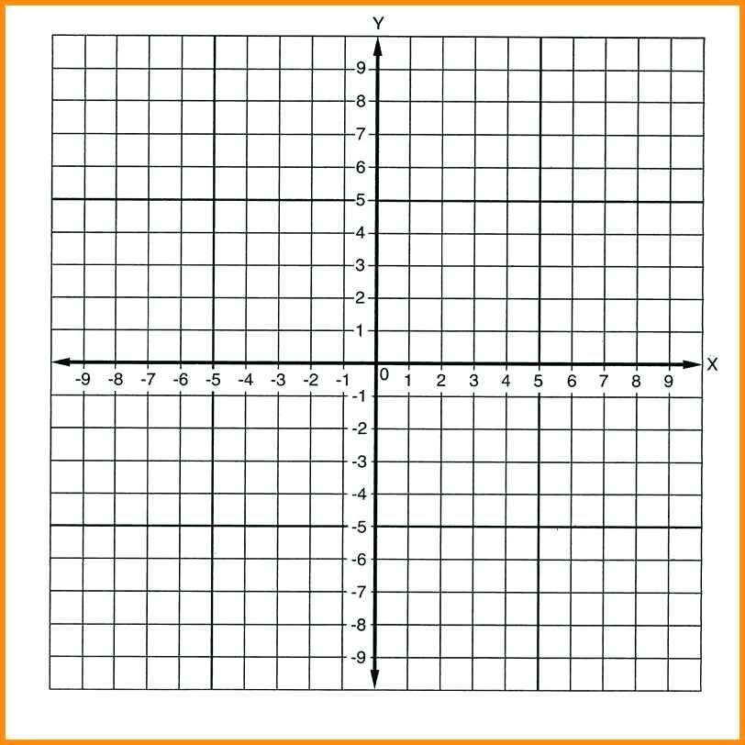

(a)

(b)

(c) 1

(d) 2

2. Place a point on the coordinate grid at .



3. Subtract.

(a)

(b)

(c)

(d)

4. Multiply.

(a)

(b)

(c)

(d)

5. Joan wants to cover a box in the shape of a rectangular prism with tin foil.

3. (b) Turn the subtraction problem into an addition problem.

Convert each term in the second polynomial into its opposite.

4. (d) When multiplying with exponents, add.

Don’t forget the exponent of invisible 1!

5. (c) The formula for the surface area of a rectangular prism is given on the formula sheet.

That can look complicated. All it means is that there are 3 pairs of rectangles. We find the area of each one, add them up, and multiply the sum by 2.

How many square inches of foil will she need?

11

10

5

(a) 26 (b) 210 (c) 430 (d) 550

1. Three bookstores are advertising weekend sales to celebrate National Poetry Month.

1. Find the price per book of each store.

Olympia, Europa, Appolinaire’s

2. (d) The formula for the slope is given on the formula sheet.

We’re given two points on a line. The slope of a line is easily found. The numerator is the difference of the values of . The denominator is the difference of the values of .

It doesn’t matter which point we choose as “point 1” or “point 2.” The answer will always be the same.

3. (d) Set up the division problem.

We’re not allowed to have decimals outside the box. Move the decimal point two places to the right in both values.

Divide as normal. The decimal in the answer will be directly above the decimal in the box.

Place the bookstores in order from least to greatest price per book.

EUROPA BOOKS

2 $5.00

4 $10.00

6 $15.00

OLYMPIA BOOKS $2.25 EA

APPOLINAIRE’S BOOKS

3 FOR $7.99

______________ ______________ ______________

2. What is the slope of the line which passes through the points and ?

(a)

(b)

(c)

(d)

3. Without a calculator, divide.

(a) 0.0091

(b) 0.091

(c) 0.91

(d) 9.1

4. Which of the following is the same as the expression shown?

4. (c) Distribute throughout the polynomial, remembering how we work with exponents.

5. (d) When adding mixed numbers, take care of the fractions first. We need to find a common denominator for 3 and 5. The LCD will be 15.

Now we add:

6. (a) Multiply by each term in the binomial.

(a)

(b)

(c)

(d)

5. Without a calculator, add.

(a)

(b)

(c)

(d)

6. Distribute the following expression.

(a)

(b)

(c)

(d)

40

1. James is building a stone wall around a circular area that is 40 feet across from one side to the other.

1. (b) We are looking for the total length all around the circular wall. This is called the circumference of a circle.

Here, we are given the diameter, , of the circle.

2. (b) We need to find the area of the circle.

The radius, , is the distance from the center of the circle to any point on the circle. It is half of the diameter.

Each pallet covers 12 , so we divide the area by 12.

He will need 105 pallets of sod.

3. **PEMDAS!**

What will the length of the wall be, rounded to the nearest foot?

(a) 125

(b) 126

(c) 1257

(d) 5027

2. After the wall is built, James will order sod to put down in the enclosed area. He must order the sod by the full pallet.

Each pallet holds 12 square feet of sod.

How many pallets of sod will James need to order?

(a) 11

(b) 105

(c) 126

(d) 1257

3. Without a calculator, evaluate the following expression.

4. Name the ordered pair at which the following line intersects the -axis.

4. The axis is the vertical (up-and-down) number line.

This line crosses (intersects) the axis at .

To name the point, we start from the center (origin.)

We name the ordered pair .

5. (c) We must find the area of the trapezoid. The formula for the area of a trapezoid looks complicated.

A trapezoid has a pair of parallel sides. These are called its , and .

The , , is the distance between the bases.

To find the area of a trapezoid, we average the length of the two bases, and multiply the result by the height.

5. The Mendez family owns a trapezoidal

lot that is 40 feet wide. One of its sides

 50 40 70 is 50 feet long, and the other is 70 feet

long. What is the size of the lot, in

square feet?

(a) 1200

(b) 1600

(c) 2400

(d) 4800

1. (a) Don’t be intimidated by the vocabulary of *rational expression*. Remember: if it looks like a fraction, we can work with it just like any other fraction.

Example:

2.(c) How many dollars did the car lose in value?

What percent is 8000 of 18000?

3. (d) We can’t take the square root of a negative number.

All negative numbers are less than zero.

What value of will make the expression in the radical a negative number?

Solve for .

1. Simplify the following rational expression.

(a)

(b)

(c)

(d)

2. Five years ago, Kirsten bought a car for $18,000. She sold it for $10,000. What was the percent decrease in the value of the car? Round your answer to the nearest whole percent.

(a)

(b)

(c)

(d)

3. For what value or values of is the following expression undefined in the set of real numbers?

(a)

(b)

(c)

(d)

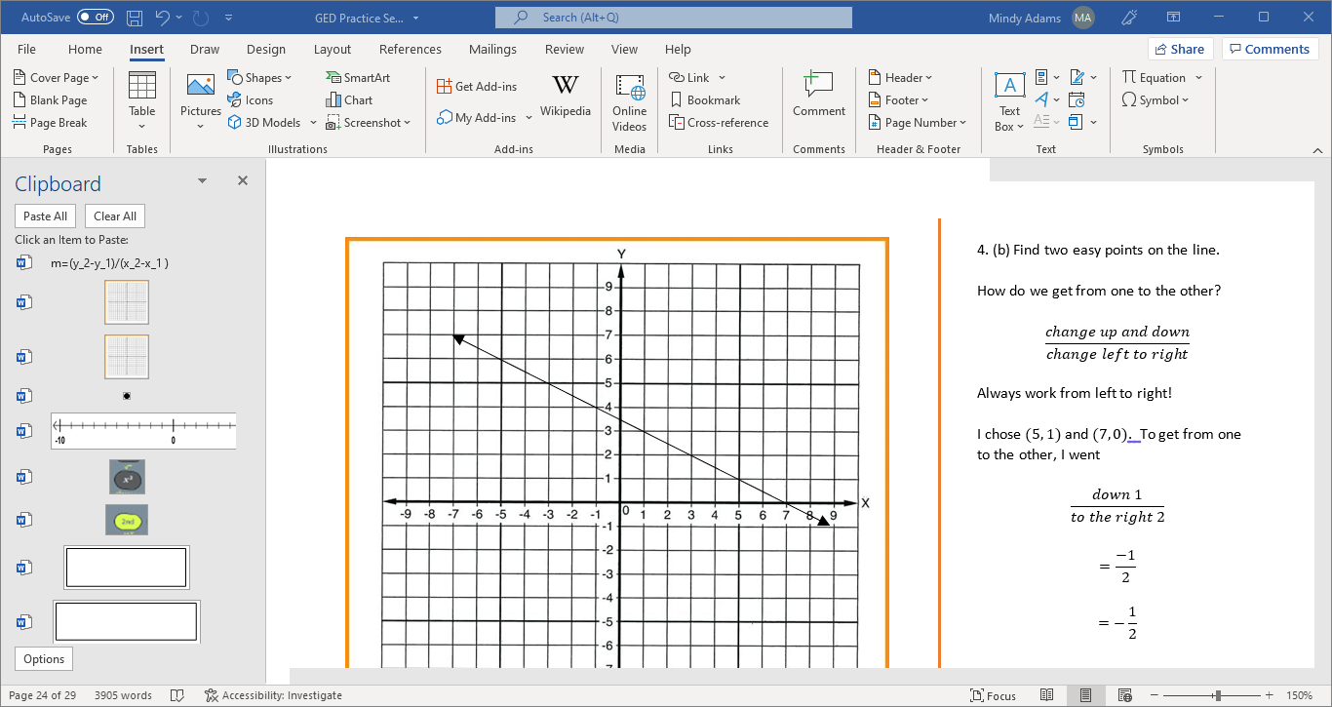

4. What is the slope of the line illustrated above?

4. (b) Find two easy points on the line.

How do we get from one to the other?

Always work from left to right!

I chose and . To get from one to the other, I went

5. The number line we’re given is divided into *fourths*. The fraction we need to locate is divided into *eighths*.

Can we turn *eighths* into *fourths*?

That is one way to think about it. Here’s another:

If we wanted to imagine that the number line were divided into *eigths*, we would insert a mark between each of the *fourths*.

(a)

(b)

(c)

(d) 2

5. Place a point on the number line to represent .

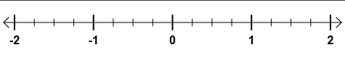

1. Solve and graph the following inequality.

1. The product of a number and two is

Three more than that is

2.(d) First, find the total cost before tax and tip.

After converting the percentages into their decimal forms, add a 1 to each. Multiply to find the running total.

Round to the *hundredths* place.

3. (d) There are only two kinds of undefined expression that concern us: the square root of a negative number and a fraction with a denominator of zero.

is the square root of a negative number.



2. Armando is having lunch at a small cafe with his wife. He orders a Fish Taco Plate for $7.99 and a side salad for $3.99.

His wife orders a bowl of Clam Chowder for $5.99 and a side salad for $3.99. They both order Iced Tea for $1.75 each.

After tax of 8.25%, Armando adds a 20% tip to the total.

How much, in all, will the meal cost? (Round to the nearest cent.)

(a) $8.02

(b) $25.46

(c) $30.49

(d) $33.07

3. Which of the following expressions is undefined in the set of real numbers?

(a) (b) (c) (d)

4. If the surface area of a sphere is 1018 square inches, what is its radius? (Round your answer to the nearest whole number.)

4. (b) The formula for the surface area of a sphere is on the formula sheet.

We are solving for the radius, .

5. (b) Turn the subtraction problem into an addition problem, and turn every term in the second polynomial into its opposite.

6. (b) These points are given to us in table form. Each column is a point, .

Choose any two points and subtract:

(a) 7

(b) 9

(c) 41

(d) 81

5. Subtract.

(a)

(b)

(c)

(d)

6. What is the slope of the line represented by the following table?

|  |  |  |  |  |  |
| --- | --- | --- | --- | --- | --- |
|  |  |  |  |  |  |
|  |  |  |  |  |  |

(a)

(b)

(c)

(d)

13 1. b

2. c

3.

4.

5. d

6. b

7. a

14 1. c

2. d

3. 12:00 PM (Noon)

4. a

5.

6. d

15 1. c

2. b

3. b

4. c

5. b

16 1. d

2. d

3. c

4. c

5. c

6. d

17 1. d

2. c

3.

 4.

5. d

18 1. b

2.

3. b

4. c

5. c

19. 1.

2. b

3. b

4. c

5. b

6. 1

7. a

20. 1. b

 2.

3. b

4. d

5. c

21. 1. Olympia, Europa, Appliinaire’s

2. d

3. d

4. c

5. d

6. a

22. 1. b

2. b

3. 3

4.

5. c

23. 1. a

2. c

3. d

 4. b

5.

24. 1.



2. d

3. d

4. b

5. b

6. b