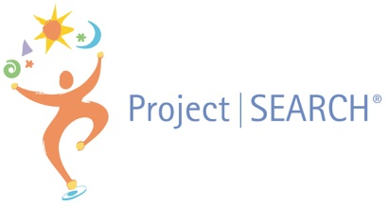

Project SEARCH was developed at Cincinnati Children’s Hospital Medical Center, a research environment that fosters visionary thinking and innovation. It began in 1996, when Erin Riehle was Director of Cincinnati Children’s Emergency Department. Erin felt that, because the hospital served individuals with developmental disabilities as patients, it made sense that they should commit to hiring people in this group. She wondered if it would be possible to train people with developmental disabilities to fill some of the high-turnover, entry-level positions in her department. These jobs involved complex and systematic tasks, such as stocking supply cabinets. To learn more about the feasibility of her idea, she turned to Great Oaks Career Campuses and the Hamilton County Board of Developmental Disability Services. Through this outreach, Erin met Susie Rutkowski, then the special education director at Great Oaks. Erin and Susie formed a partnership that was instantaneous, and together they turned the idea of filling a handful of jobs in Cincinnati Children’s Emergency Department into a comprehensive, internationally recognized program model—Project SEARCH.

**OUR STORY**

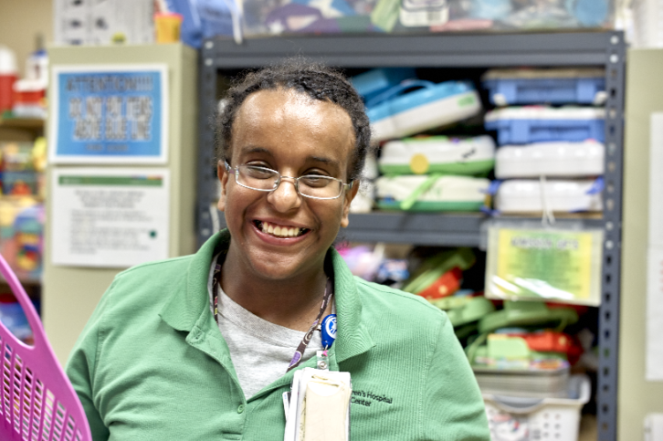

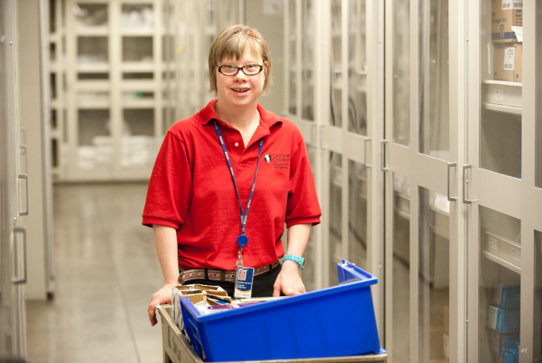

Project SEARCH has grown from one original program site at Cincinnati Children’s to over 600 programs across 47 states and ten countries. Some of our business partners include: Fifth Third Bank, Dow Chemical, The Smithsonian Institute, Henry Ford Hospital, Duncan Aviation, Medtronic, Embassy Suites in many locations, Zoo Miami, Indiana, Michigan and Minnesota State Governments, Emory Midtown Hospital, Drexel University, Xavier University, Kaiser Permanente, McConnell Air Force Base, Joint Base Andrews, National Institutes of Health, Henry Ford Beaumont Hospital, and Cleveland Clinic to name a few**.**

**Project SEARCH’s primary objective is to secure competitive, integrated employment for people with disabilities.**

Project SEARCH is driven by collaboration with many community partners: A host business, an education partner, a supported employment provider, Vocational Rehabilitation and the local Development Disability organization.

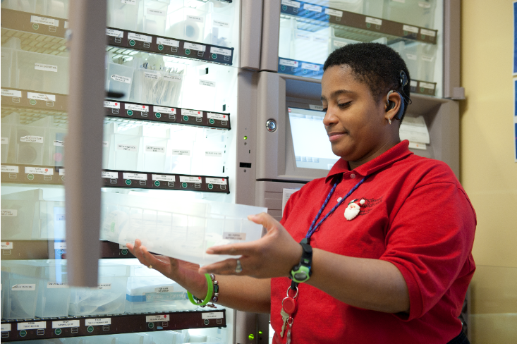

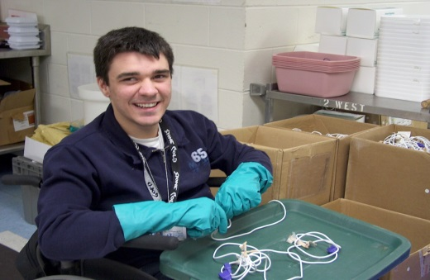

*“When businesses identify the strengths of employees with disabilities, then help them find them jobs that match their skills, those employees turn out to be faithful, low-turnover, hard-working employees… The Project SEARCH community, whether the instructors, skills trainers or other partners, all help us at Fifth Third Bank contribute to the team effort. As experts in running this type of program, they offer the experience to truly make our students successful.  Fifth Third Bank sees Project SEARCH as an opportunity to strengthen the community, as well as a true recruitment strategy.  We achieve both these things by helping our student interns learn valuable and transferable life and employment skills.” Bob Shaffer, Executive Vice President, Fifth Third Bank, Chief Human Resources Officer*

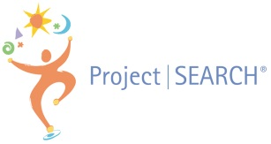

***To Learn More:***

* Visit our website: [www.projectsearch.us](http://www.projectsearch.us)
* Check out the videos on this page: <https://projectsearch.us/who-we-are/>
* Like us on Facebook: <https://www.facebook.com/ProjectSEARCHhq/>
* Follow us on Twitter: <https://twitter.com/ProjectSEARCHHQ>

*“While the interns are gathering marketable and transferrable skills to improve their ability to secure meaningful employment, the host business is learning about working with people of all types of abilities.  The interns have a safe space to fail, learn and grow while experiencing many typical job situations.  Here at Dow, we have gained as much, or more, than the interns that have gone through the program.  We’ve learned that there are different ways to accomplish a task, that communication is more than the words we say or instructions we provide, and that everyone brings value.  It’s improving our culture and bringing life to our inclusive journey.”  Rhonda Thomas, Global Talent Acquisition Operations Manager, Dow Chemical*

*“As the TSYS host site business liaison since 2016, I’ve witnessed tremendous growth in our interns over each nine-month program year.  During the program they establish a solid foundation to build upon by learning competitive and marketable job skills as well as life skills. Although TSYS is the host site, Project SEARCH belongs to and benefits our community.  Not every business can be a host site, but every business can hire a graduate.  If you’re looking for a great candidate, find a Project SEARCH graduate…because* ***Everyone Can Work****!” Pino Wells Davis, Director – Quality and Community Business Partner, TSYS*

**Project SEARCH** is a nine-month internship program for people with intellectual and developmental disabilities. It is targeted for individuals whose goal is competitive employment. The program takes place in a healthcare, government or business setting where total immersion in the workplace facilitates the teaching and learning process as well as the acquisition of employability and marketable work skills. Interns participate in three internships to explore a variety of career paths. The interns work with a team that includes their family, an instructor, and local and state agencies to create an employment goal.

**BENEFITS of the Project SEARCH Model:**

***Benefits to the Students:***

* Participate in a variety of internships within the host hospital/business
* Acquire competitive, transferable and marketable job skills
* Gain increased independence, confidence, and self esteem
* Obtain work based individualized coaching, instruction and feedback
* Develop linkages to Vocational Rehabilitation and other adult service agencies

***Benefits to the Business:***

* Access to a new, diverse, talent stream with skills that match labor needs
* Interns and employees with disabilities who serve as role models for customers
* Access to a demographic of the economy with intense buying power: people with disabilities represent one of the fastest growing market segments in the United States
* Increased regional and national recognition through marketing of this unique program
* Increased performance and retention in high-turnover, entry-level positions

**OUR PROGRAM MODEL**