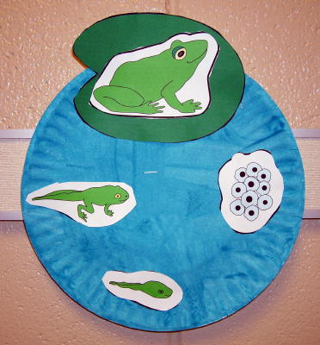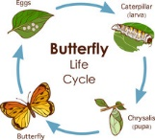

CLASS NEWS
Mrs. Williams
Date: April 6, 2026

Math: wrap up geo/spatial unit; begin fractions

Science/Social Studies: plant parts/functions

Upcoming Events:
April 6 – no school for students – Professional Development

