Mrs. Cannon’s Newsletter
December 16-20, 2024

New

Reading:
- Review main idea and details
- Review compare and contrast

Word Study Words:
Review R controlled vowels

High Frequency Words:
Review Unit 4 words

Math:
- Addition to 100 review

Language:
- Letters to Santa

Social Science:
- Christmas Around the World

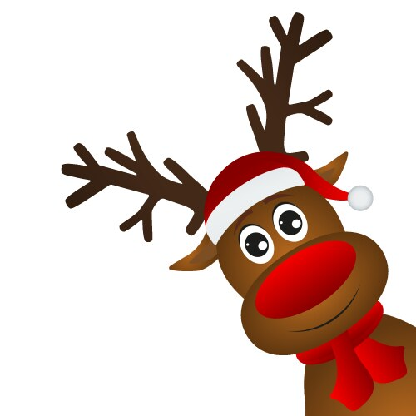
this week’s focus



Upcoming Events & Important Info

Student of the Week
Jakavious
(If your child is student of the week and you would like to send in treats for the class, please send them in on Friday.
- PLEASE SEND EXACT CHANGE FOR SNACK. ($0.75 or $1.50) I do not have change to give back.
- PE: 11:20-112:05
- Lunch: 12:26-12:51
- Please label any money sent in (ex. -snack, field trip, etc.)
- Your child must wear tennis shoes or closed toe shoes to PE EVERYDAY!

- Wonderful Wednesday (special snack)- Wednesday for $2.00 (only send money on this day)
- Cookies with Santa- Monday
- Grinch Day- Wednesday (wear green)
- Polar Express Day- Thursday (wear pajamas)
- ½ Day of school for students- Dec. 20th
- Vision Screener has been rescheduled
- Please send in your “stuff the stocking” item
- Please refer to the blue Christmas letter that was sent home last week.

Reminders

