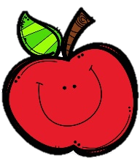
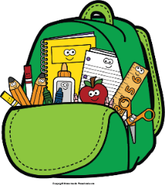
Mr. Marks’ Messages
September 8-12, 2025
Assessments
Thursday Assessments: grammar quiz, Topic 2 Math Test
Friday Assessments: Spelling Test, Reading Test, math weekly quiz
Reminders
- Monday, September 8th: YMCA Water Safety, Open House (5:00-6:30)
- Friday, September 12th: Kona Ice
- Friday, September 19th – Literacy Day 10:00 - 10:30
- Please check your child’s binder daily for important information, homework, and their behavior chart.
- Homework will be sent home Monday and is due Friday. Please send math homework to school each day. We will go over it in class.
Reading Story and Skills:  Story: The Bat, Birds, and Beasts  Phonics/Fluency:  Inflectional Endings –s, -es, -ed  Writing:  Write an opinion piece  Text-Based Comprehension:  Cause/Effect  Grammar/Language:  Helping/linking verbs |  | Vocabulary Words  - annual: happening or returning once a year  2. emphasize: to give special attention or importance to  3. strategy: a skillful plan to achieve a goal  4. inquired: to ask for information  5. loyal: staying to support and show affection to a person or group  6. accepted: to take with favor or approval willingly
Math  Topic 2  Lesson 4-5  Students will continue to learn to learn about even and odd numbers. We will also learn to use and make arrays to find totals. We will do study guide on Wednesday and test Thursday. |  |  |  | Social Studies/Science  Social Studies:  The students will learn about important American Symbols. They will identify and name The Statue of Liberty, Liberty bell, and a bald eagle.
Spelling Words:
- clapped  - shops | - locked  - patches |  | - picked  - wishes |  | - started  - stacks | - grabbed  10. pitches

