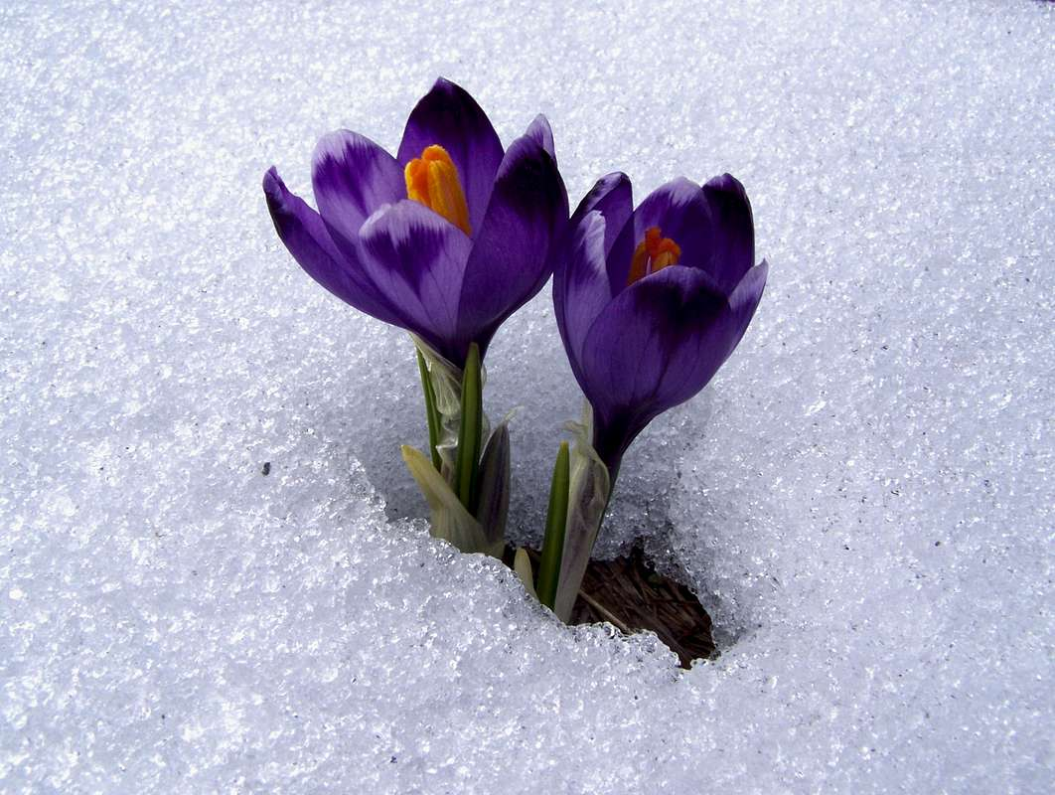

CLASS NEWS
Mrs. Williams
Date: February 23, 2026

Math: wrap up money w/test; begin unit on telling time

Science/Social Studies: wrap up unit on famous people – test this week

Upcoming Events:

